Preliminary Design Report



UC Irvine Rocket Project

**March, 10 2019**

**Advisors**

Professor Mark Walter & Professor Ken Mease

**Leads**

Rasheed Aziz, Mitchell Zarro Martinez, Tan Nguyen, Griffith Wagner, Kevin Chen, Richard Umboh, Sergio Sandoval, Cesar Ramirez

**Members**

Aleeza Roque, James Jamgotchian, Seungmin Lee, Amy Yee, Caitlyn Copeland, Derek Nguyen, Paul Badalian, Cameron Goedinghaus, Adam Park, Srinath Gopalakrishnan, Michel Soliman, Brian Fox, Sebastian Rosiak, George Ahl, Owen Browne, Mariam McCloskey, Amy Duong, Ahmed Elsayed, Akash Idnani, Harry Pak, Logan Marceau, Nathan Jump, Kaylee Miranda, Phillip Adler

|  |  |  |  |
| --- | --- | --- | --- |
| **Release and Revision** | | | |
| **Rev** | **Description** | **Date** | **Approved By** |
| [-] | Phase 1 Preliminary Design Report | 3/22/19 | Brian Fox |
|  |  |  |  |

Table of Contents

1. Project Overview **4**

1.1 UCI Rocket Project 4

2. System Design **6**

2.1 Design Approach 6

2.2 Mission Analysis 7

2.3 System Requirements and Architecture 8

2.3.1 Top-Level System Architecture 8

2.4 Mission Concept of Operations 8

2.4.1 Assembly and Preparations 8

2.4.2 Fueling 9

2.4.3 Launch 9

2.4.4 Flight 9

3. Propulsion System **9**

3.1 Design Approach 9

3.1.1 Derived Design Requirements 10

3.1.2 Basic Rocketry Equations 10

3.1.3 Assumptions 10

3.1.4 Derivation of Rocket Trajectory 11

3.1.5 Program Description and Results 12

3.2 Propellants 15

3.3 Engine 15

3.3.1 Requirements 15

3.3.2 Injector 15

3.3.2.1 Injector Selection 15

3.3.2.2 Injector Design Process 18

3.3.2.3 Sample Calculation 19

3.3.2.4 Sources 23

3.3.3 Combustion Chamber 23

3.3.3.1 Combustion Chamber Geometry 23

3.3.3.2 Combustion Chamber Data Generation 24

3.3.3.3 Combustion Chamber Cooling Methods 26

3.3.3.4 Future Design and Considerations 28

3.3.4 Nozzle 28

3.3.4.1 Design 28

3.3.4.2 Future Designs/Considerations 31

3.3.5 Cooling 31

3.4 Fuel System 31

3.4.1 Tanks 31

3.4.1.1 Requirements 31

3.4.1.2 Metal Alloys of Interest 32

3.4.1.3 Composite Tanks Analysis 37

3.4.1.4 Manufacturers of Interest 41

3.4.2 Pumps 43

3.4.2.1 Pumps Selection 44

3.4.2.2 Motor Consideration 45

3.4.3 Pressurized Gas Feed System 46

3.4.3.1 Method 1 of Determining Pressurant Mass 46

3.4.3.2 Method 2 of Determining Pressurant Mass 49

3.4.3.3 References 51

4. Structures **52**

4.1. Requirements 52

4.1.2. Force and Stress Analysis 52

4.2. Air Frame 54

4.2.1.1 Material Selection Strategy 54

4.2.1.2 Material Properties 55

4.2.1.3 Carbon Fiber 56

4.2.1.4 Aluminum 57

4.2.1.5 Fiberglass 59

4.2.1. Air Frame Internal Structure 60

4.3. Nose Cone 63

4.3.1. Aerodynamic Design 63

Types of Nose Cones 63

4.3.2. Thermal Analysis 69

4.3.3. Manufacturing Processes 71

4.4 Control Surfaces 71

4.4.1. Aerodynamic Design 71

4.4.2. Assembly, Integration, and Electromechanical Design 71

4.4.4. Flight Dynamics and Stability 72

4.5. Recovery System 73

4.5.1. Recovery System Design 73

4.5.2. Sample Calculations 75

5. Avionics **79**

5.1 Flight Control and Monitoring 79

5.1.1 Foreword 79

5.1.2 Hardware 81

5.1.3 Software 82

5.2 Propulsion System Control and Monitoring 84

5.2.1 Foreword 84

5.2.2 Hardware 85

5.2.3 Data Acquisition 85

5.3 Telemetry 86

5.3.1 Foreword 86

5.3.2 Hardware 87

5.3.3 Software 87

5.4 Instrumentation 88

5.4.1 Selection 88

5.4.1.1 Pressure Transducers 88

5.4.1.2 Thermocouples 88

5.4.1.3 Load Cells 88

5.4.1.4 Solenoid Valves 89

5.4.1.5 Valves and Actuators 90

5.4.1.6 Electronic Pressure Regulator 90

5.4.1.7 Flight Instruments 91

5.4.2 Verification 91

5.4.2.1 Verification of Pressure Transducers 91

5.4.2.2 Verification of Thermocouples 92

5.4.2.3 Verification of Load Cells 92

5.4.2.4 Verification of Solenoid Valves 93

5.4.2.5 Verification of Valves and Actuators 93

5.4.2.6 Verification of Electronic Pressure Regulator 94

5.5 Overall System Interface 95

5.5.1 Software 95

5.6 Summary 95

6. Engine Test **96**

6.1 Engine Test Stand Design 96

6.1.1 Full Test Stand Assembly Drawing and BOM¶ 97

7. Safety **98**

7.1 Hazard Analysis 98

7.1.1 High Pressure Systems 98

7.1.2 Cryogenics 98

7.1.3 Ignition System 98

7.2 Risk Assessment 99

7.2.1 Fueling 99

7.2.2 Launch 99

7.2.3 Flight 99

8. Team Development **100**

8.1 Succession Planning 100

8.1.1 Recruitment 100

8.1.2 New Member Development 100

8.1.3 Leadership Development 100

8.2 Knowledge Retention 101

8.2.1 Documentation 101

8.2.2 Drive Organization 102

8.2.3 GrabCad 103

8.2.4 Summary 103

8.3 Outreach 103

8.3.1 Lab Tours 104

8.3.2 Community College Collaboration 106

8.4 Business and Marketing 107

8.4.1 Overall Budget 107

8.4.2 Marketing Strategy 107

# 1. Project Overview

## 1.1 UCI Rocket Project

The UCI Rocket Project (UCI RP) is a senior engineering design team at the University of California, Irvine, dedicated to the design and development of liquid bi-propellant rockets. The team is young, having official status on campus for only a few years. Prior to 2017, UCI RP had very minimal traction with students. The team lacked structure, funds, personnel, and continual direction. In those prior years, goals continually switched from year to year, as old members graduated and new members joined. As the team matured and started to gain traction, Base11 donated $1,000,000.00 to UCI. This donation set in motion substantial growth for the team, allowing the project to build an entire rocketry lab solely dedicated to UCI RP. From that point on, UCI RP has focused on developing a program that would foster growth and innovation for all the students involved. The lab finished construction in February of 2018. The first step was to create a team structure that would make most sense for a university team. A figure outlining the team structure is included at the end of this section. The students finished off spring of 2018 with an unfortunate lesson in preparation attempting to conduct a static test fire at the FAR site in the Mojave desert. Despite this, the team structure stayed in tact, allowing decisions to be made more efficiently. Over the summer, as old leadership left, and new leadership stepped up, a decision was made to build a foundation for the team. This foundation would attempt to reduce the instabilities in the team structure and team focus that occur due to the high turnover rate of design teams. Taking notes from older teams like FSAE and HyperXite, UCI RP management built an organization system that alleviates the common issues that happen with young students on a high-turnover design team. These issues and organization strategies are discussed more in depth in sections 8.1-8.4.

With the organizational foundation built, the team was able to focus on making progress in the design and manufacturing of a rocket for the Base11 competition. The team then had a decision to make. Previously, a lot of time and effort went into designing a rocket for the FAR Mars competition. This rocket was also a liquid bi-propellant engine designed to get to 45,000 ft. Originally, the team’s plan was to push forward with a static test fire of that engine, and then completely start over with a design for the Base11 rocket. Half of the team was focused on pushing into the manufacturing and testing phase of the smaller engine, and half the team was in the preliminary design phase for the larger rocket. The splitting of resources was challenging, and proved difficult for the team to make much progress. However, through the preliminary design process and initial downselection, the team realized that a lot of the same design choices that were made in the smaller rocket could also be made in the larger rocket. This lead to the inception of the Preliminary Test Rocket (PTR). The PTR is the project’s version of a prototype rocket, allowing the members to get experience in testing, manufacturing, aerostructure design, flight software, telemetry, etc. Current leadership on UCI RP decided that the experience gained in these areas would streamline the design process for the larger rocket, as long as similar systems could be used. The decision to focus on the smaller PTR design has allowed us to progress into the testing phase, and UCI RP will be conducting a static test fire of the engine over the Spring quarter.

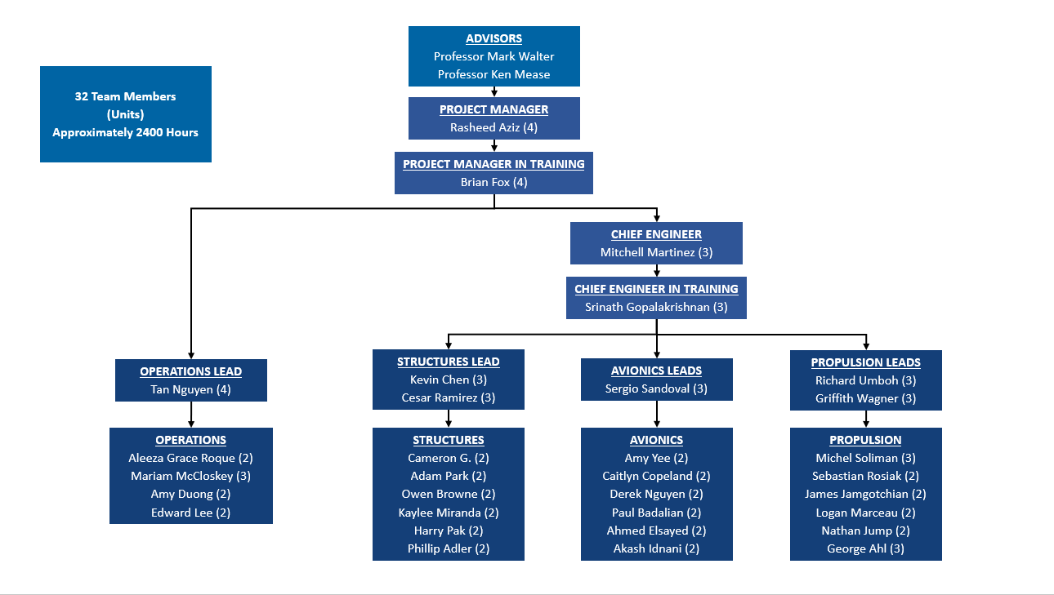

*Figure 1.1 Team Structure Organization*

# 2. System Design

## 2.1 Design Approach

To develop a rocket capable of reaching the Karman Line at an undergraduate level, a considerable amount of resources must be used. Many of which are not readily available to undergraduate student projects. These include but are not limited to: Industry specialists in the subjects of combustion and stability, injector manifold design and manufacturing, pressure vessel, fluid flow and control, data transfer and telemetry, aerostructure design and manufacturing, aerodynamics and aircraft control. UC Irvine has been afforded the ability to collaborate with professors who are experts in some of these respective fields, but the lack of mentorship through the application of theory and design has at times stagnated the design process, and so UC Irvine Rocket Project (UCIRP) is developing a system to avoid these issues in the future. In addition, UCI RP is expanding the network of industry experts and have collaborated with professional engineers from NASA Marshall Space Flight Research Center, Northrop Grumman and Interorbital Systems, and are currently reaching out to various industry professionals across the rocketry field to conduct design reviews and mentor through the development process.

UCI RP is currently developing a subscale rocket; Preliminary Test Rocket (PTR), to verify the design and manufacturing process prior to constructing the full-scale rocket to be used in the Base 11 Space Challenge. The ability to test PTR, will allow the team to verify the approach to engine development, data acquisition and telemetry, aerostructure development, pressure vessel development, aircraft stability and control, and fluid flow and control which will directly be used for the development of the full-scale rocket. Both systems will utilize a pressure fed feed system, ablatively cooled engine, have similar fluid flow control techniques, plumbing assembly, aerostructure development as well as data acquisition and telemetry systems.

To build a liquid bipropellant rocket of any magnitude, a considerable amount of sub-system tests must be conducted to verify each respective assembly for flight. UC Irvine is currently in the verification test phase, which is vital to verify systems leading up to the goal of a static fire test, and subsequent integration into a flight-ready rocket. These verification tests are to qualify the system for a static fire test of UC Irvine’s first generation liquid bipropellant engine. These systems are broken down into subsystems which encompass the work of each sub-team: Avionics, Propulsion and Structures. As the subsystems are integrated, problems may arise from an assembly, testing and general design standpoint; of which these preliminary tests are designed to uncover. The series of tests leading to the static fire test will include verification of plumbing assembly procedures, avionics sensor integration, engine assembly procedures and valve actuation sequencing. Each component integrated into the system has passed initial verification and its performance will be again verified as each consecutive test is performed. Each consecutive test in the sequence will model static fire operating conditions more closely than the previous to verify that all systems will operate nominally during the static fire test. In addition, valuable data will be collected to verify parameters necessary to fine tune the control system to deliver optimal performance of the engine during the static test fire. Such parameters include head loss of each propellant line in the system, pressure drop across the injector face. injector inlet pressures and mass flow rate accuracy. By determining these parameters, the team is able to adjust operating conditions to reduce error as each subsequent test is conducted.

As the team moves forward to hot fire the engine, the same philosophy will follow as the PTR is developed concurrently with the design of the full scale rocket. The teams goals are to test as much as possible on a cost and time effective basis to uncover any errors in the design and test phase. The current progress encompasses detailed assembly and test plans, the method of design for the plumbing system, engine and test stand and sensor integration work statements which will all be used as guides to qualify the full-scale Base 11 subsystems for tests and subsequently flight. The team plans to use the development of the PTR aerostructure to work out errors and design flaws to ensure a greater chance for success on a larger scale. This method models the Agile Development Process, where “sprints” are made to verify individual sections of the subsystem which allows for more periodic deliverables of major milestones than that of standard development techniques. Rather than using all the resources on a system that is not proven to work, the team will devote extra effort to making sprints to individually verify the system at a smaller scale, detailing the exact method of design, production and testing which will then be used as a foundation to scale the system up to the full-scale Base 11 rocket which will follow the same method of development to produce concrete deliverables.

## 2.2 Mission Analysis

The mission as described by Base 11 is to launch a suborbital, single-stage launch vehicle to 100 km with the use of non-toxic, non-hypergolic liquid propellants.

From the mission requirements stated, the choices of propellants were restricted to a short list. The oxidizers considered were hydrogen peroxide and liquid oxygen, while the fuels considered were RP-1, ethanol, liquid methane, and other liquid hydrocarbon fuels. For the purposes of this report, the LOX/RP-1 combination of propellants was considered for the most part, with some consideration for LOX/LCH4 as well, since these two combinations are our top choices for propellants based on cost, safety, feasibility, and performance.

A mass ratio of 2 was chosen as a baseline maximum for design. This signifies that at maximum weight, the structural mass of the launch vehicle is equal to the mass of the total propellant. The mass of total propellant was calculated by using a greater altitude of 130 km to account for losses due to drag and inefficiencies in the system. This estimate yielded an estimated propellant mass of around 660-770 pounds of propellant, varying with chamber pressure and propellant type. Structural requirements for design and material were derived from these mass estimates.

## 2.3 System Requirements and Architecture

From the mission requirements, we derived the system requirements by considering the maximum altitude, the total impulse, and the efficiencies of different propellant combinations. The maximum altitude was set to 130 km, overshooting the target altitude of 100 km, for the purpose of this analysis, as it does not include lossed to aerodynamic drag and inefficiencies in the engine design. The maximum impulse of the engine was also limited at 200,000 lbf, which was taken fully into account to give us the total propellant mass for each propellant combination based on their specific impulse.

### 2.3.1 Top-Level System Architecture

Below is a table showing our top-level system design for two most likely configurations.

|  |  |  |  |
| --- | --- | --- | --- |
| Table 1: System Architectures in Consideration | | | |
| **Item** | **Unit** | **Fuel Option #1** | **Fuel Option #2** |
| Estimated Length  Estimated Diameter  Propellants  Feedsystem  Chamber Pressure Range  Engine Thrust Range | ft  ft  -  -  psi  lbf | 21.5  2.0  LOX/LNG  Helium Pressurant  300-450  4,200-5,800 | 17.5  2.0  LOX/RP-1  Helium Pressurant  300-450  4,300-6,000 |
|
|
|
|
|
|
|
|
|

## 2.4 Mission Concept of Operations

### 2.4.1 Assembly and Preparations

The assembly of our system cannot be completed without a detailed assembly procedures. These assembly procedures, already created for our current test stand design, contain the detailed assembly of each subsystem and each component, down to the tightness of each bolt in the system.

The assembly stage will take place in before arrival at the competition. It would be broken up into several parts for ease of transportation, which will be designed for ease of integration. At the launch site, the full vehicle will be assembled and prepared for launch through verifications.

### 2.4.2 Fueling

Fueling will take place once the launch vehicle is assembled and integrated into the launch rail. The umbilicals will be attached to the necessary fuel dewars that carry the liquid oxygen and hydrocarbon fuel. The fueling and launch procedures will be automated with fail safes in place. The purpose of this automation is to reduce human error and to prevent excessive boil off of the cryogenic fuel(s) and excessive pressure build up.

### 2.4.3 Launch

The ignition and launch sequences will also be fairly automated, depending on directions and procedures of the launch team in charge of the Spaceport America launch site in New Mexico. At this point in the mission, system conditions are constantly monitored as the system is purged, cryogenically primed, fueled, and finally ignited.

### 2.4.4 Flight

During the flight stage, the system will be constantly monitored using pressure transducers and thermocouples to measure thermodynamics parameters at different points in the system. The telemetry system will send out the monitoring information as well as the position and acceleration of the rocket to keep track of its location and orientation during flight. This information is also used for automated failsafe sequences in case of system failures and trajectory failures. The recovery system will also be triggered using this information.

# 3. Propulsion System

## 3.1 Design Approach

The propulsion system designed must be capable of delivering a rocket to an altitude of 328,000 ft, and must have a maximum total impulse of 200,000 lbf-s. The maximum allowable propellant mass can be calculated for a given propellant combination by dividing the total impulse by the specific impulse, and from this other key parameters can be determined. The UC Irvine Rocket Project’s approach to the Base 11 Space Challenge was to design a system that was modular, robust, and simple such that should any unforeseen complications be found later on in the design process, major delays and setbacks can be mitigated.

With this in mind, the UCI Rocket Project has decided to take a top-down approach with regards to the design of the Base 11 Rocket. That is, rather than starting with the thrust chamber, the design is beginning with the choice of propellant. Many different design iterations were made based on different propellant combinations, as seen in *Propellant Data Analysis.* However, for the purpose of brevity the focus of this report will be one propellant combination with parameters that maximize the allowable non-propulsive structural mass, as stated in section 2.3.1.

## 3.1.1 Derived Design Requirements

The position of a rocket relative to Earth’s surface is a multivariable problem that can halt project development. This fact results from the nature of how the rocket’s acceleration is a function of drag, weight, thrust, evolution of the rocket’s mass with time, and the actual height that is desired. As a result, it is pertinent to simplify the problem in order to estimate important parameters and by establishing a region in the design space. This document demonstrates the preliminary design process that was taken along with the assumptions that were utilized.

## 3.1.2 Basic Rocketry Equations

The following equations are ubiquitous in the study of rockets and their design. Some simplifications will be made to aid in the estimation of the rocket parameters in the next section.

$Thrust=T=ṁu_{eq}=ṁu_{e}+(p_{e}-p_{a})A_{e}$

$ma_{rocket}=ΣF=Thrust-Drag-Weight$

$I_{sp}=\frac{T}{ṁg}=\frac{u_{eq}}{g}=Specific impulse$

$I_{total}=∫Fdt$

## 3.1.3 Assumptions

The following assumptions are made in order to simplify the computation of our current rocket’s system parameters.

1. Ideal expansion as the rocket climbs to apogee
2. No drag force
3. Constant mass flow rate
4. Adiabatic combustion
5. Constant exhaust velocity

As a result of these assumptions we can generate the following equations that describe the rocket.

$Thrust=T=ṁu_{eq}=ṁu_{e}$ (1)

$ma_{rocket}=ΣF=Thrust-Weight$ (2)

$I_{sp}=\frac{T}{ṁg}=\frac{u_{eq}}{g}=Specific impulse$ (3)

$I_{total}=∫Fdt=T×tb$ (4)

$M_{propellant}=\frac{t_{b}}{ṁ}$ (5)

## 3.1.4 Derivation of Rocket Trajectory

The following derivation was produced from the text Mechanics and Thermodynamics of Propulsion, 2nd Edition Hill/Peterson. It produces an equation for the apogee as a function of exhaust velocity, mass ratio, and burn time.

Variables:

$M_{o}=initial mass$

$M_{b}=mass at the end of thrust period$

$g_{e}=gravity of earth$

$u_{e}=exit velocity$

$ℛ=\frac{M_{o}}{M_{b}}$

For vertical flight the altitude attained at burnout is

$h_{b}=\int_{b}^{t_{b}}{}udt$

Where u is

$u= -u_{e }ln\frac{M}{M_{o}}-g_{e}t$

M is the mass of the rocket as a function of time. Assuming fuel consumption is at a constant rate:

$M(t)=M_{o}-(M_{o}-M_{b})t/t_{b}$

Then u becomes

$u= -u_{e}ln[1-(1-\frac{1}{ℛ})\frac{t}{t_{b}}]-g_{e}t$

and $h_{b}$ becomes

$h_{b}=-u_{e}t_{b}\frac{ln ℛ}{ℛ - 1}+u_{e}t_{b}-\frac{1}{2}g_{e}{t_{b}}^{2}$

Equating the kinetic energy of the mass at burnout, $M_{b}$, with its change of potential energy between that point and the maximum height, $h_{max}$, we obtain

$M_{b}\frac{{u_{b}}^{2}}{2}=M_{b}g_{e}(h_{max}-h_{b})$

and thus

$h_{max }= h_{b}+\frac{{u_{b}}^{2}}{2g_{e}}$

Finally,

$h_{max}=\frac{{u_{e}}^{2}(lnℛ)^{2}}{2g_{e}}-u_{e}t_{b}(\frac{ℛ}{ℛ-1}lnℛ-1)$ (6)

Once a propellant selection has been made, the knowns in the above equation are the maximum height and exhaust velocity. The burn time and the mass ratio (R) are the only unknowns. In the following analysis, all major rocket parameters will be plotted versus R.

## 3.1.5 Program Description and Results

Two MATLAB programs were implemented to provide iterative calculations with the equations 1-6. The function script that is supplied in the appendix of this report reads in data from a excel file then performs the calculation of propellant mass flow rate, propellant mass, thrust, structural mass, and burn time based on the user input. The script file immediately following the function script in the appendix is a plotting script that iteratively calls the function to plot all the propellant combinations on the same plots. In order to meet the competition specifications, the maximum total impulse of 2*10^5 lbf was used in the computations. Lastly, the maximum height was raised from the challenge height of 100km to 110 km since the analysis neglects drag.

|  |  |  |
| --- | --- | --- |
| Propellant Combo | Mixture Ratio (weight) | Isp (seconds) 1000 psi |
| Hydrogen Peroxide 95%/RP1 | 7.3500 | 273 |
| Hydrogen Peroxide 85%/ RP1 | 7.8400 | 258 |
| LOX/RP1 | 2.5600 | 300 |
| LOX/Methane | 2.7700 | 299 |
| LOX/ethanol+25% water | 1.2900 | 269 |

Below are the graphs of the results.

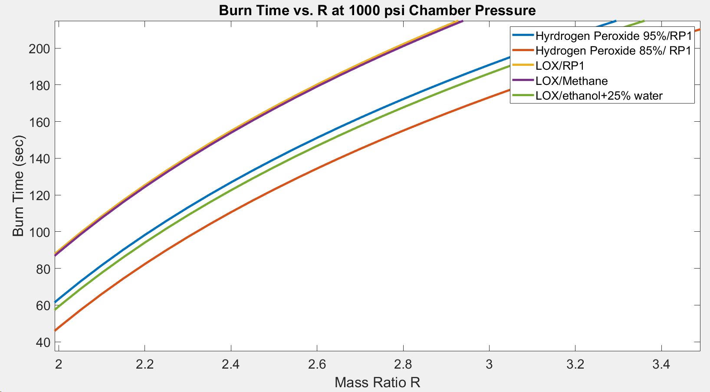

*Figure 3.1.5.1. Burn time vs mass ratio at 1000 psi chamber pressure*

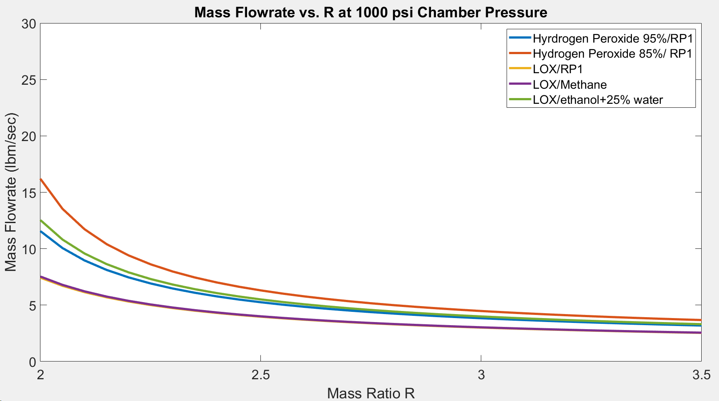

*Figure 3.1.5.2. Mass flow rate vs mass ratio at 1000 psi chamber pressure*

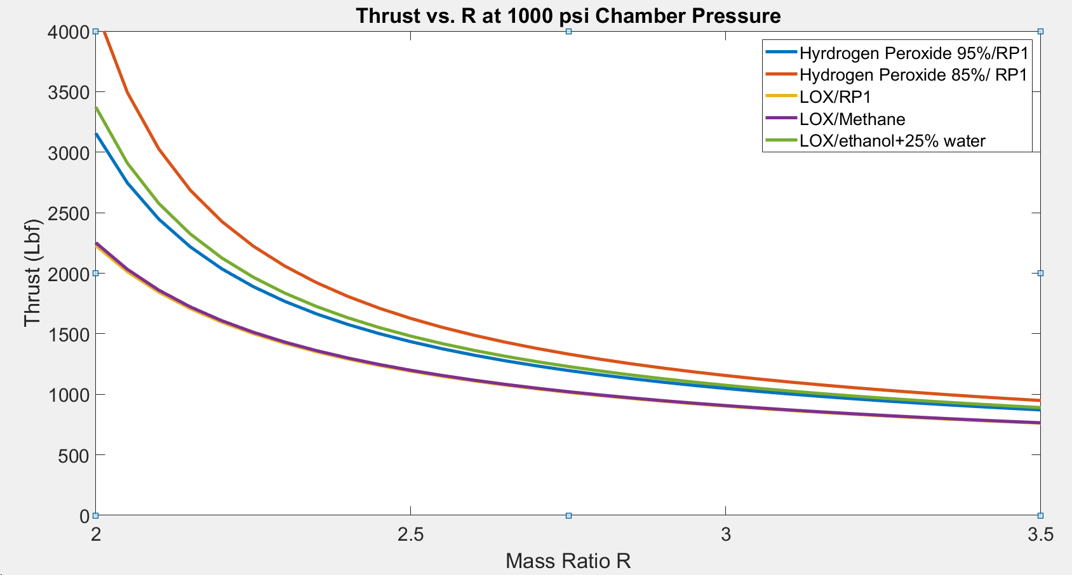

*Figure 3.1.5.3. Thrust vs mass ratio at 1000 psi chamber pressure*

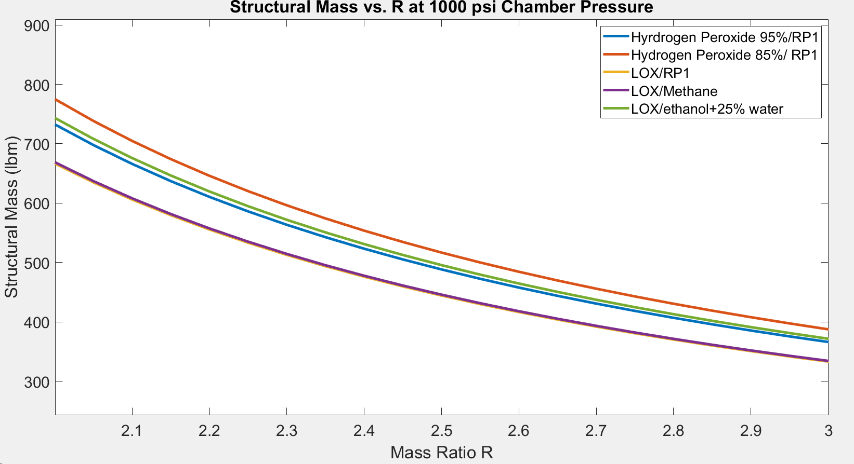

*Figure 3.1.5.4. Structural mass vs mass ratio at 1000 psi chamber pressure*

## 3.2 Propellants

After lengthy trade studies, the UC Irvine Rocket Project has tentatively chosen a Liquid Oxygen (LOX) and RP-1 propellant combination for the Base 11 Space Challenge. There were several reasons behind this choice. First is that LOX/RP-1 has a relatively high specific impulse when compared with the other propellants. Furthermore, LOX/RP-1 is the most widely used propellant combination in the launch industry, and thus has a plethora of available literature behind it and systems derived from it. This is extremely beneficial for an undergraduate team with less expertise and resources than that of a dedicated large launch company with hundreds of industry experts.

## 3.3 Engine

This section details the preliminary design of the engine and its associated major components: the injector, the combustion chamber, and the nozzle.

### 3.3.1 Requirements

Engine Design Restrictions:

* Total impulse not to exceed 200,000 lbf-sec
* Achieve apogee of 100,000 km
* Not to exceed an altitude of 150,000 km
* Liquid bi-propellant (no solids/hybrids)
* No hypergolics, hydrazine, and nitrogen tetroxide

Implied Requirements:

* Available propellant mass: 666 - 757 lbm
* Mass flow rate: 9.22 - 22.1 lbm/s
* Thrust: 2765 - 5827 lbf

### 3.3.2 Injector

The purpose of this section is to discuss how the injector element type was selected, the preliminary design of the orifice geometry, and the element pattern.

#### 3.3.2.1 Injector Selection

The primary consideration in designing injectors for heavy-hydrocarbons, LOX and RP-1 in this case, is vaporization. The lower inherent volatility of the fuel must be compensated by better vaporization performance of the injector. Based on the trade study below and recommendations from reference 3, the selected injector is a triplet composed of two jets of oxidizer impinging on a single jet of fuel (O-F-O). This type of injector was found to be most efficient (highest C* efficiency) when compared to a like-doublet, and split-triplet [3]. Element arrangement used is shown below.

|  |  |  |  |  |
| --- | --- | --- | --- | --- |
| **Injector Type** | **Element Designation** | **Description** | **Advantages** | **Disadvantages** |
| **Unlike Impinging** | Doublet  (1 on 1) | Oxidizer and fuel jets are made to impinge in pairs | Good mixing and atomization  Simple to manifold  Proven dependability | The resultant angle of momentum vector will vary with mixture ratio  Subject to blowapart with hypergolic propellants  Sensitive to design tolerances |
| Triplet  (2 on 1) | Two streams of one propellant impinging symmetrically on one stream of the other propellant | Good mixing and atomization  Resultant spray direction is axial  Proven dependability  High combustion performance | Subject to blowapart with hypergolic propellants  Sensitive to design tolerances |
| Quintuplet  (4 on 1) | Four streams of one propellant impinging on one stream of the other propellant in a symmetrical pattern | Excellent mixing and performance  Applicable to very high or very low mixtures of density ratios | Subject to blow-apart with hypergolic propellants  Difficult to manifold  Tends to produce high heat flux to injector face |
| **Like Impinging** | Self-impinging | This pattern, also known as a like-on-like impingement, generally employs self-impinging pairs of fuel and oxidizer. | Good inherent combustion stability  Easy to manifold  Not subject to blow-apart  Proven dependability | Requires increased axial distance to mix fuel and oxidizer |
| **Non-Impinging** | Showerhead | Employs non-impinging oxidizer and fuel streams which emerge normal to the injector face. | Excellent for boundary layer cooling  Excellent for wall compatibility  Easy to manifold  Not subject to blowapart  Proven dependability | Poor mixing and atomization |
| Coaxial (concentric tube) | Employs two concentric tubes for two propellants, which are injected coaxially. | Very good wall compatibility  Low pressure drop  Excellent atomization | Difficult to fabricate  Tends to become unstable when throttled |
| **Hybrid** | Splash plates | Injected propellants are deflected by the splash plates. The plates will be kept cool by the impinging liquid propellants which do not ignite until they have left the plate | Insensitive to design tolerances  Large thrust per element  Proven dependability | Wall compatibility problems  Complex design  No correlations for level of mixing and spray size |
| Throttleable injector (Pintle) | Variable injection slot areas. | Proven dependability  Large thrust per element  Simple to manufacture | Wall compatibility problems  No correlations for level of mixing and spray size |

Table 3.3.2.1.1 Trade studies of different element types

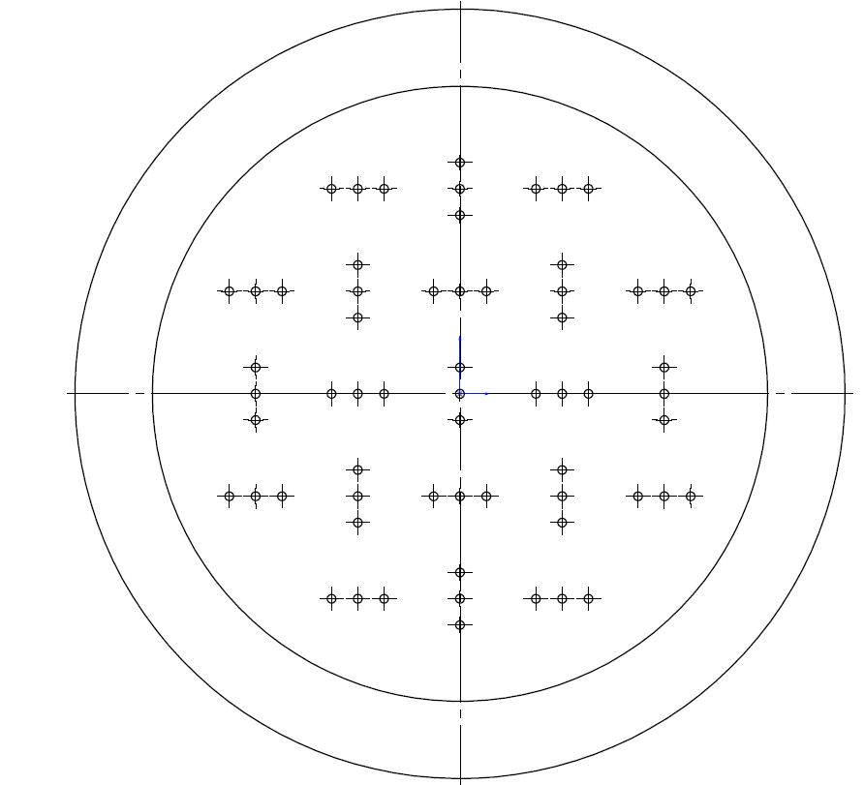

*Figure 3.3.2.1.1 Injector element pattern to be used*

#### 3.3.2.2 Injector Design Process

**Injection Pressure Drop:**

With unlike-impinging elements, the pressure drop across the injector ($ΔP_{inj}$) should be 10 to 15 percent of the chamber pressure $(P_{ch})$. [2]

$10≤ΔP_{inj}/P_{ch}≤15$

The equation for the pressure drop across the injector [1] is:

$ΔP_{inj} = \frac{ρ}{2g}(\frac{V}{C_{d}})^{2}$

where,

$ρ$ = Propellent density [$lb/in^{3}$]

V = Injection velocity

g = Gravity constant [$in/s^{2}$]

$C_{d}$ = discharge coefficient

Knowing that injection velocity is

$V = \frac{ẇ}{A ρ}$

Where,

ẇ = propellent mass flow [$lb/s$]

A = Total injector orifice area [$in^{2}]$

The equation for pressure drop across the injector becomes

$ΔP_{inj} = \frac{ρ}{2g}(\frac{V}{C_{d}})^{2} = \frac{1}{2gρ}(\frac{ẇ}{C_{d}A})^{2}$

which can be used to find the total area of the orifice for each of the propellants.

**Orifice Diameter Ratio:**

This equation is used to define the diameter ratio of center orifice to outer orifice that produces optimum mixing for unlike-impinging elements when designed for an included impinging angle of 60 degrees. The orifice diameter ratio that produces the optimum mixing can be used to determine the mixing efficiency of the injector. [2]

$(\frac{d_{c}}{d_{ou}}{)^{2}}_{MME}=M[\frac{ρ_{ou}}{ρ_{c}}(\frac{ẇ_{c}}{ẇ_{ou}})^{2}]^{0.7}$

Where,

$d_{c}$ = Diameter of the center orifice

$d_{ou}$ = Diameter of the outside orifice

M = Mixing factor, determined from experiment (see table below)

Subscript MME = Maximum mixing efficiency

|  |  |
| --- | --- |
| **Element Type** | **M** |
| 1-on-1, 2-on-2 | 1.0 |
| 2-on-1 | 1.6 |
| 3-on-1 | 3.5 |
| 4-on-1 | 9.4 |
| 5-on-1 | 27.5 |

**Impinging Distance:**

Impinging distance or free-stream jet length is the length of the jet from the orifice exit to the point of impingement measured along the jet centerline. Ratio of free-stream length to the orifice diameter ($L_{fs }/ d_{or}$) is usually between 5 and 7. Large values of this ratio (>10) magnify the effects of stream misalignment. For unlike-impinging, since the diameter for oxidizer and fuel are different, an average should be used. Using the impinging distance and the impinging angle of 60 degrees, the distance between the impinging orifices can be calculated. [2]

#### 3.3.2.3 Sample Calculation

|  |  |
| --- | --- |
| **Given** | **Selected** |
| $ρ_{ox}=65 lbm/ft^{3}$ $ρ_{f}=50.57 lbm/ft^{3}$ $ẇ_{ox}= 13.01 lbm/s$ $ẇ_{f}= 5.94 lbm/s$ $C_{d}=0.8$ $P_{ch}=350 psi$ | R (Mass Ratio) = 2 $ΔP_{inj}/P_{ch}$ = 15%  Number of Elements = 89  Impinging Angle = 60° $L_{fs }/ d_{or}$ = 5 |

|  |  |
| --- | --- |
| **Oxidizer** | **Fuel** |
| Based on a 15% pressure drop across the injector: $ΔP_{inj}$ = 15% ($P_{ch}$) $ΔP_{inj}$ = $0.15 x 350 = 52.5 psi$ Using injection drop equation, calculate total orifice area: $ΔP_{inj}= \frac{1}{2gρ}(\frac{ẇ}{C_{d}A})^{2}$ $52.5 = \frac{1728}{2 x 32.2 x 12}(\frac{13.01}{0.8 x A})^{2}$ $A_{ox}=0.4163 in^{2}$ Injector pattern of 89 elements of impinging triplet has 178 orifices for the oxidizer. The orifice area and diameter are: $a_{ox}=0.002338 in^{2}$ $d_{ox}=0.0546 in$ | Based on a 15% pressure drop across the injector: $ΔP_{inj}$ = 15% ($P_{ch}$) $ΔP_{inj}$ = $0.15 x 350 = 52.5 psi$ Using injection drop equation, calculate total orifice area: $ΔP_{inj}= \frac{1}{2gρ}(\frac{ẇ}{C_{d}A})^{2}$ $52.5 = \frac{1728}{2 x 32.2 x 12}(\frac{5.94}{0.8 x A})^{2}$ $A_{f}=0.2155 in^{2}$ Injector pattern of 89 elements of impinging triplet has 89 orifices for the fuel. The orifice area and diameter are: $a_{f}=0.002421 in^{2}$ $d_{f}=0.0555 in$ |
| The orifice diameter ratio that produces the optimum mixing with M = 1.6: $(\frac{d_{c}}{d_{ou}}{)^{2}}_{MME}=M[\frac{ρ_{ou}}{ρ_{c}}(\frac{ẇ_{c}}{ẇ_{ou}})^{2}]^{0.7}$ $(\frac{d_{f}}{d_{ox}}{)^{2}}_{MME}=1.6[\frac{65}{50.57}(\frac{5.94}{13.01})^{2}]^{0.7}$ $\frac{d_{f}}{d_{ox}}{}_{MME}=1.41$ Actual orifice diameter ratio: $\frac{d_{f}}{d_{ox}}{}_{}=1.04$ Mixing Efficiency: $Mixing Efficiency =100 - (100 x \frac{1.41-1.04}{1.41}) = 73.4\%$   To find the distance between the impinging orifices, we calculate the average orifice diameter: $d_{or}= \frac{0.0546 + 0.0555}{2}= 0.0550 in$ $L_{fs}=5 d_{or} = 0.275 in$ With an impinging angle of 60° the distance between the impinging orifices will equal the free-stream length. Distance between oxidizer-oxidizer orifices: $d_{ox-ox}=0.275 in$ The fuel orifice is exactly in the middle between the two oxidizer orifices. Distance between oxidizer-fuel orifices : $d_{ox-f}=$ 0.275 ÷ 2 = 0.1375 $in$ | |

With an even distribution of the elements across the injector we obtain the following design:

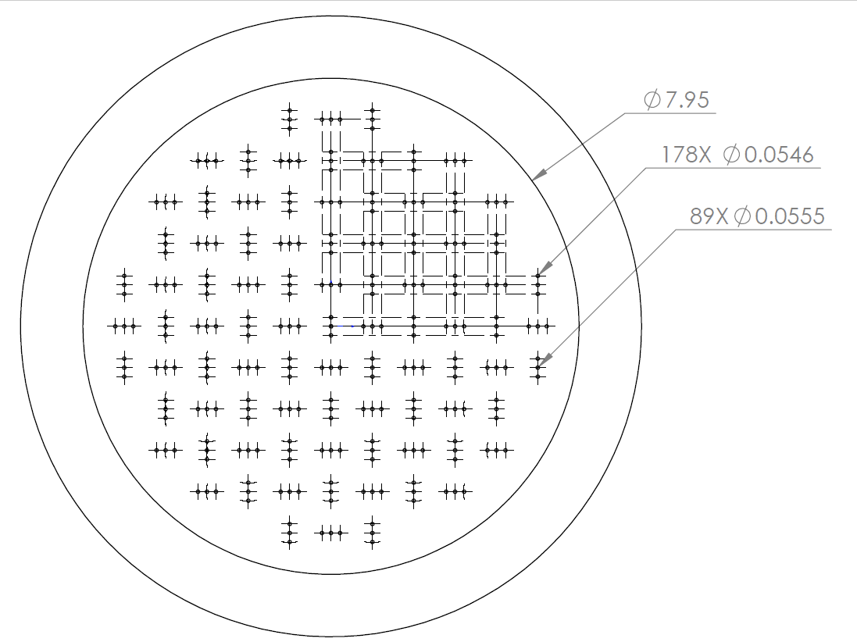

#### 3.3.2.4 Sources

[1] NASA SP-125: https://ntrs.nasa.gov/archive/nasa/casi.ntrs.nasa.gov/19710019929.pdf

[2] Liquid Rocket Engine Injectors: https://ntrs.nasa.gov/archive/nasa/casi.ntrs.nasa.gov/19760023196.pdf

[3] DESIGN AND EVALUATION OF HIGH PERFORMANCE ROCKET ENGINE INJECTORS FOR USE WITH HYDROCARBON FUELS:

https://ntrs.nasa.gov/archive/nasa/casi.ntrs.nasa.gov/19800004908.pdf

### 3.3.3 Combustion Chamber

The purpose of this section is to discuss how to size the combustion chamber of the rocket, methods of cooling, and to provide insight into the gas side heat transfer.

#### 3.3.3.1 Combustion Chamber Geometry

The three main types of engines are the cylindrical, spherical, and near spherical geometries. These are listed below.

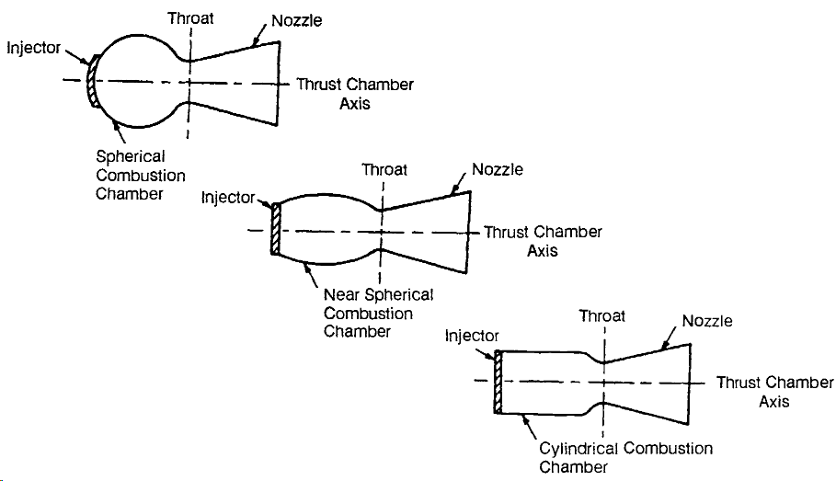

*Figure 3.3.3.1.1 Chamber Geometries*

Moving forward the UCI Rocket Project will only consider cylindrical engines since they are the industry standard and are the easiest to manufacture. The geometric makeup of a cylindrical combustion chamber can be described by its diameter and length. Historically, the parameter L* is used to compare developing engines with ones that have worked in past. Below is the definition of L*.

$L^{*}=\frac{V_{c}}{A_{t}}=Ẇνt_{s}$

Here, $V_{c}$ is the chamber volume, $A_{t}$ is the throat area, $Ẇ$ is the mass flow rate, $ν$ is the specific volume of the combustion gases, and $t_{s}$ is the stay time usually on the order of .002-.04 seconds). The mass flow rate is determined by the thrust requirements of the system and the throat area is determined by the isentropic flow equations with ideal expansion assumed. At this point it is appropriate to note that the volume of the combustion chamber is not explicitly given by this formulation nor does it lend any insight into how fast the products move through the chamber. As a result, an empirical relation that computes the chamber length $L_{c}$ as a function of throat diameter will be utilized.

$L_{c}=exp(.029ln(D_{t}){}^{2}+.47ln(D_{t})+1.94)$

From this equation the chamber diameter can be computed with throat area, the computed value of $L_{c},$ and historical data of L*. Below is some historical data on L*.

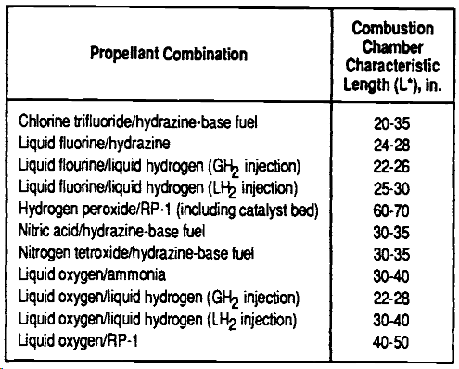

*Figure 3.3.3.1.2 Historical L* Values*

#### 3.3.3.2 Combustion Chamber Data Generation

A MATLAB program was created in order to generate data for approximate combustion chamber sizing. Approximate values for stay time, chamber length, chamber diameter, chamber volume, and mach number inside the chamber were calculated. A sample run of the code is provided below for a chamber pressure of 1000 psi.

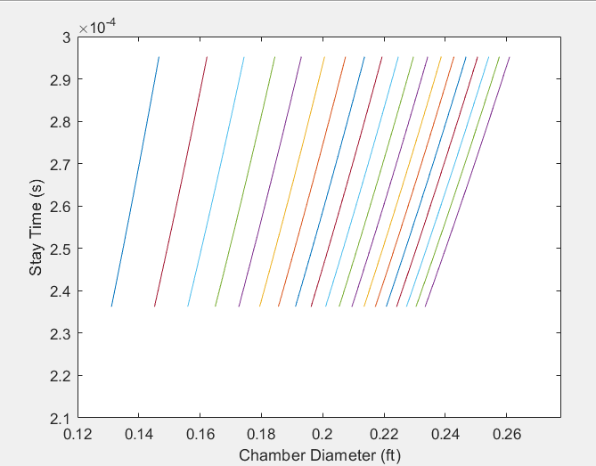

*Figure 3.3.3.2.1 Combustion Chamber Stay Time v Chamber Diameter for 1000 psi*

Additionally, matrices of values for Chamber volume and Mach number were computed for varying L* values and varying mass flow rates. Values for these are shown in the figure below.

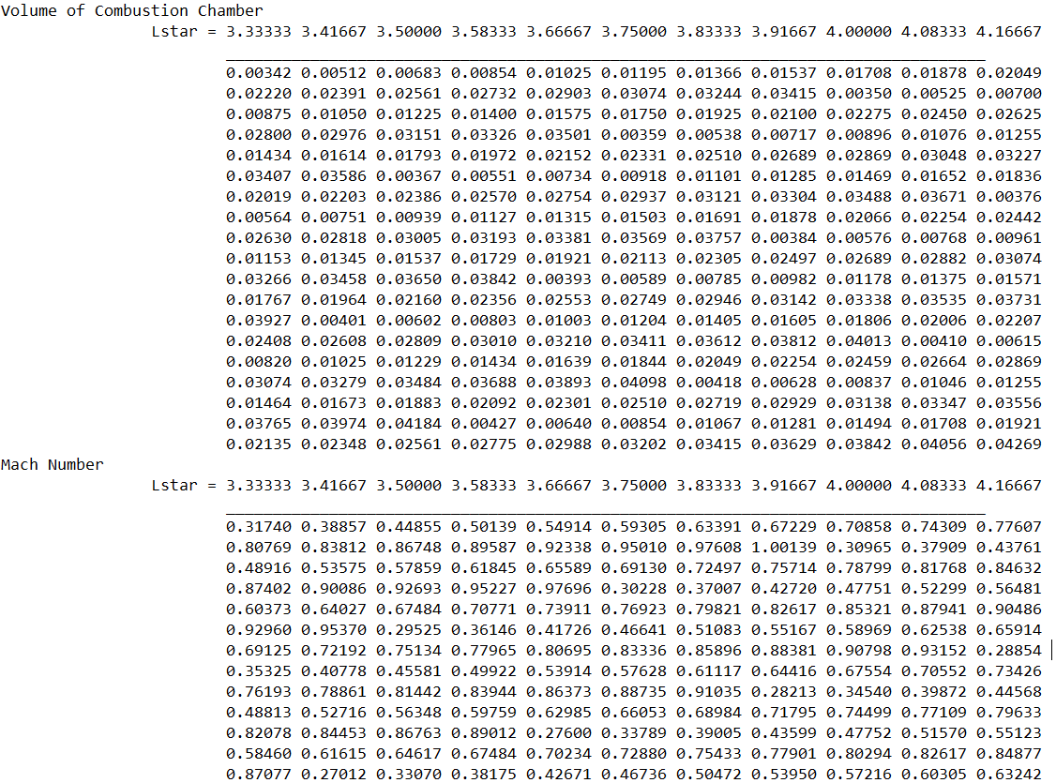

Figure 3.3.3.2.2 Volume and Mach Number for 1000 psi. Descending row represents increasing mass flow rates.

#### 3.3.3.3 Combustion Chamber Cooling Methods

High combustion chamber temperatures generate the need for cooling methods to avoid catastrophic engine failure. The most promising strategies are presented in this section.

**Regenerative Cooling**

Regenerative Cooling is a cooling method that has seen application in high pressure and heat flux engines. Its implementation involves diverting the fuel, oxidizer, or both to thermally conductive channels surrounding the engine. The liquid propellants absorb thermal energy from the engine before injection into the combustion chamber, which aids in the vaporization process. This method generates a great system efficiency but its complexity produces some drawbacks. In particular, avoiding fluid cavitation in the coolant flow, designing the coolant channel/mounting, manufacturing the coolant system, and producing the required flow rate are the difficult challenges that come with implementing regenerative cooling systems.

**Dump Cooling**

Dump cooling is a cooling method that diverts some of the propellants into channels along the engine. Unlike regenerative cooling, a dump cooling system does not reintroduce the heated propellants back into the combustion chamber. Instead, in this method the propellant (coolant) is superheated and exhausted. This method has seem to channel geometries implemented, one that has channels that run longitudinally down the engine and another that has channels that spiral around the engine. The advantage of dump cooling is that the implementation is rather straightforward and simple. However, its efficiency comes from exhausting the heated propellant instead of combusting it.

**Film Cooling**

Film cooling is a cooling method that introduces either liquid or gaseous propellant into the combustion chamber through small ports. This method works as a result of the introduced propellant forming an insulative cooling layer between the hot combustion gases and the combustion chamber wall. Difficulties with this method stem from the manufacturing of the ports and the high performance pumps required to maintain flow through the ports. Another issue that accompanies the introduction of liquid propellant into the chamber is the difficulty in analyzing two phase flow.

**Mixturing Ratio Biasing**

Mixture biasing is accomplished by adjusting where the fuel elements are on the injector face. It is ideal to separate the oxidizer from the wall at injection to ensure that the fuel is primarily oxidized and not the wall material. As a result, mixture biasing is accomplished by placing fuel injector elements near the wall to form an insulative layer between the hot gaseous and unreacted oxidizer.

**Ablative Cooling**

Ablative cooling is achieved by inserting an insulative material into the combustion chamber. During the firing of the rocket, certain wall liners can react with the flowing combustion gases to form a charred layer on the wall. These types of reactions absorb thermal energy and shield the metal wall of the combustion chamber. Erosion of charred layer can further cool the engine as hot material is ejected from the engine. In practice, ablative cooling is best used in conjunction with other methods since it has limited performance by itself.

#### 3.3.3.4 Future Design and Considerations

Moving forward, a variety of combustion chamber designs will be generated and compared against each other in order to downselect to the best options. Important considerations include manufacturing costs, materials, testability, and ease of integration.

### 3.3.4 Nozzle

The determination of the nozzle geometry for any rocket can be one of the most challenging and computation-heavy tasks of the design process. In order to achieve the desired thrust levels, the nozzle must be appropriately designed such that the combustion products are expanded to high exit velocities. In addition, the gases must be expanded to sufficient pressures in order to maximize lift. Additionally, high mach numbers in the nozzle require careful design of nozzle geometry such that shock waves and shock propagation are minimized. A fundamental tool that has been used in the Aerospace Industry for a long time is called the Method of Characteristics (MOC). The flow is idealized as an isentropic expansion from the nozzle throat area to the exit of the nozzle, where the mach number is increased from 1 to the desired exit mach number. In the MOC, a series of expansion waves are propagated from an initial divergent point, whose endpoints form the contour of the nozzle.

A typic al rocket nozzle for a single-stage engine is designed for maximum thrust at a specific altitude and associated ambient pressure. This is called the ‘Pressure-Matched’ condition, where the exit pressure of the nozzle matches the ambient pressure. The nozzle designed in this document has been designed such that it has maximum thrust at sea level.

#### 3.3.4.1 Design

In order to understand the processes and results of the preliminary nozzle design, it is vital to understand the calculations used in the MATLAB. The Method of Characteristics makes use of concepts from supersonic gas dynamics such as the Prandtl Meyer Function, Mach Angle, and Riemann Sums. These concepts are explained in more detail in the [Nozzle Code Documentation](https://docs.google.com/document/d/1uQStqDsY6qJt74cmjzFM4Y0A4551msJqGYsbNLAvWuU/edit#). For now, it is sufficient to say the expansion of the combustion gases is governed by isentropic relations between area, mach number, and Prandtl-Meyer function.

The first iteration of the Base 11 Rocket Nozzle has utilized a reasonable simplification to give a good estimate of the nozzle sizing and contour. Rather than computing the curvature of each characteristic line upon its intersection with other lines, each line has been assumed to be straight. While not giving a completely accurate result, such an assumption gives a good ballpark estimate for nozzle sizing and can be used to compute approximate weight of the component.

Given the combustion chamber temperature, pressure, mass flow rate, coefficient of heat, gas constant value, and optimum altitude, the nozzle will produce a graph of the characteristic lines of the flow throughout the nozzle. The endpoints of these lines are stored as (x,y) points which are exported to an excel file. From these points, a curve in a 3D modeling software such as Solidworks can be produced to give an approximate model of the nozzle.

The initial run of the nozzle code was used with the following inputs:

* Chamber Temperature: 5000R
* Chamber Pressure: 1000 Psi
* Ratio of Specific Heats (gamma): 1.2
* Mass flow rate: 10lbm/s

The initial run using such inputs produced the following graph:

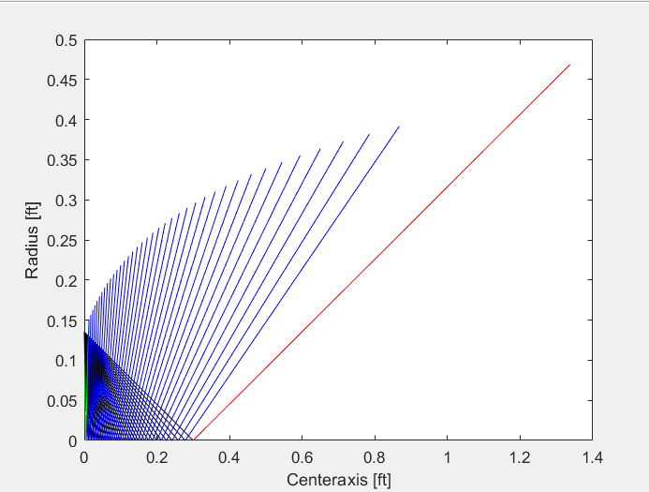

*Figure 3.3.4.1.1: Graph of characteristic lines in MATLAB*

Following the production of the characteristic line graph in MATLAB, the code outputs the endpoints of the characteristic lines to an excel file which can be imported into SolidWorks to produce a curve representing the contour of the nozzle. See the image below to see importation of the curve into SolidWorks.

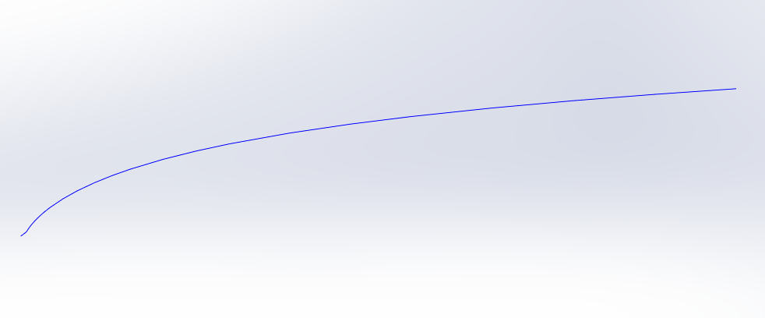

*Figure 3.3.4.1.2 Curve in SolidWorks from output X,Y points*

Such a curve can then be revolved around the X-axis to produce the full nozzle geometry.

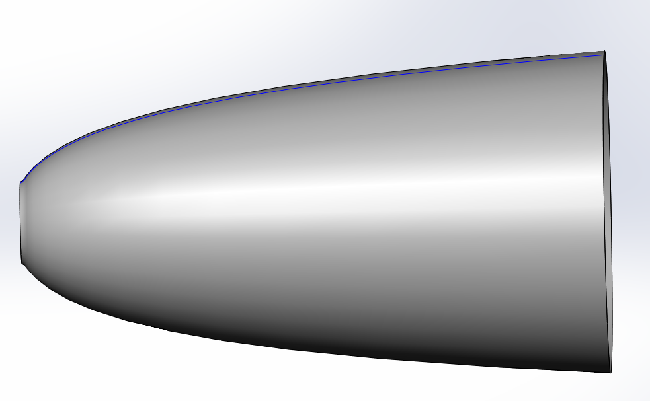

*Figure 3.3.4.1.3 Nozzle Constructed in SolidWorks*

Results of the program give the final specifications of the nozzle as the following:

* **Throat Area**: 0.0575ft^2
* **Throat Radius**: 0.1352 ft
* **Exit Area**: 0.6904 ft^2
* **Exit Radius**: 0.4688 ft
* **Length**: 1.374 ft
* **Exit Temperature**: 3086.3 R
* **Exit Pressure**: 18.5 Psi (slightly higher than ambient)

With these vital values, ballpark estimates can be made for the nozzle sizing, material, weight, and other factors which will aid in the mission analysis and mission architecture components of design.

#### 3.3.4.2 Future Designs/Considerations

The final goal of the nozzle code will be to complete a fully operational, user-friendly, and accurate MATLAB script which will compute area ratios of the throat and exit area, as well as producing a full Bell-Nozzle Contour. Due to current time constraints, the current version of the code utilizes straight line assumptions, but the code will be updated continually in the coming months until the final desired result is produced.

### 3.3.5 Cooling

Reiterate system requirements related to cooling design and requirements for the cooling system (gas temperature, velocity, density, viscosity, etc). Show distribution of the heat transfer coefficient along the length of the combustion chamber and nozzle. Consider ablative materials, film cooling, and dump cooling. Show calculations for cooling channels and a 2D simulation for heat transfer in the combustion chamber and the nozzle throat.

## 3.4 Fuel System

This section details the preliminary analysis design of the fuel system and its associated components: tanks, pumps,

### 3.4.1 Tanks

#### 3.4.1.1 Requirements

When choosing a tank it is important to maximize volume and service pressure, while minimizing weight and cost. The tanks themselves take up a large portion of the total volume of the rocket, so it is important to ensure that this volume is being used efficiently. Also, due to this fact, it is to be noted that the tank’s design and material present the team with an interesting opportunity to innovate and limit the contribution to the weight budget. Additionally, the methods for mounting the tanks are critical features that should be taken into consideration.

#### 3.4.1.2 Metal Alloys of Interest

**Aluminum Alloys**

*Thickness of wall: ~0.020 in

Minimum Service Temp ($∘C$): -273

6061-T6 (Wrought):

Composition: Al 96-99 / Mg 0.8-1.2 / Si 0.4-0.8 / Cu 0.15-0.4 / Cr 0.04-0.35

T6: Solution heat-treated and artificially aged

Cost (USD/kg): 2.02-2.17

Density (kg/m^3): 2.69e3-2.73e3

CTE ($μstrain/∘C$): 22.7-23.9

Specific Heat (J/kgC): 878-914

Poisson’s Ratio: 0.325-0.335

Bulk Modulus (GPa): 66.6-70

Thermal Conductivity (W/mC): 152-169

Graph of Young’s Modulus vs Temperature

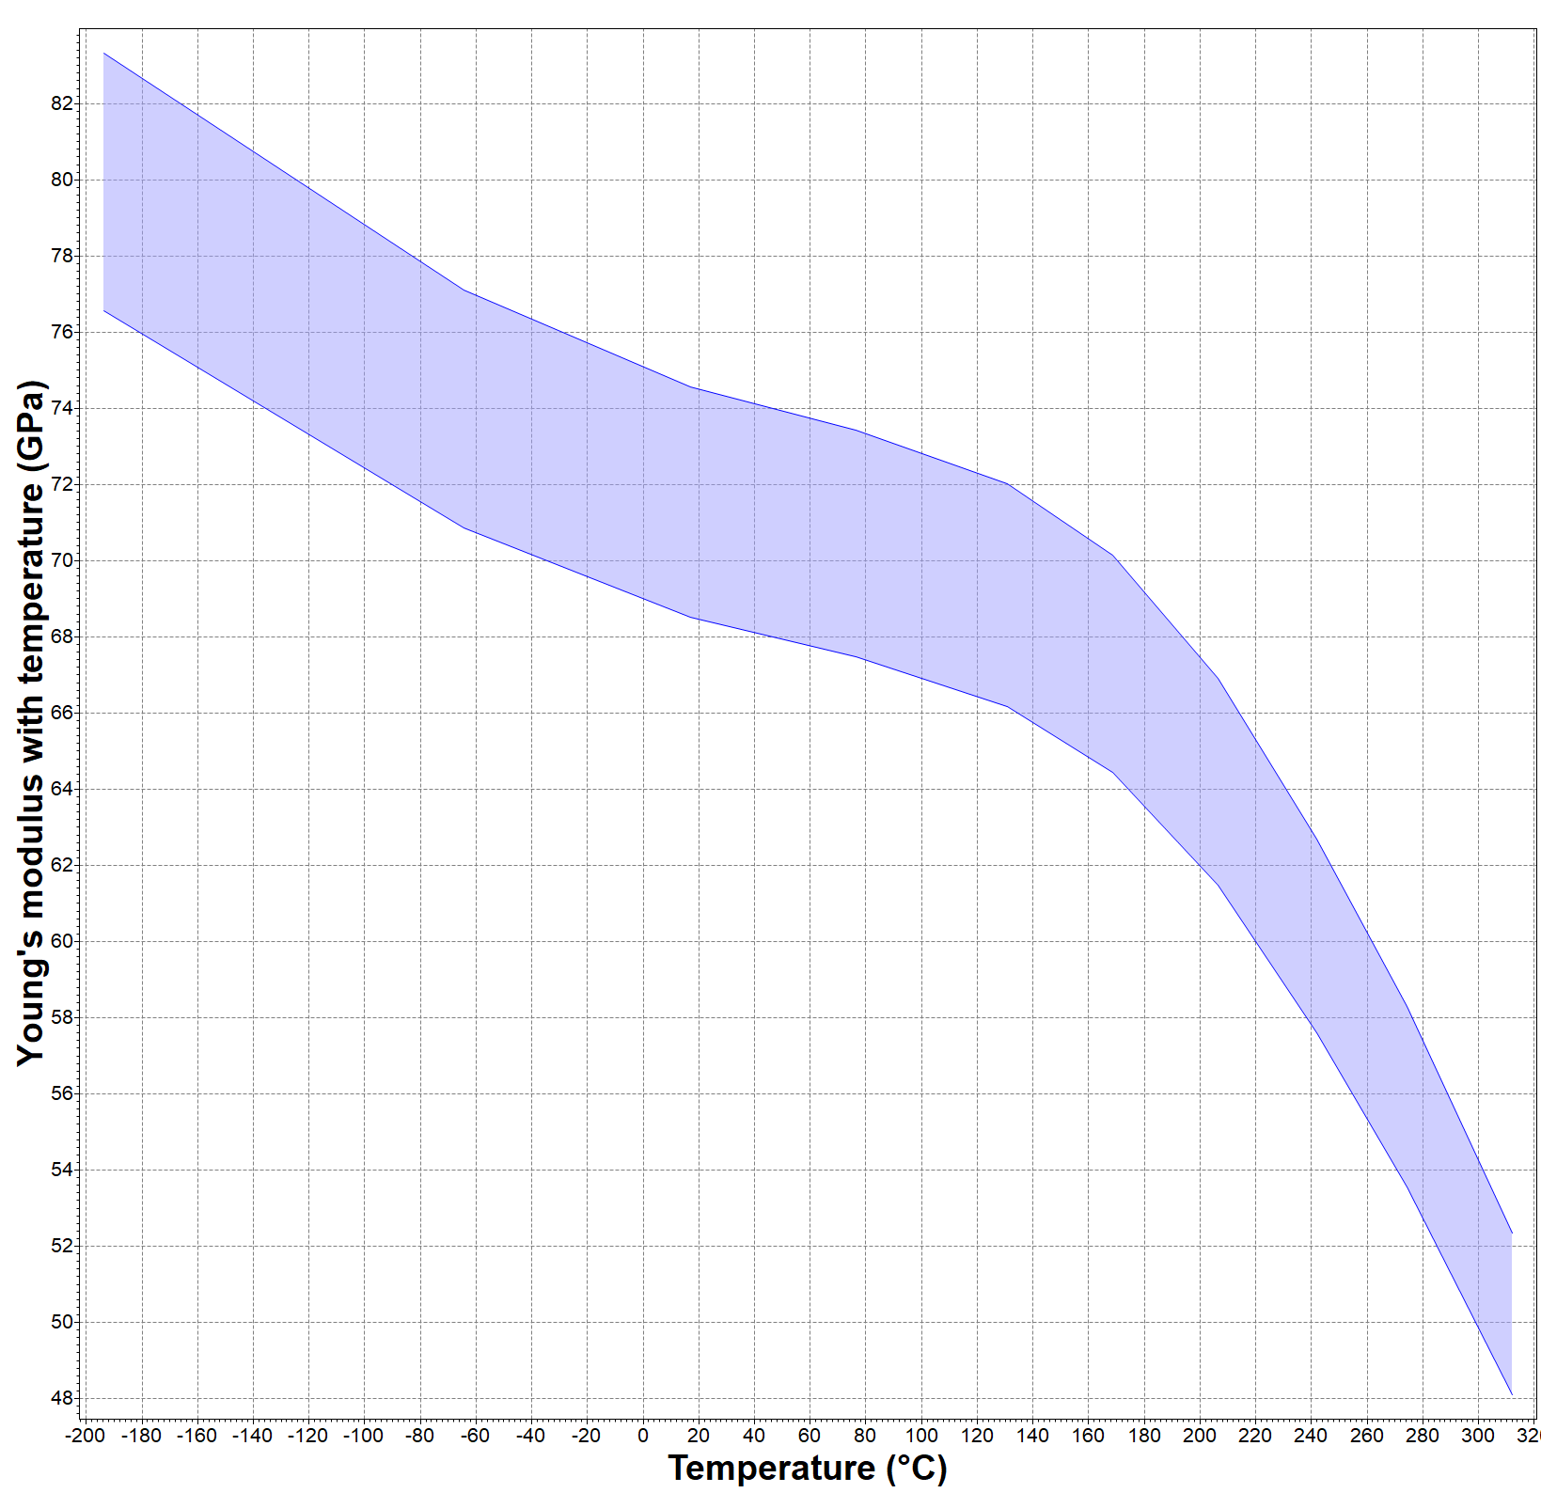

*Figure 3.4.1.2.1 Graph of Young’s Modulus vs Temperature for 6061-T6 Wrought Aluminum*

6066-T6 (Wrought):

Composition: Al 93-97 / Si 0.9-1.8 / Mg 0.8-1.4 / Mn 0.6-1.1 / Cu 0.15-0.4 / Zn 0-0.25

T6: Solution heat-treated and artificially aged

Cost (USD/kg): 3.77-4.06

Density (kg/m^3): 2.78e3-2.82e3

CTE ($μstrain/∘C$): 21.2-25.2

Specific Heat (J/kgC): 870-905

Poisson’s Ratio: 0.325-0.335

Bulk Modulus (GPa): 67.3-70.7

Thermal Conductivity (W/mC): 141-153

Young’s Modulus (GPa): 67.3-70.7 at standard conditions (No Graph Available)

2014-T6 (Wrought)

Composition: Al 90-95 / Cu 3.9-5.0 / Si 0.5-1.2 / Mn 0.4-1.2 / Mg 0.2-0.8

T6: Solution heat-treated and artificially aged

Cost (USD/kg): 2.16-2.32

Density (kg/m^3): 2.77e3-2.83e3

CTE ($μstrain/∘C$): 22.2-24.2

Specific Heat (J/kgC): 858-937

Poisson’s Ratio: 0.325-0.344

Bulk Modulus (GPa): 68-75

Thermal Conductivity (W/mC): 152-171

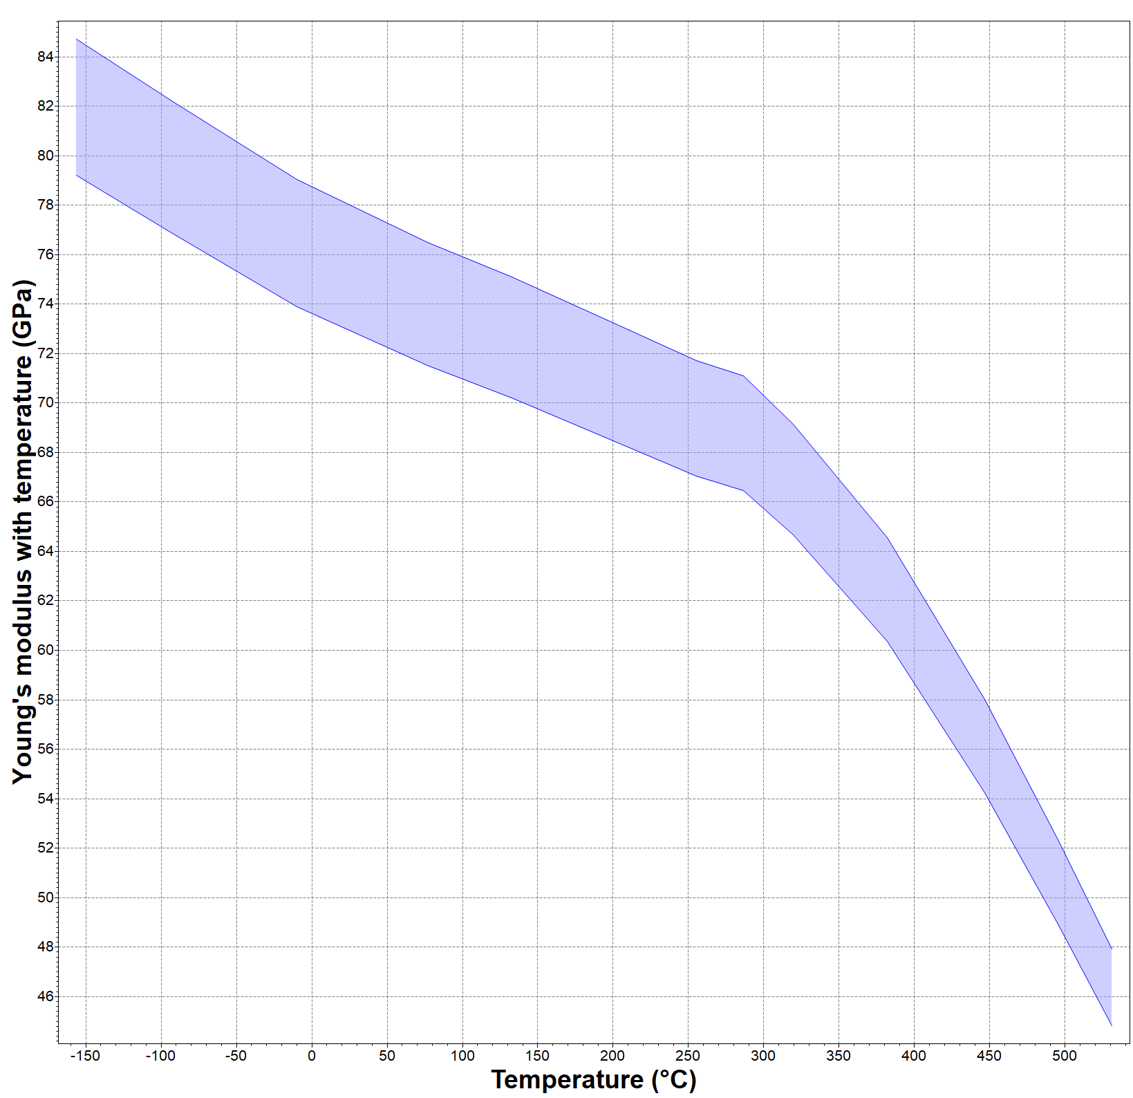

*Figure 3.4.1.2.2 Graph of Young’s Modulus vs Temperature for 2041-T6 Wrought Aluminum*

**Iron Based Alloys**

*Thickness of wall: ~0.010 in

AISI 347 (Annealed):

Composition: Fe 64-74 / Cr 17-19 / Ni 9.0-13 / Nb 0.1-1.0 / C < 0.08

Condition: Solution annealed

Cost (USD/kg): 2.81-3.32

Density (kg/m^3): 7.86e3-7.97e3

CTE ($μstrain/∘C$): 16.0-18.0

Specific Heat (J/kgC): 490-530

Poisson’s Ratio: 0.265-0.275

Bulk Modulus (GPa): 134-152

Minimum Service Temp ($∘C$): -175

Thermal Conductivity (W/mC): 15-17

Graph of Young’s Modulus vs Temperature:

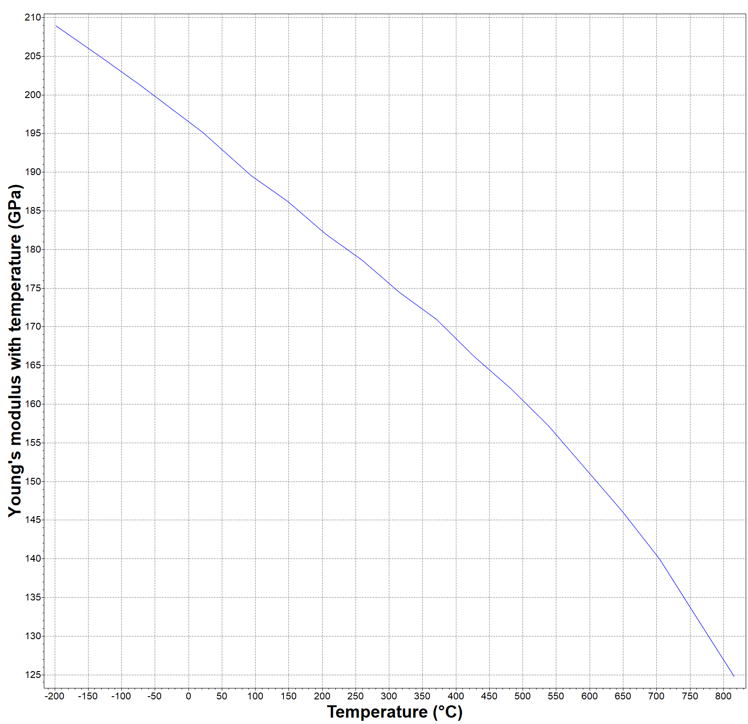

*Figure 3.4.1.2.3 Graph of Young’s Modulus vs Temperature for AISI 347 Annealed Iron*

17-7PH (Semi-Austenitic):

Composition: Fe 71-77 / Cr 16-18 / Ni 6.5-7.8 / Al 0.75-1.5 / C < 0.09

Condition: (TH1050) Solution annealed; precipitation (age hardened at 566C; air cooled)

Cost (USD/kg): 5.66-6.04

Density (kg/m^3): 7.6e3-7.68e3

CTE ($μstrain/∘C$): 11.7-12.3

Specific Heat (J/kgC): 480-530

Poisson’s Ratio: 0.28-0.291

Bulk Modulus (GPa): 152-159

Minimum Service Temp ($∘C$): -73 to -43

Thermal Conductivity (W/mC): 16.4-17.8

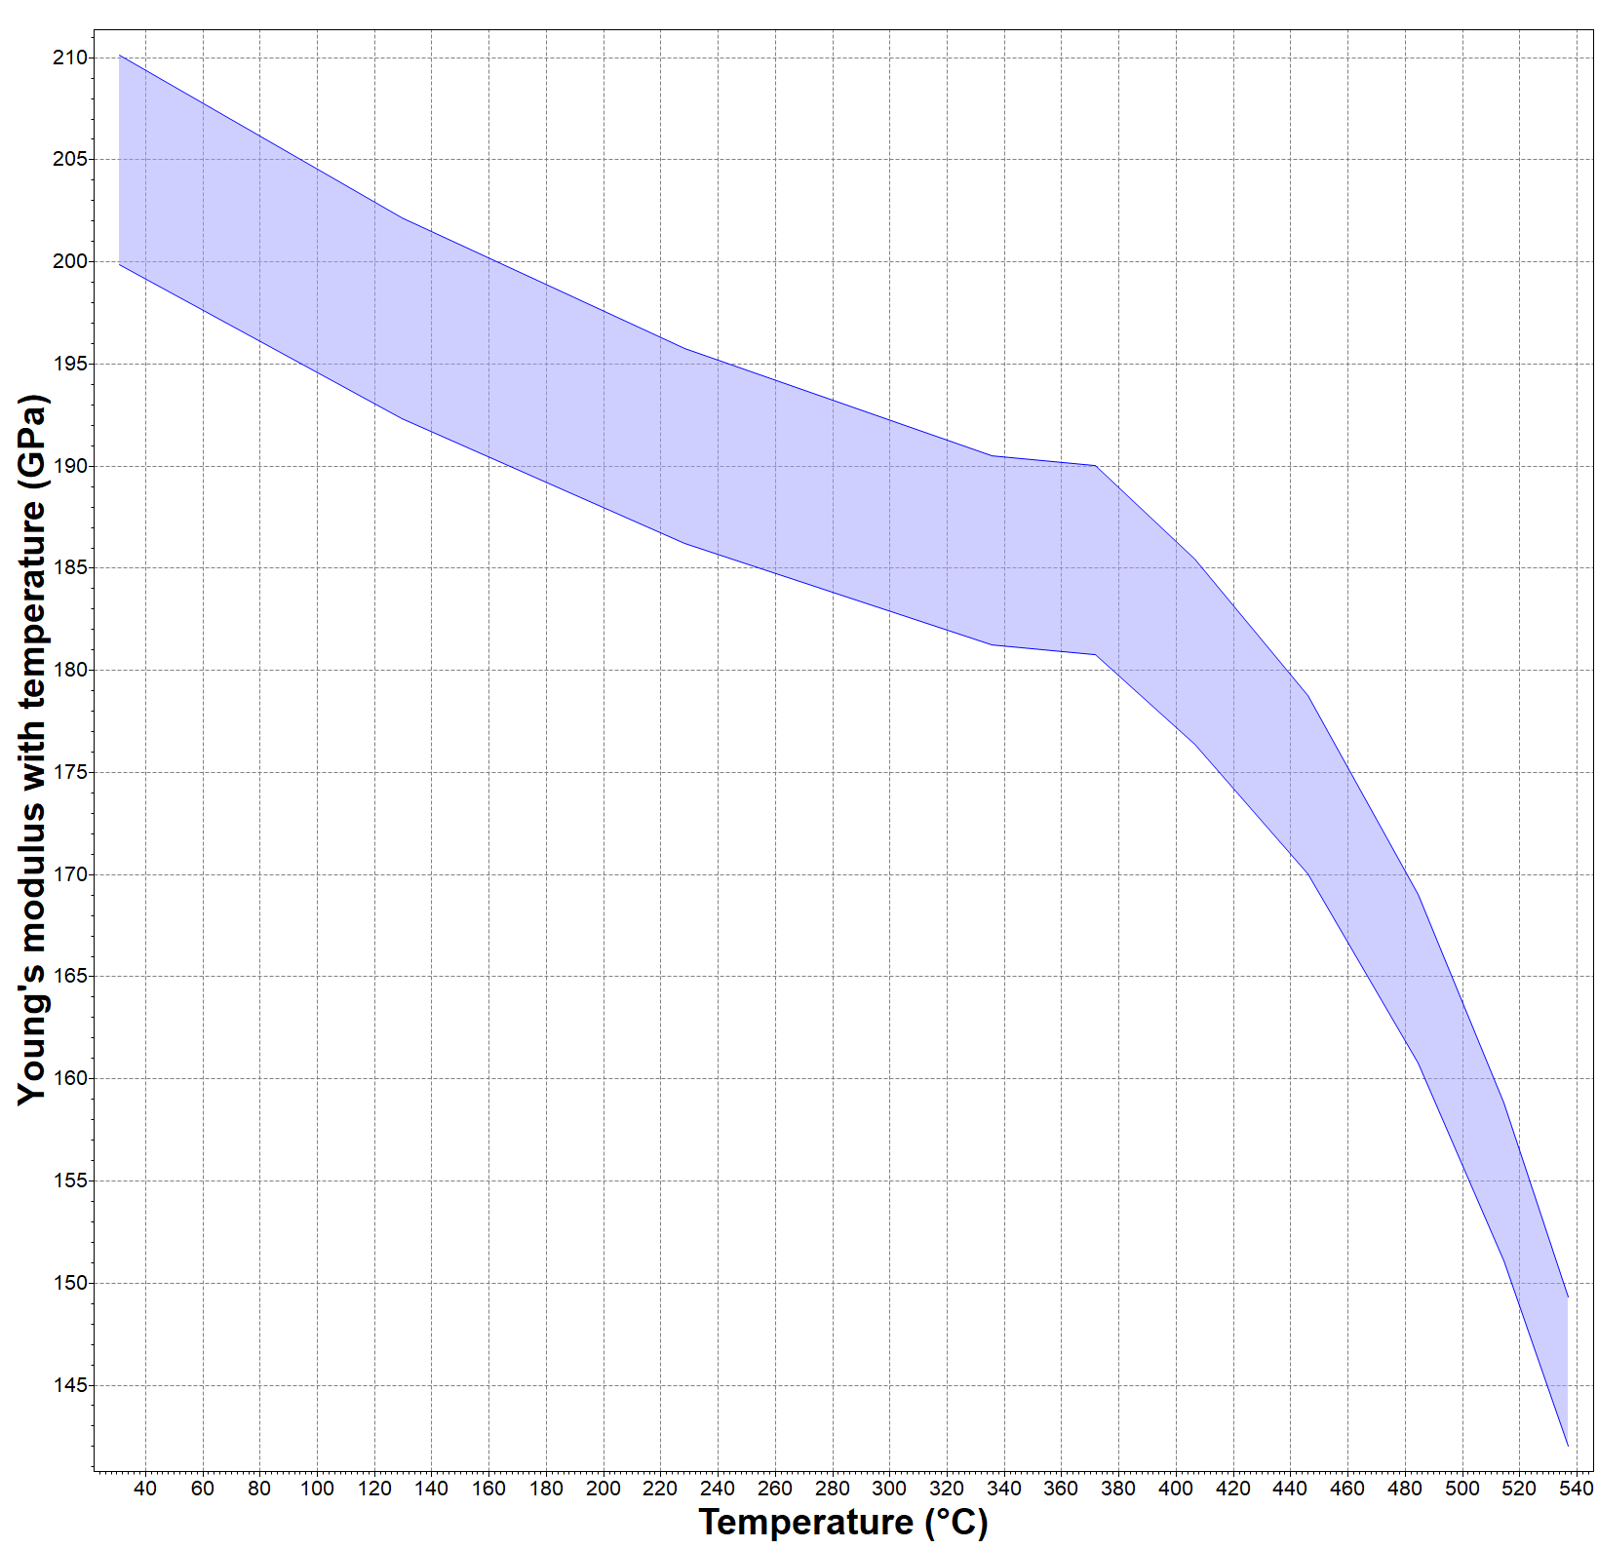

*Figure 3.4.1.2.4 Graph of Young’s Modulus vs Temperature for 17-7PH Semi-Austenitic Iron*

PH15-7Mo (Semi-Austenitic)

Composition: Fe 70-77 / Cr 14-16 / Ni 6.5-7.8 / Mo 2.0-3.0 / Al 0.75-1.5 / C < 0.09

Condition: (TH1050) Solution annealed; precipitation (age hardened at 566C; air cooled)

Cost (USD/kg): 6.11-6.54

Density (kg/m^3): 7.63e3-7.71e3

CTE ($μstrain/∘C$): 11-11.5

Specific Heat (J/kgC): 490-510

Poisson’s Ratio: 0.28-0.291

Bulk Modulus (GPa): 152-159

Minimum Service Temp ($∘C$): -73 to -43

Thermal Conductivity (W/mC): 15.1-16.4

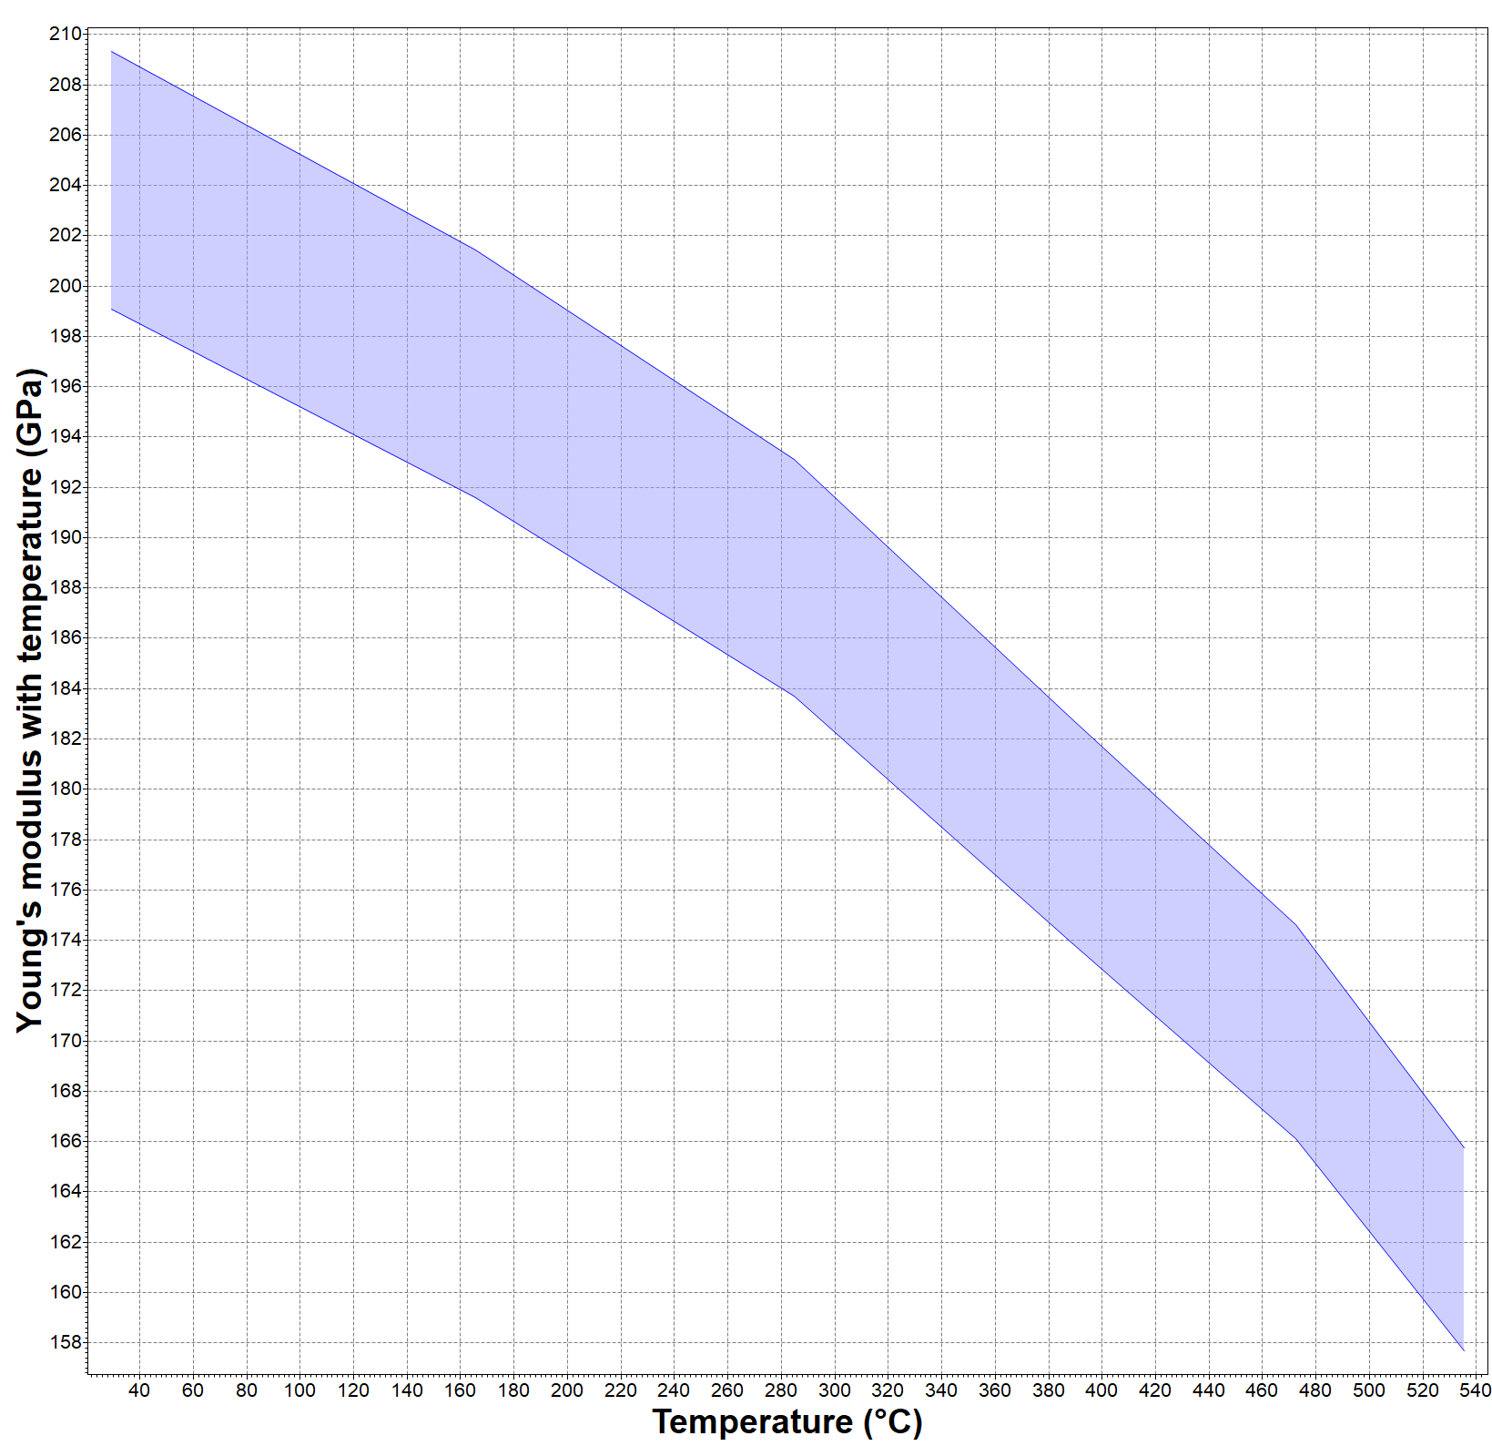

*Figure 3.4.1.2.5 Graph of Young’s Modulus vs Temperature for PH15-17PH Semi-Austenitic Iron*

*Note: General thickness obtained from p.335/336 Design of Liquid Propellant Rocket Engines

#### 3.4.1.3 Composite Tanks Analysis

Composite tanks are a relatively new concept in the aerospace industry. There are several companies that were involved in research for composite tanks, a few being; NASA, Boeing, Lockheed-Martin, and Northrop Grumman. These companies researched several method for manufacturing and the composition/design of the tank itself. In addition to these industry leaders there are a couple of companies that specialise in contsruction and testing composite tanks; HyperComp and Luxfer Cylinders. Below is a brief article discussing current updates on composite tanks:

<https://www.compositesworld.com/articles/an-update-on-composite-tanks-for-cryogens>

**Intech Case Study**

Intech created a formal document, which consolidated various company’s experience with carbon fiber reinforced resin matrix composite materials (CFRC). The document discusses the benefits of CFRC, which include, high strength-to-weight and high stiffness-to-weight ratios. The objective of the study was to ensure that CFRC’s demonstrated robustness, durability, and high factors of safety. The tanks were designed to hold both LOX and LH2, which are both cryogenic liquids. LH2 is also a great standard when testing for the permeability of a material. The sections below will discuss companies of interest, along with their respective results.

Metal Alloy vs. Composite (Large Capacity Tanks)

During the Composite Cryotank Technology Demonstration (CCTD) four tanks were manufactured. NASA developed a metallic aluminum-lithium alloy cryotank as the baseline to compare the results of the three other companies; Boeing, Lockheed Martin, and Northrop Grumman. Each company experimented with a different method of strengthening the tanks, which is depicted in Figure 3.4.1.3.1 below. The technique for manufacturing the tanks is called automated fiber placement process or AFP. This process allowed for an average cost saving of 20-25% relative to the aluminum alloy NASA tank. The results also showed that the thin (65 to 70 g/ $m^{2}$) ply used was effective in preventing LH2 permeation. In order to speed up the production process Boeing utilized both thick plies (145 g/ $m^{2}$) and thin plies in conjunction. The weight saving of each composite tank relative to NASA’s are displayed below in Table 3.4.1.3.1. It is to be noted that the tanks tested in this particular study were IM7/977-2. The IM7 represents the fiber, which in this case is a PAN-based (polymerization of acrylonitrile) graphite fiber by Hexcel. The 977-2 code represents a toughened epoxy resin from Cycom that cures at 177 $∘C$. The overall hydrogen permeation was measured to be approximately 3%, which leads to the assumption that a larger compound like methane (CH4) will have a negligible permeation percentage.

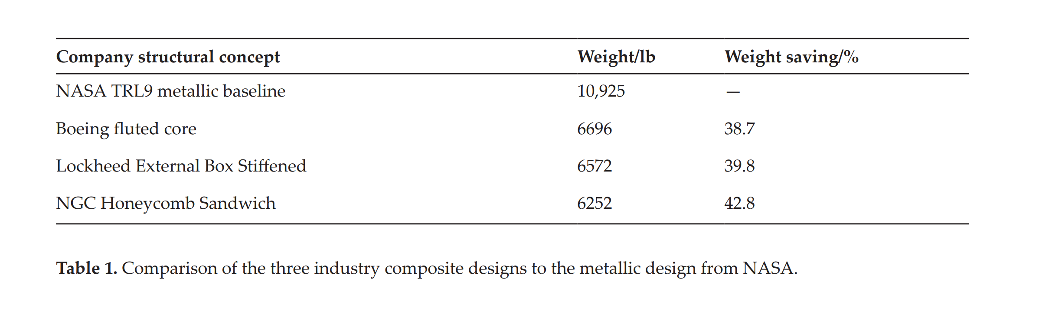

Table 3.4.1.3.1 Comparison of the Industry composite designs to the metallic design from NASA

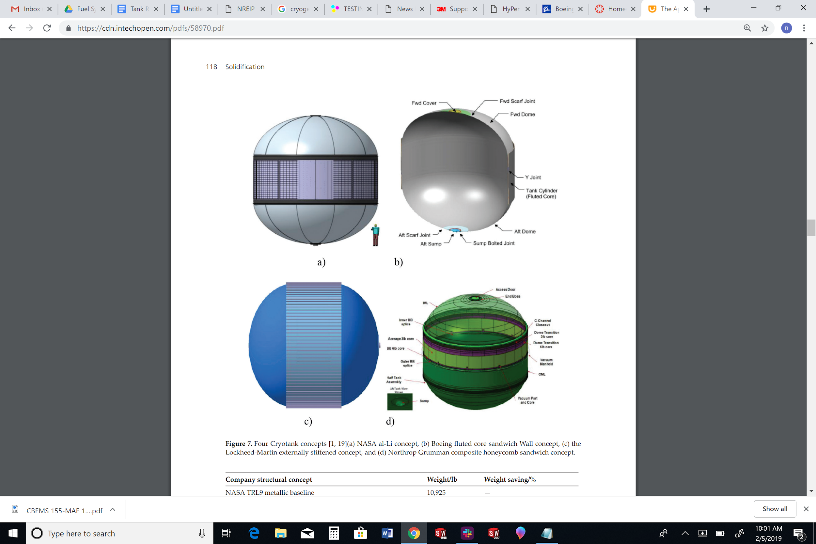

*Figure 3.4.1.3.1 Four Cryotank concepts [1, 19](a) NASA al-Li concept, (b) Boeing fluted core sandwich Wall concept, (c) the Lockheed-Martin externally stiffened concept, and (d) Northrop Grumman composite honeycomb sandwich concept*

Fiber Type and Directional Properties

Three different fibers systems were analysed; IM600 made by Toho (Japan), IM7 made by Hexcel (used by NASA), and T800H made by Toray. All of which are intermediate modulus fibers, PAN-based, and have a high-tensile strength. Intermediate modulus fibers are chosen for cryogenic tank applications because a higher modulus for the fiber corresponds to a higher crystallinity of the fiber, which results in reduced surface active functional groups and a lower interlaminar shear strength. Table 3.4.1.3.2 lists the three fiber types and their corresponding physical properties.

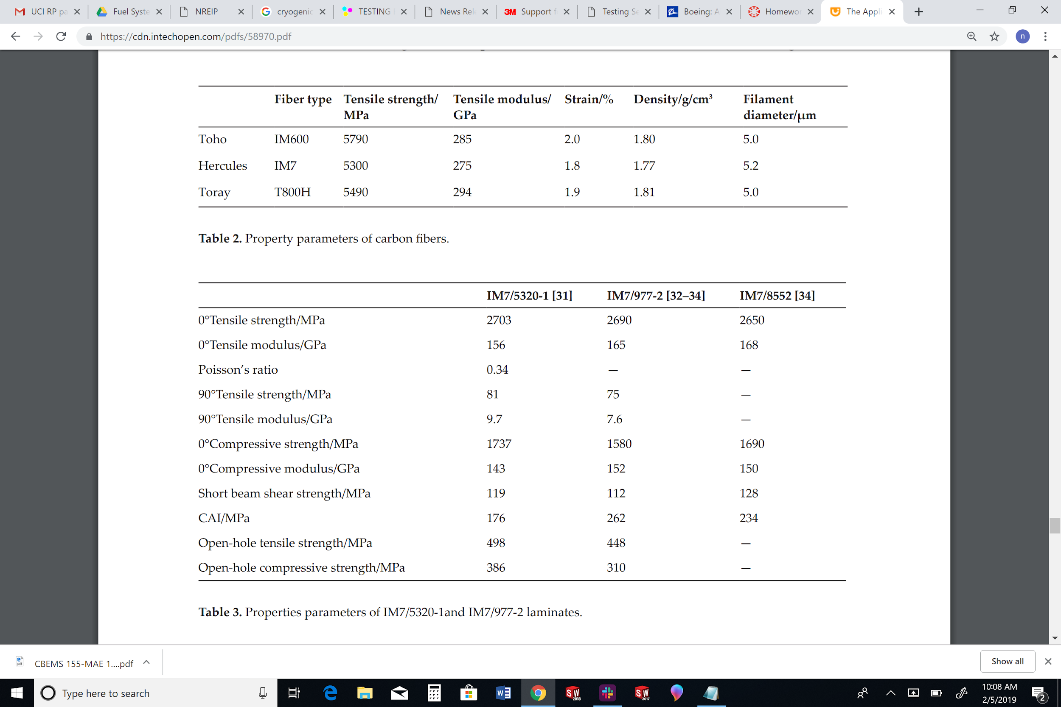

*Table 3.4.1.3.2 Property Parameters of Carbon Fibers*

Along with the fiber types, three epoxy resins were compared. The IM7 fiber was used as the common fiber. All three resins are considered toughened resins, two of which (977-2 and 5320-1) are from CYCOM, and the third (8552) is from Hexcel. The toughened resins demonstrated high levels of impermeability after thermo mechanical cycling and also had relatively high compression-after-impact strength (CAI). The three resins all had somewhat similar properties as shown in **Table 3**, but it should be noted that 5320-1 does not require autoclave curing, so this resin would be the best choice for “in-house” manufacturing. The 5320-1 resin only requires a vacuum bag to cure.



*Table 3.4.1.3.3 Property Parameters of Carbon Fibers*

Fiber Type and Directional Properties

When designing a LOX cryotank it is important to consider the reactivity of the material and liquid oxygen. During the experiment, toughened resins appeared to be generally more resistant to ignition; therefore, toughened resins were used in LOX tank fabrication. For the LOX tank comparison a similar study was conducted, in which, the composite tank was 2.7m in length, 1.2m in diameter, weighed less than 225 kg, and had a weight saving percentage of 18% compared to a metal tank of similar design.

#### 3.4.1.4 Manufacturers of Interest

When considering the use of a composite tank it is important to decide if the construction of the tank should be outsourced or done “in-house”. While researching for manufacturers it became apparent that there are not many companies that make composite rocket fuel tanks for commercial use. As mentioned before, it is possible to make the tanks in-house, requiring only a few additional components.

**HyperComp**

Recent Pressure Vessels and Testing Services

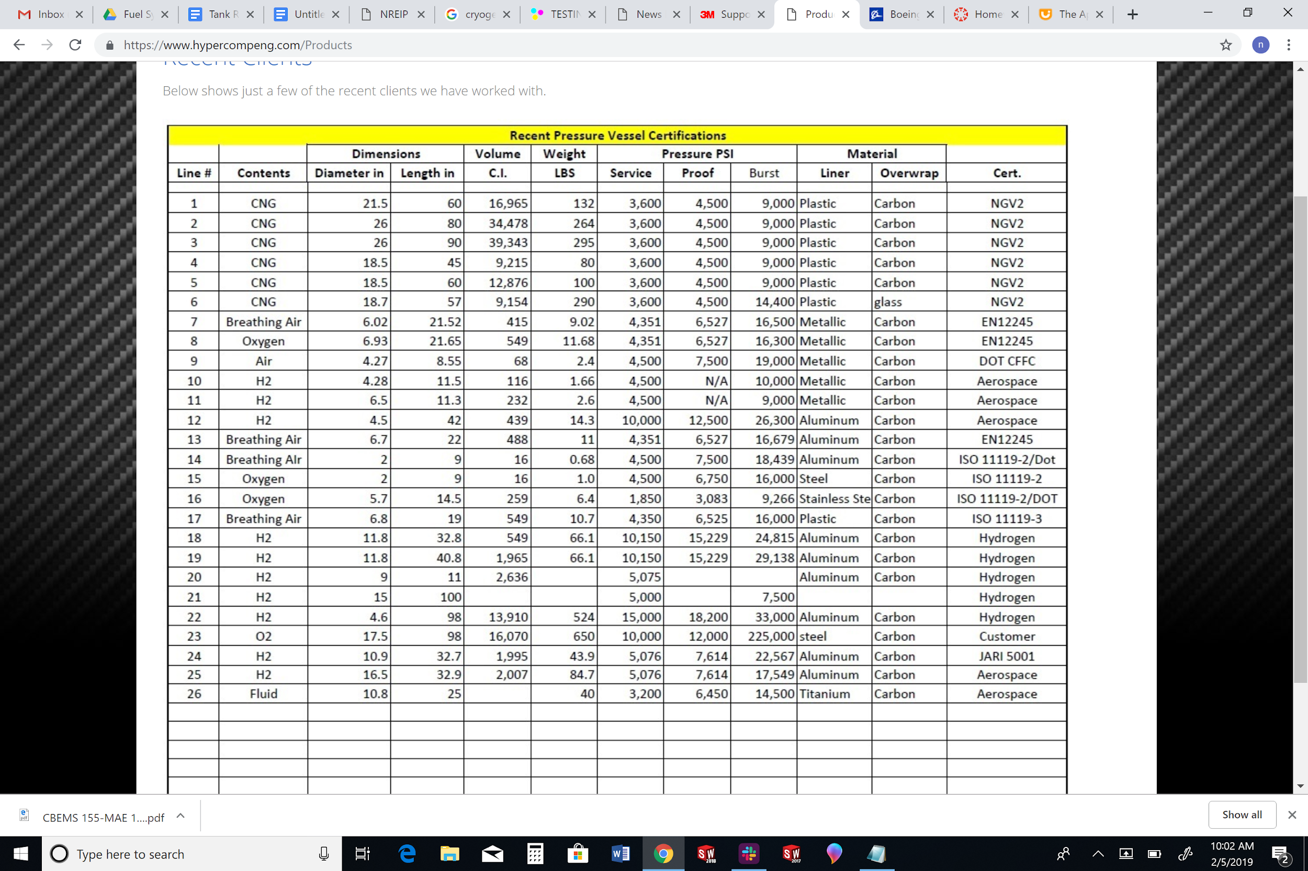

*Figure 3.4.1.4.1 Pressure vessels manufactured by HyperComp*

Analysis and Testing Services

It is important to note that for the Base 11 Space Challenge composite tanks require a few additional tests in order to use them for the rocket assembly. Fortunately, HyperComp offers many of the burst/failure tests that are required. The tests they offer are listed below:

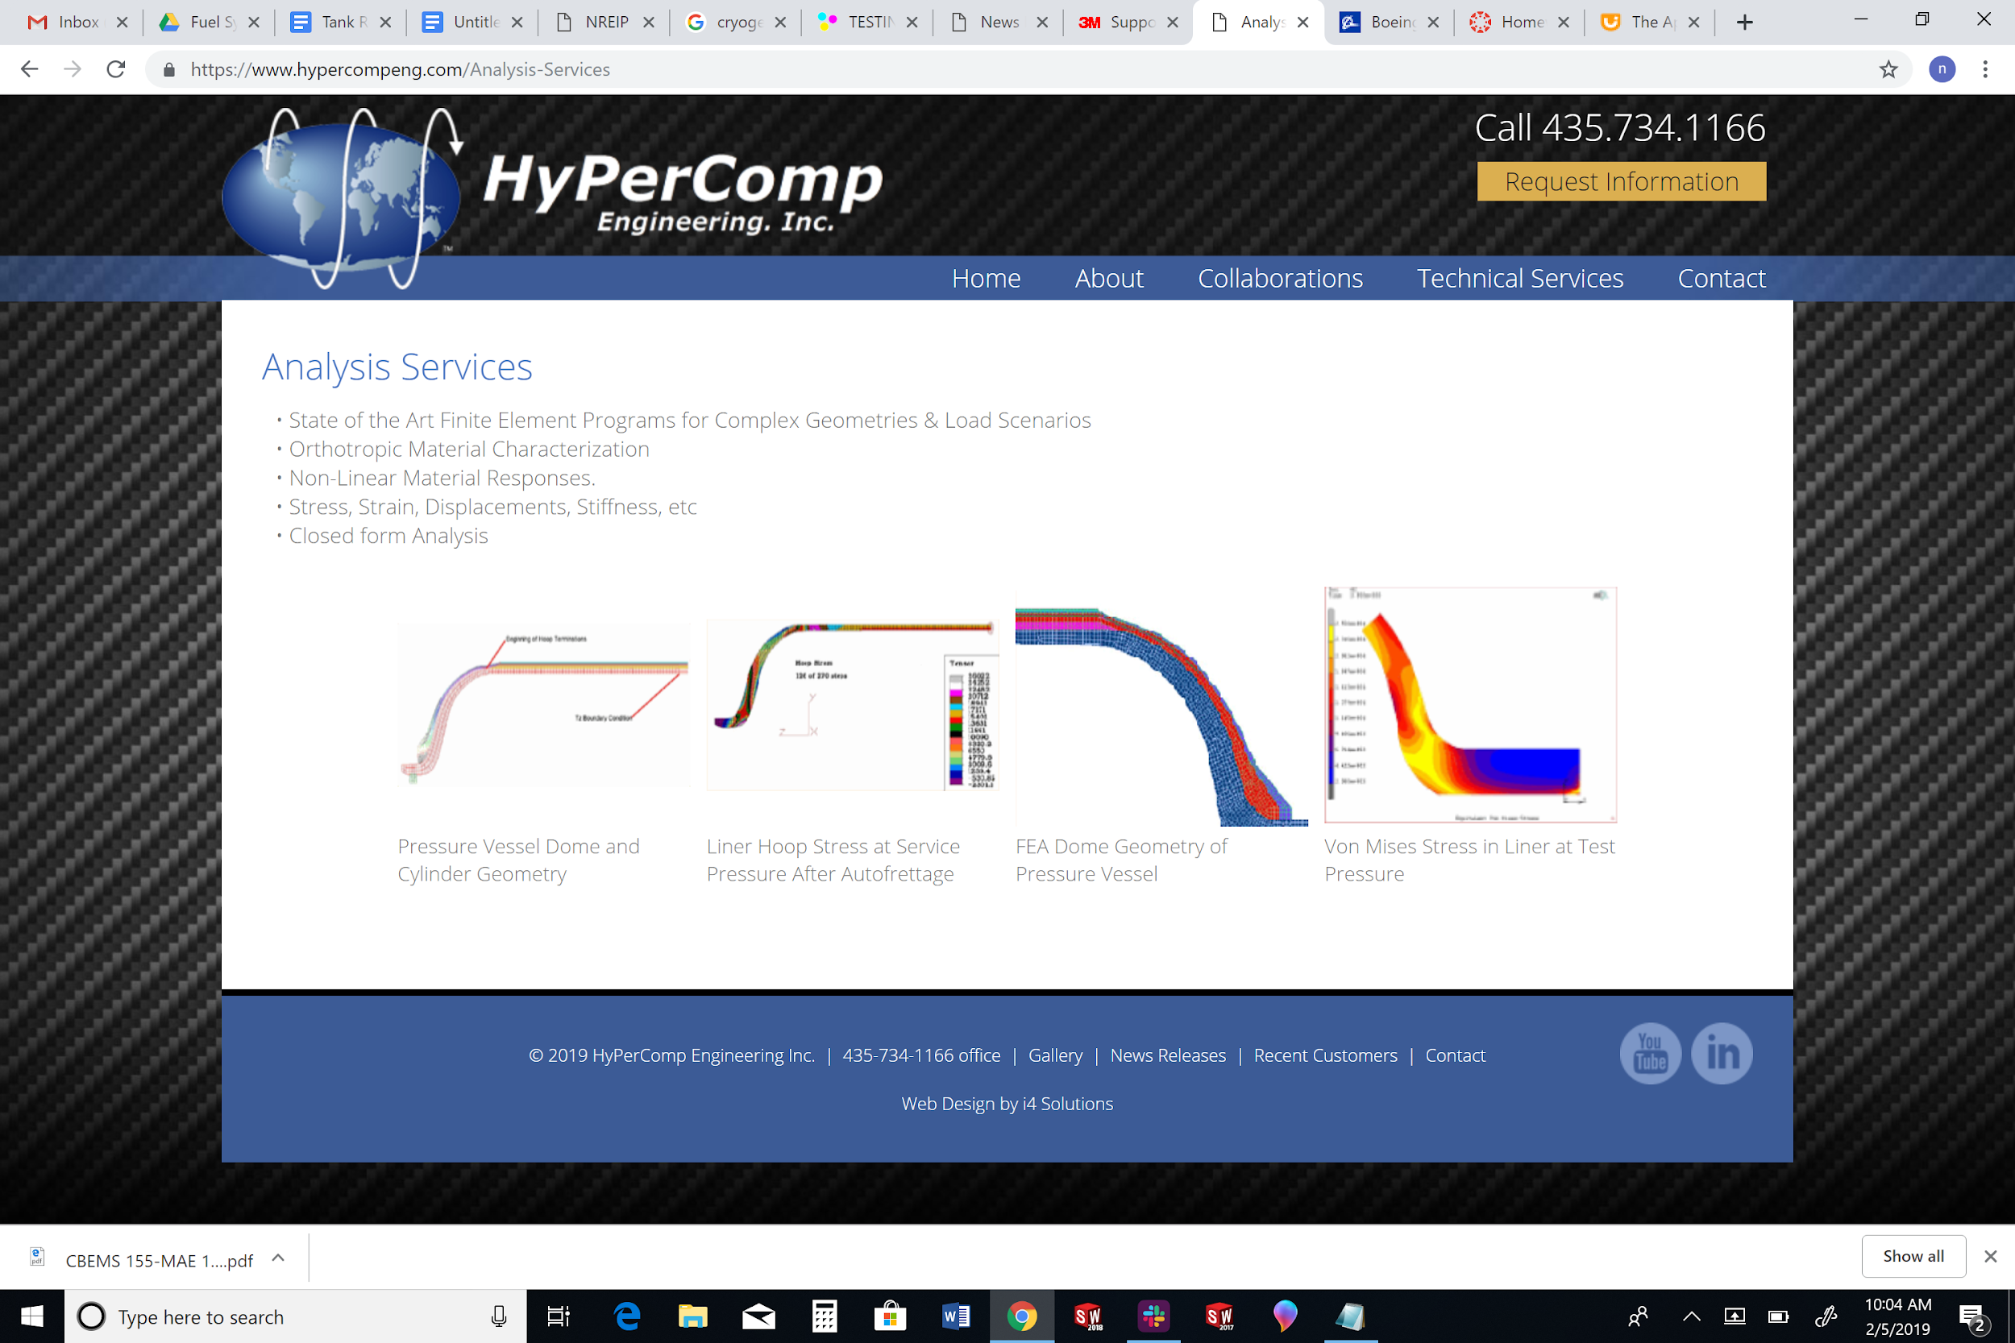

*Figure 3.4.1.4.2 Failure analysis services provided by HyperComp*

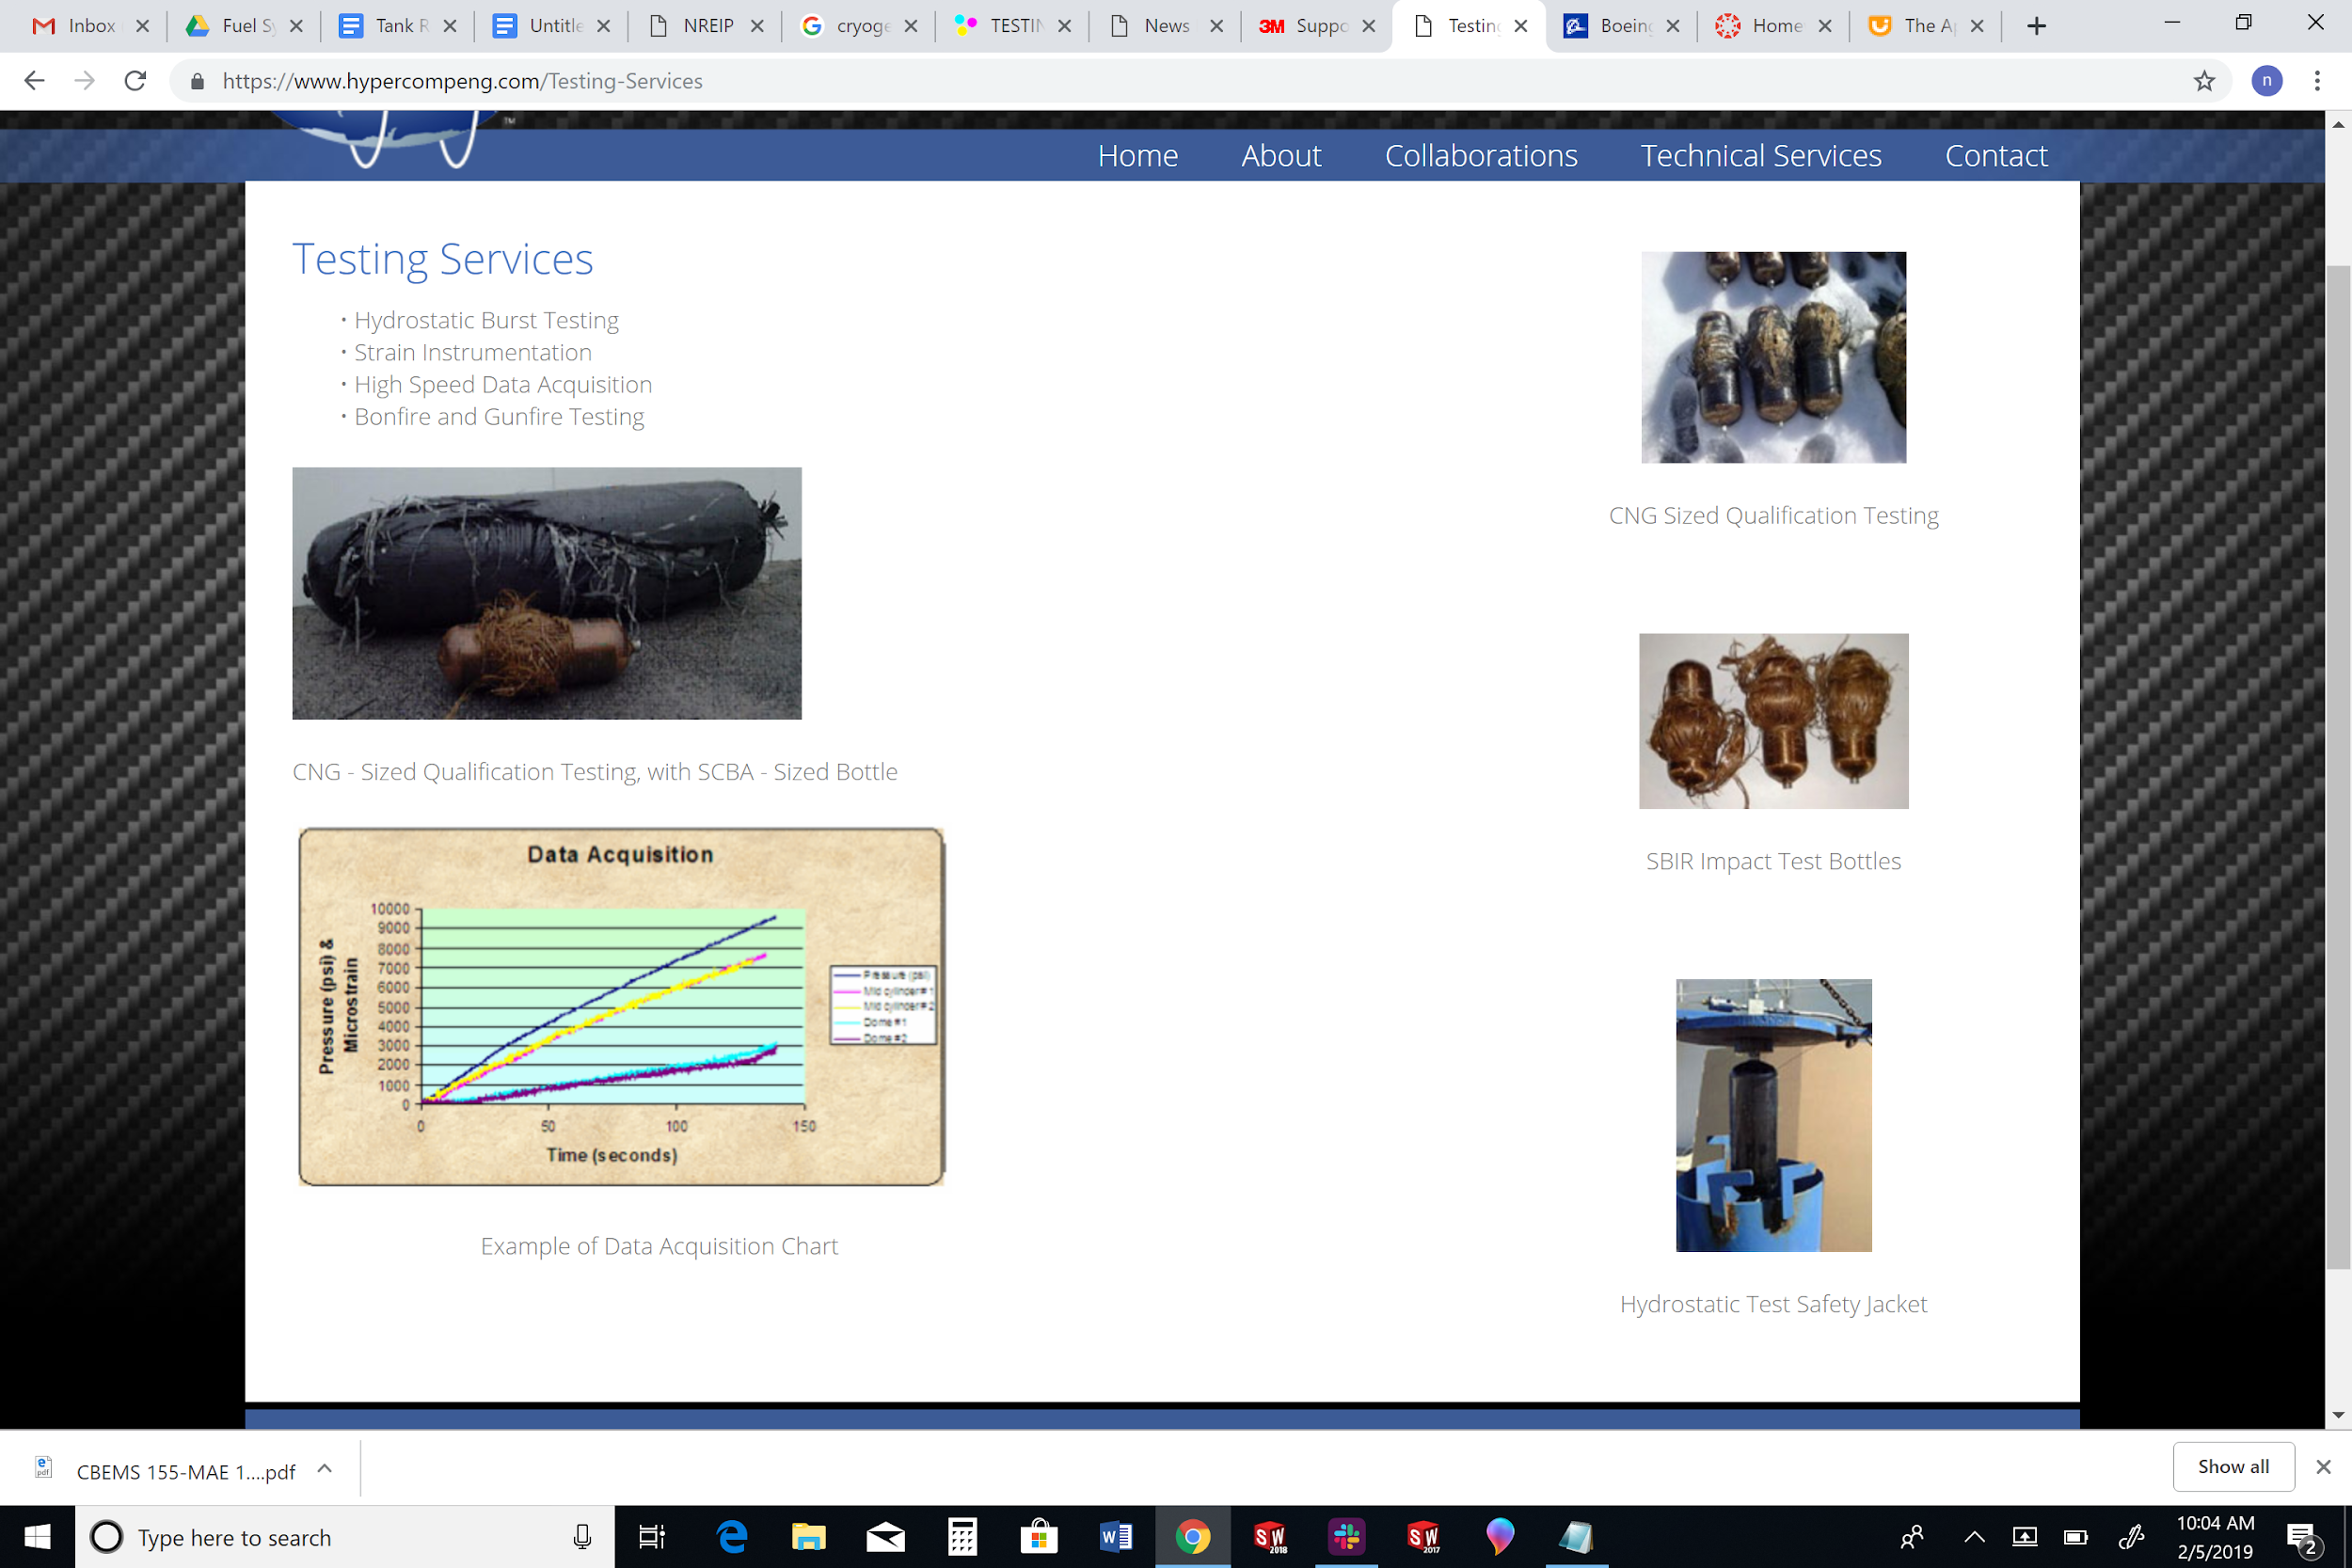

*Figure 3.4.1.4.3 Failure testing services provided by HyperComp*

**Luxfer Cylinders**

Commercially Available Tank Designs

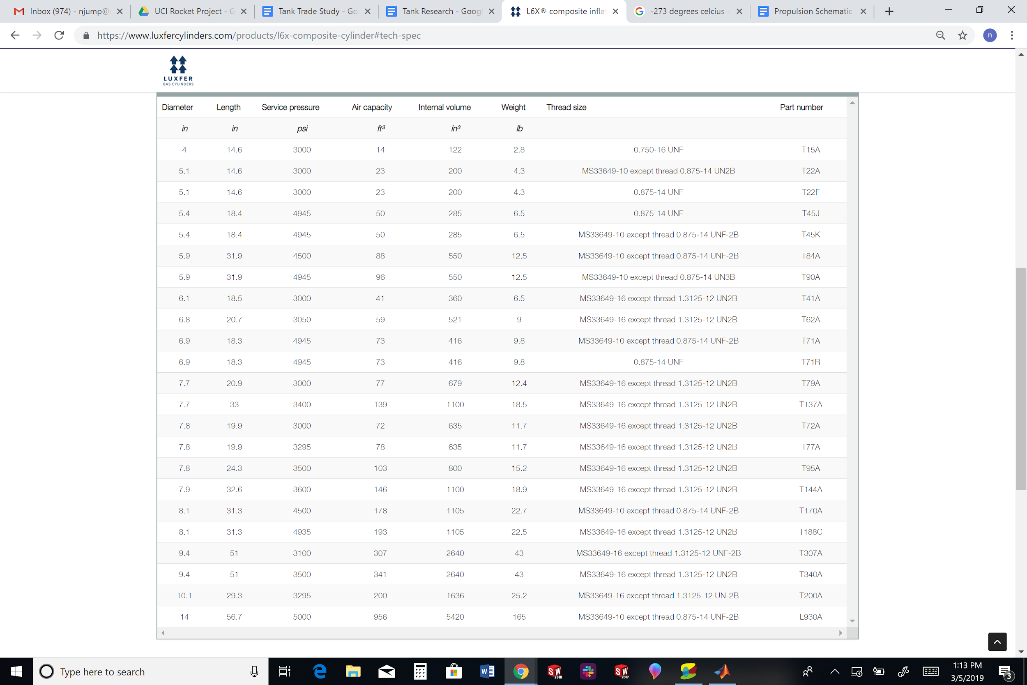

# 

*Figure 3.4.1.4.1 Pressure vessels offered by Luxfer*

### 3.4.2 Pumps

During the early stages of developments, pumps were considered as a potential propellant feed system. Turbopumps were eliminated very early on due to their inherent cost, difficulty, and complexity. Thus electric pumps were the focus of consideration. Due to the added complexity of designing a custom pump, the adaptation of Commercial Off the Shelf (COTS) pumps was considered instead.

Based on a LOX/RP-1 system, the requirements for both the fuel and the oxidizer are as follows.

Fuel pump:

* Must be a commercially available pump
* Compatible with RP-1
* Capable of generating flow rates between 24.87 gpm and 61.8 gpm
* Capable of generating discharge pressures between 400 psi and 1333 psi
* Total assembly (including motor and battery) weighs less than 200 lbs

Oxidizer pump:

* Must be a commercially available pump
* Compatible with Liquid Oxygen (i.e. cryogenically compatible)
* Capable of generating flow rates between 44.3 gpm and 104.33 gpm
* Capable of generating discharge pressures between 400 psi and 1333 psi
* Total assembly (including motor) weighs less than 200 lbs

#### 3.4.2.1 Pumps Selection

A large number of pump vendors were parsed through. However finding Commercial Off The Shelf (COTS) pumps that would suit the needs of a liquid bipropellant rocket feed system, even one that is relatively small, is extremely difficult due to the high performance and low weight needs of a rocket. Various commercially available pumps were considered based on the parameters and requirements given. After parsing through a multitude of different pump vendors, below are the pumps that were initially considered.

|  |  |  |  |  |  |
| --- | --- | --- | --- | --- | --- |
| **Vendor** | **Name** | **Flow rate (gpm)** | **Discharge pressure (psi)** | **Weight (lbs)** | **Cryogenic compatibility (Y/N)** |
| High Pressure Equipment | eTensifier | 15.32 | 4,600 | N/A* | N |
| Hydra Cell | H25 series | 11.56 - 20 | 1000 | 125 | N |
| Hydra Cell | D15/D17 series | 10.10 - 15.51 | 500 - 2500 | 145 | N |
| Hydra Cell | D35  series | 33.77 - 35.84 | 1200 - 1500 | 257 | N |
| Cryostar | CS/CBSD | 52.73 - 145.2 | 520 | N/A* | Y |
| Parker | Electric Motor-Driven Pump | 0.2 - 25 | 1000 - 3000 | 8 - 67 | N |
| Eaton Aerospace: Vickers Fluid Systems | PV3-115 | 32.99 | 3000 | 11.5 | N |
| Dynex Hydraulics | PF6046-3174 | 25.97 | 8000 | 240 | N |
| Dynex Hydraulics | PV2032 | 24.49 | 3000 | 38 | N |
| ACD | AC-48 (Heavy Duty Gearbox Pump) | 30 - 390 | 173 - 867 | N/A* | Y |

* Weights for these pumps were not given on the vendors’ website/catalogue

*Table 3.4.2.1 Comparisons of various COTS pumps considered for adaptation*

After compiling this initial list, further down selection was conducted once more refined preliminary design parameters were determined. Nearly all of the pumps shown above were capable of generating the necessary discharge pressure, however several were quickly eliminated based on the flow rate they could generate. Of the remaining pumps available, the Eaton Vickers PV3-115 had the lowest weight and thus was chosen for further analysis despite lacking its own motor. The Parker Aerospace Pump was also given significant consideration due to having its own motor while still being of moderate weight. However, its lower flow rate would necessitate a higher chamber pressure to achieve the same mission. This would introduce more complications and require higher strength materials, effectively negating the mass savings with having an integrated motor.

#### 3.4.2.2 Motor Consideration

After researching many different pumps it became apparent that a motor would separately need to be coupled with the pump. The number of pumps were downselected until the PV3-115 inline pump from Vickers was chosen. The lightest motor that would provide the 244 lb-in of torque and 1.14 ${in}^{3}$ of displacement at the theoretical psid of 1333 was found to be a 580 lb motor from PTJ industrial. Since this alone, not including the actual pump or the battery, is much heavier than the 200 lb limit of the total assembly it was decided the pressurized gas feed system would be a much better fit for the rocket.

The torque was calculated via the following equation which was provided from the pump website.

$T=\frac{in^{3}/rev x psid}{2π}$

The results were then used in the following equation to calculate the power (shaft)

$P= \frac{Torque x RPM}{63,025}$

### 3.4.3 Pressurized Gas Feed System

After determining that adopting COTS pumps into a rocket propellant feed system would not be viable, the UCI Rocket Project has decided to pursue a pressurized gas feed system as its propellant feed system. This section will go over the preliminary design and analysis of a pressure fed system. A pressure fed system consists of an additional fuel tank, which contains a highly pressurized inert gas. This pressurized gas is what forces the propellants form the tanks to the combustion chamber.The inert gas chosen for this analysis is helium (He) due to its compatibility with LOX and RP-1.

#### 3.4.3.1 Method 1 of Determining Pressurant Mass

The pressure fed system for this section will be designed for two fuel combinations; LOX/RP1 and LOX/CH4. The different fuel combinations have an effect on the total volume of the He gas required, therefore two different MatLab codes were established.

**Derivation of Equations**

The concept for determining the total volume and mass of helium required for a pressure fed system is based off a simple concept of having enough gas in an initial tank to fill two larger tanks and still have enough pressure to prevent backflow. To calculate this, the ideal gas equation can be adapted to output an initial helium volume. This volume can be converted into moles, which can be converted to a mass at equilibrium conditions. This derivation is detailed below.

**Volume of Helium Required**

Derived from: $PV=nRT$

n = number of moles (constant, because ideally no helium is lost)

R = Ideal gas constant

=>

=>

=>

+ => +

+ =>

equation (1)

Final and Initial Temperature Relation

$η$ = 1.67 (isentropic expansion of He)

$\frac{T_{f}}{T_{i}}=(\frac{P_{f}}{P_{i}})^{\frac{η-1}{η}}=T_{r}$ equation (2)

*note the pressures for this calculation are absolute

Simplifying Equation 1

By plugging equation 2 into equation 1 the exact initial and final temperatures do not need to be know, instead a ratio can be applied. The final equation is below.

=> $V_{i}=$ $\frac{V_{prop}}{\frac{P_{i}}{TiP_{f}}T_{f}-1}=\frac{V_{prop}}{\frac{P_{i}}{P_{f}}T_{r}-1}$ equation (3)

**Mass of Helium Required**

Using equation (3) the initial volume ($V_{i}$) of He is calculated.

Constants and Conversion Factors:

R = 8.314 g/molK

M (molar mass) = 4.002602 g/mol (He)

0.00220462 lbm = 1 g

1 $ft^{3}$ = 0.0283168 $m^{3}$

1 psi = 6894.76 Pa

$n_{i}=\frac{P_{i}V_{i}}{RT_{i}}$

$lb_{He}=\frac{PV}{RT}*(4.002602g/mol *0.00220462 lb/g)$

$lb_{He}=\frac{(P*6894.76 \frac{Pa}{Psi}) (V* 0.0283168 \frac{m^{3}}{ft^{3}})}{RT}*(4.002602g/mol *0.00220462 lbm/g)$

*Note: In order to calculate the weight of helium, the temperature (T) is assumed to be room temperature (298K) due to the fact that after sufficient time the temperature of the tank will equalize to the ambient temperature.

**Weight and Volume of Helium**

The weight and volume of He required for a certain fuel combination and final pressure are in the table below. For the calculation the following parameters were established:

* No heat transfer between the pressurant and the walls of the tanks
* Ullage and residual volumes of propellant are negligible
* Burn time = 80 seconds
* Density (RP1) = 50.57 lbm/ft^3
* Density (LOX) = 65 lbm/ft^3
* Density (CH4) = 26.7 lbm/ft^3
* Total mass flow rate of 10lbm/s
* LOX/RP1 (m_dot) = 7.19/2.81 lbm/s
* LOX/CH4 (m_dot) = 7.35/2.65 lbm/s

|  |  |  |  |  |
| --- | --- | --- | --- | --- |
|  | LOX/RP1 | | LOX/CH4 | |
| Final Pressure | Volume (ft^3) | lbm (He) | Volume (ft^3) | lbm (He) |
| 400 | 4.9885 | 12.1410 | 6.3738 | 15.5123 |
| 450 | 5.5040 | 13.3955 | 7.0324 | 17.1152 |
| 500 | 6.0249 | 14.6632 | 7.6979 | 18.7349 |
| 550 | 6.5531 | 15.9489 | 8.3728 | 20.3776 |
| 600 | 7.0906 | 17.2568 | 9.0595 | 22.0488 |
| 650 | 7.6387 | 18.5909 | 9.7598 | 23.7533 |
| 700 | 8.1991 | 19.9547 | 10.4758 | 25.4958 |
| 750 | 8.7731 | 21.3518 | 11.2093 | 27.2808 |
| 800 | 9.3622 | 22.7856 | 11.9620 | 29.1128 |
| 850 | 9.9678 | 24.2595 | 12.7357 | 30.9960 |
| 900 | 10.5914 | 25.7772 | 13.5325 | 32.9350 |
| 950 | 11.2344 | 27.3421 | 14.3540 | 34.9346 |
| 1000 | 11.8985 | 28.9582 | 15.2025 | 36.9995 |

*Table 3.4.3.1.1. Pressurant Mass Calculation Results*

#### 3.4.3.2 Method 2 of Determining Pressurant Mass

The second method for determining the mass of pressurant was taken from the paper *Opportunities for a Liquid Rocket Feed System Based on Electric Pumps*[[2]](https://docs.google.com/document/d/1zLFJaRyvfpCYChu_iEY6d8_trKCVqXZl1wPCFs6ekoA/edit#heading=h.4y6y6lf7e0aw). The model was then exerted into an excel spreadsheet to be able to easily change input parameters such as chamber pressure.

**Nomenclature Required to Determine Pressurant Mass**

mg : Mass of pressurant

mp: Mass of propellant

ρf: Density of fuel

ρo: Density of oxidizer   
Pt,f : Pressure of fuel tank  
Pc : Chamber pressure  
Pt,o : Pressure of oxidizer tank  
Vt,f : Volume of fuel tank  
Vt,o : Volume of oxidizer tank  
Vf: Volume of fuel  
Vo: Volume of oxidizer

$\frac{O}{F}$: Oxidizer to fuel ratio

Kg: Safety factor  
Kt,g: Safety factor relating to thickness of wall of pressurant tank

Kt,p: Safety factor relating to thickness of wall of propellant tanks

γg: Specific heat ratio of pressurant

Mg: Molar mass of pressurant

T0: Initial temp of pressurant

p0: Initial pressure of pressurant

R0: Universal gas constant

**Assumed Conditions**

Pressure inside the fuel and oxidizer tanks are assumed to be the same and the dimensionless ratio is defined below.

$k_{p1}=\frac{P_{t,f}}{P_{c}}=\frac{P_{t,o}}{P_{c}}$

The volume of the fuel and oxidizer tanks are assumed to be the same and the dimensionless ratio to account for ullage is defined below.

$K_{u}=\frac{V_{t,f}}{V_{f}}=\frac{V_{t,o}}{V_{o}}$

The variable alpha is defined to simplify the final equation for calculating the pressurant mass of helium.

$α_{f}=\frac{1}{ρ_{f}}\frac{1}{1+\frac{O}{F}}$

$α_{o}=\frac{\frac{O}{F}}{ρ_{o}}\frac{1}{1+\frac{O}{F}}$

$α=α_{f}{+α}_{o}$

**Final Equation to Determine Pressurant Mass**

The total mass of the pressurant is then given by the following equation

$m_{g}=αK_{p1}K_{u}K_{g}\frac{γ_{g}M_{g}}{R^{0}T_{0}}\frac{m_{p}p_{c}}{1-K_{p1}\frac{p_{c}}{p_{0}}}$

**Numerical Analysis**

Using the initial conditions given in [[6]](https://docs.google.com/document/d/1zLFJaRyvfpCYChu_iEY6d8_trKCVqXZl1wPCFs6ekoA/edit#heading=h.4y6y6lf7e0aw) at a chamber pressure of 300psi the total mass of the pressurant given by the above model was calculated to be 1.845lb which is much lower than the expected result. Several iterations of the model were conducted and the mass of the pressurant was consistent with the result of 1.845lb. Because of this the model was deemed to be inaccurate and will not be used unless with further analysis the error is determined.

**Conclusions**

After comparing the results from the two methods in the above sections method 1 will be used for further analysis and design of a pressure fed fuel system until more accurate parameters are required. The MATLAB code designed for method 1 can be easily changed for several different initial conditions of a liquid propelled rocket and can be modeled accordingly for future use. Method 2 has been declared to be inaccurate, further consideration can be made to determine why this discrepancy has occurred but currently is not a wise investment of time and resources when model 1 is accurate enough for preliminary design.

#### 3.4.3.3 References

1. Cannon, J. L. (2010). Liquid Propulsion: Propellant Feed System Design. Encyclopedia of Aerospace Engineering, 2. <https://doi.org/10.1002/9780470686652.eae110>
2. Solda’, N., & Lentini, D. (2008). Opportunities for a Liquid Rocket Feed System Based on Electric Pumps. Journal of Propulsion and Power, 24(6), 1340–1346. <https://doi.org/10.2514/1.35074>
3. Design of Liquid Propellant Rocket Engines (1st Edition) - Huzel, Huang <https://drive.google.com/file/d/1LgrJVFF3t8egAKBg5f28SWSxfUY4K91K/view?usp=sharing>
4. Hahn, R. H. S., & Deeken, J. (2018). Studies on Electric Pump-Fed Liquid Rocket Engines for Micro-Launcher STUDIES ON ELECTRIC PUMP-FED LIQUID ROCKET ENGINES FOR MICRO-LAUNCHERS, (May).
5. Kwak, H. D., Kwon, S., & Choi, C. H. (2018). Performance assessment of electrically driven pump-fed LOX/kerosene cycle rocket engine: Comparison with gas generator cycle. Aerospace Science and Technology, 77, 67–82. <https://doi.org/10.1016/j.ast.2018.02.033>
6. Propellant Data Analysis <https://docs.google.com/spreadsheets/d/18ZKkcyuLv6_2uRfnYpG86mdCVrmusTDezB6lavqH2S4/edit?usp=sharing>

# 

# 4. Structures

## 4.1. Requirements

### 4.1.2. Force and Stress Analysis

Loads on structural components can be separated into two types, ground loads and air loads. Ground loads consist of the forces experienced while in transportation or on the ground, while air loads consist of those acting on the structure while in flight. Air loads can further be categorized into surface forces and body forces. Surface loads are those such as aerodynamic forces, which will not be discussed in this section. Here body forces will be addressed.

* A designing load determines one or more structural characteristic, such as:
  + Shape
  + Thickness
  + Material
* Critical load is the load that gives the minimum margin of safety for a component.

The following loads will primarily determine the structure of the aircraft.

* Gravity
* Thrust
* Atmospheric conditions (wind and temperature fluctuations)
* Vibrations

Aircraft structures, in this case fuselages, are composed of thin sheets of material that are stiffened by longitudinal stringers as well as transverse frames. These types of structures can often be complicated, and as such it is necessary to make some level of assumptions in order to simplify analysis. The quantity and type of assumptions made influences both the complexity and the accuracy of the analysis. During a preliminary analysis of the various options such as this, speed is often of more importance than high levels of accuracy. Later in the design process, a significantly more accurate approach, such as computer analysis of a Finite Element Model, can be utilized. Aircraft structures can often be simplified into direct stress carrying booms combined with shear stress carrying skin. “Generally, they carry bending moments, shear forces and torsional loads which induce axial stresses in the stringers and skin together with shear stresses in the skin; the resistance of the stringers to shear forces is generally ignored” (Megson). Therefore, the analysis shown here is an idealization of the true structure.

Bending Moment stress

The stress due to bending moment is calculated using the equation below.

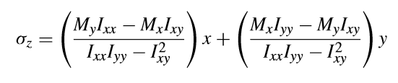

Shear flow

The shear flow in the skin is calculated through the following equation.

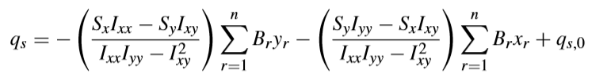

Where Br is the cross-sectional area of the rth boom.

Torsion

The shear flow due to an applied torque is given by the following equation

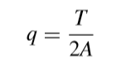

This value can then be superimposed upon the shear flow calculated from the previous equation.

Fuselage frames, often called transverse frames, are lateral and as such perpendicular to the longitudinal stringers. Fuselage frames “transfer loads to the fuselage shell and provide column support for the longitudinal stringers. The frames generally take the form of open rings so that the interior of the fuselage is not obstructed” (Megson). The shear flow transmitted to the periphery of a transverse frame can be calculated by the following equation.

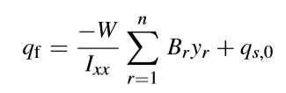

Where qs,0 san be calculated by the following equation,

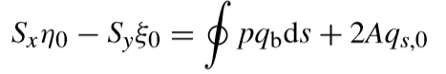

Where the load is W, $(ε_{s},η_{s})$ is the location of the shear center, and

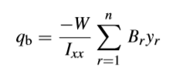

After determining the shear flow distribution in the periphery of the transverse frame, “the frame itself may be analysed for distributions of bending moment, shear force and normal force” (Megson).

Fatigue

There are many ways in which fatigue damage can occur, such as:

* Cyclic fatigue is caused by loads that fluctuate repeatedly.
* Corrosion fatigue is due to surface corrosion of the material, the corrosion penetrates beneath the surface and reduces the strength of the material.
* High frequency stress ﬂuctuations due to vibrations are the cause of sonic or acoustic fatigue.
* Thermal fatigue is due to repeated thermal expansions and contractions.
* Fretting fatigue is caused by rubbing movements between adjacent components on a small scale.

As such, it is very important that the primary components of the aircraft structure are subjected to a thorough analysis and load testing. These show that the structure has a “*safe life*” or has “*fail-safe*” characteristics (Megson).

## 4.2. Air Frame

#### 4.2.1.1 Material Selection Strategy

The goal of the rocket structure is to create a design which will be capable of withstanding the thrust forces from the engine, weight of the rocket, drag, bending moment stress from the motion of the rocket through the atmosphere, as well as shear stress, torsion, and fatigue as previously discussed. At the same time, it is necessary to choose a design that will minimize the weight of the rocket. Internal structure, skin structure, as well as materials must be decided. The material chosen must provide the strength necessary, as well as be resistant to high temperatures.

#### 4.2.1.2 Material Properties

In order to determine the appropriate material for UCI Rocket Projects applications, an understanding of the advantages of each property of the material is required, as well as the associated limitations.

This is included in the following selection criteria:

* Specific strength
* Proof and ultimate stress
* Specific stiffness
* ductility
* Stress corrosion resistance
* Fracture and fatigue resistance
* Thermal expansion coefficient and conductivity
* Ease of manufacture

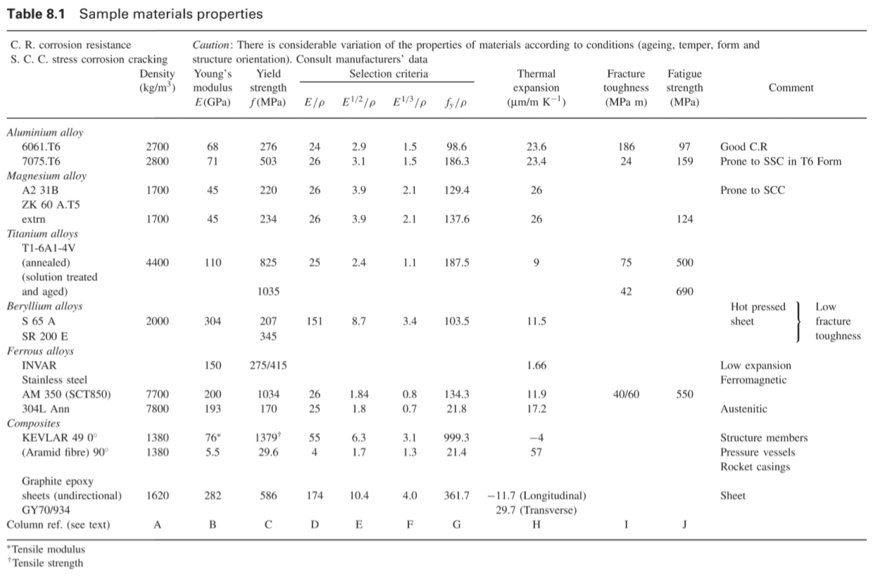

Figure #:  Material properties table - Spacecraft Systems Engineering (Fortescue 4th Edition pg 257)

#### 4.2.1.3 Carbon Fiber

**Strength**

“Weight for weight,carbon fiber offers 2 to 5 times more rigidity(depending on the fiber used) than aluminum and steel” (Carbon Fiber vs Aluminum). An example of the comparison between Aluminum, Steel, and Carbon Fiber is shown in the data below.

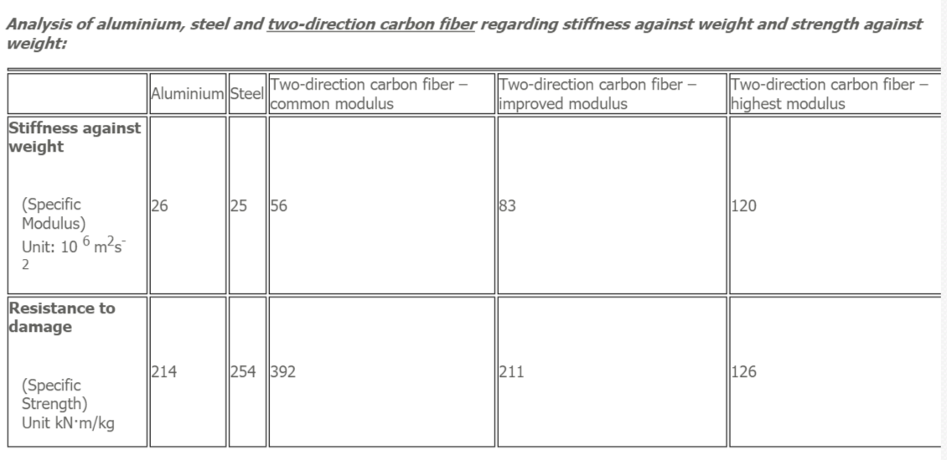

The length of the fibers in a carbon fiber affects the strength as well as the cost of the material. “Milled fibers are the shortest carbon fibers used for reinforcement. They range in length from 30 to 3,000 microns, averaging approximately 300 microns. Mean L/D ratio (length to diameter) is 30. Short chopped fibers with an L/D ratio of about 800 increase strength and modulus of composites more than milled fibers do. Cost of a molding compound reinforced with short fibers is about twice that of one containing milled carbon fibers.” The longer the fibers, the more strength the material will have, this will also increase the cost significantly. “With proper selection and placement of fibers, composites can be stronger and stiffer than steel parts with similar thicknesses but 40 to 70% less weight” (Machinedesign.com).

**Cost**

The downside to Carbon Fiber is that it is significantly more expensive than Aluminum or Fiberglass.

**Temperature Resistance**

“Carbon fiber performance and resistance to high temperatures depends on the composite structure and baking technology. It is true that carbon fiber composite is resistant to high temperature, but unfortunately that is often not the case… Standard epoxy carbon fiber composites that underwent proper baking feature resistance up to 70-100 °C (160-210 °F)” (Carbon Fiber vs Aluminum).

#### 4.2.1.4 Aluminum

Three groups of aluminum alloys have been used in aircraft manufacturing for many years. In the first type that will be discussed, “aluminum is alloyed with copper, magnesium, manganese, silicon and iron, and has a typical composition of 4% copper, 0.5% magnesium, 0.5% manganese, 0.3% silicon and 0.2% iron with the remainder being aluminum. In the wrought, heat treated, naturally aged condition this alloy possesses a 0.1% proof stress not less than 230N/mm2, a tensile strength not less than 390N/mm2 and an elongation at fracture of 15%. Artiﬁcial ageing at a raised temperature of, for example, 170◦C increases the proof stress to not less than 370N/mm2 and the tensile strength to not less than 460N/mm2 with an elongation of 8%” (Aircraft Structures).

The second alloy group contains “in addition to the above, 1–2% of nickel, a higher content of magnesium and possible variations in the amounts of copper, silicon and iron. The most important property of these alloys is their retention of strength at high temperatures which makes them particularly suitable for aero engine manufacture” (Aircraft Structures).

The third group “depends upon the inclusion of zinc and magnesium for their high strength and have a typical composition of 2.5% copper, 5% zinc, 3% magnesium and up to 1% nickel with mechanical properties of 0.1% proof stress 510 N/mm2, tensile strength 585 N/mm2 and an elongation of 8%” (Aircraft Structures)

Types of Aluminum Alloy

* 1000 Series - nearly pure aluminum with a minimum 99% aluminum content by weight.
* 2000 Series - alloyed primarily with copper, this series was one of the most common aerospace alloys used in the past.
* 3000 Series - alloyed primarily with manganese.
* 4000 Series - alloyed primarily with silicon.
* 5000 Series - alloyed primarily with magnesium.
* 6000 Series - alloyed primarily with magnesium and silicon.
* 7000 Series – alloyed primarily with zinc. This series is now most commonly used in aerospace applications.

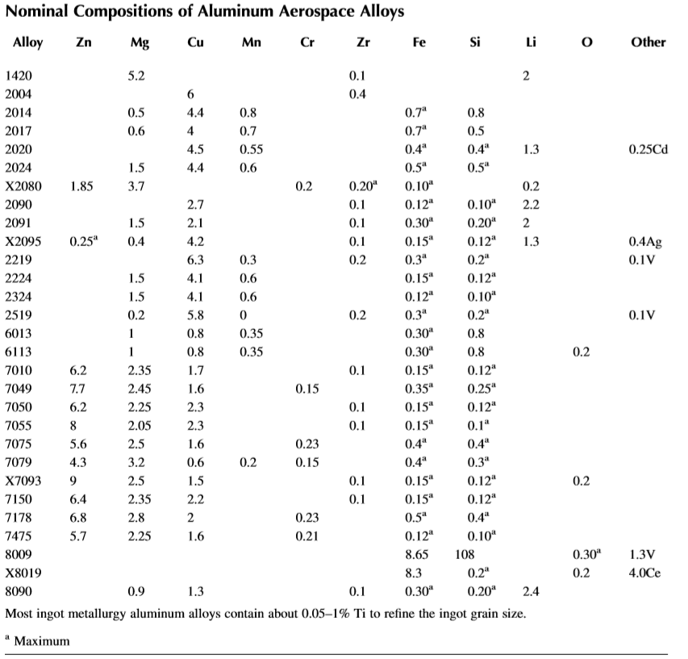

Figure # - Nominal Compositions of Aluminum Aerospace Alloys – Advanced Structural Materials (Soboyejo, Table 9.4, Pg 245)

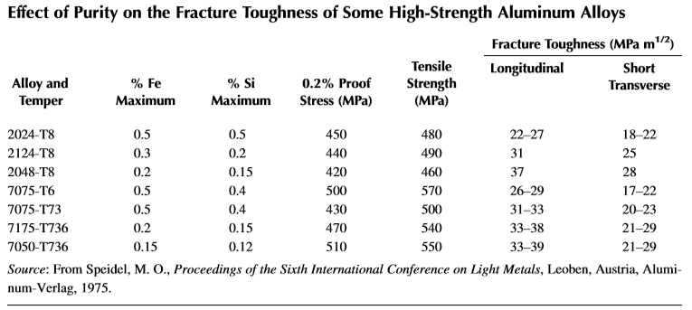

Figure #: Effect of Purity on the Fracture Toughness of Some High-Strength Aluminum Alloys - Advanced Structural Materials (Soboyejo).

**Strength**

As stated before, Aluminum is not as strong as Carbon fiber at a given weight, meaning it will be heavier to achieve the same stiffness and strength as carbon fiber. Although it is very light compared to other metals, with a specific weight  2.7 g/cm3. This is approximately one-third that of steel. Aluminum is also highly corrosive resistant, and surface treatments ca increase this corrosion resistance, when exposed to air it forms a thin oxide coating which protects the metal from its environment. Aluminum has a tensile strength of approximately 13,000 psi. It is often alloyed with elements such as manganese, silicon, copper, magnesium, or zinc to further increase strength. “The most common aluminum alloy used in aerospace is 7075, which has zinc as the primary alloying element. It is strong, with strength comparable to many steels, and has good fatigue strength and average machinability, but has less resistance to corrosion than many other aluminum alloys. Its chemical composition roughly includes 5.6-6.1% zinc, 2.1-2.5% magnesium, 1.2-1.6% copper, and less than half a percent of silicon, iron, manganese, titanium, chromium, and other metals” (Machinedesign.com).

**Cost**

Aluminum is significantly cheaper than Carbon Fiber. This gives it an advantage, as it would likely cost too much to make the outer skin entirely of carbon fiber.

**Temperature Resistance**

Aluminum has a much higher resistance to high temperatures than Carbon Fiber or Fiberglass. Some aluminum alloys retain strength up to 500 F. This is another advantage to using Aluminum over Carbon Fiber given the potentially high temperatures of the rocket engine.

#### 4.2.1.5 Fiberglass

**Strength and Temperature Resistance**

In terms of strength and resistance to temperature, fiberglass is inferior to both aluminum and carbon fiber. While it may be easier to work with and construct, for these reasons’ fiberglass may not be the best option for our uses.

**Cost**

Fiberglass is the cheapest of the researched materials, although specific costs will depend on the type of fiberglass.

### 4.2.1. Air Frame Internal Structure

There are two possible considerations for the internal structure, one is an internal skeleton design, while the other consists of a semi-monocoque structure with a thicker load-bearing skin. In order to determine the superior structure, a model must be created and analyzed using the axial and shear stress analysis previously described. After that is complete, a Finite Element Analysis can be conducted to determine the precise stress and loading calculations.

While a rocket with an internal skeleton may have a more lightweight external skin, overall the structure may potentially weigh more. The rigidity of the structure will rely on the skeleton underneath the skin. This skeleton would consist of longitudinal stringers attached to transverse frames. 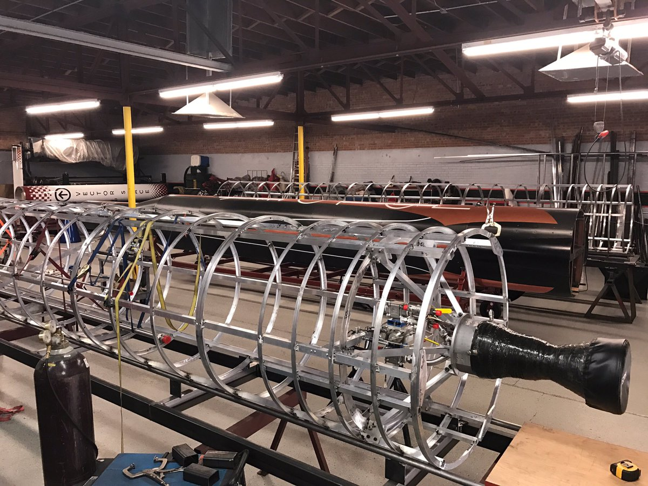

*Figure 4.2.1.1. Example of rocket with internal skeletal structure:*

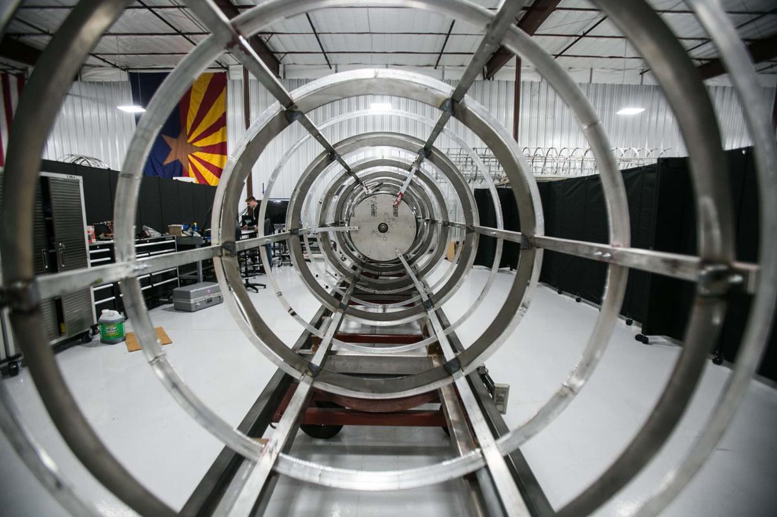

The design with a series of transverse frames or bulkheads will rely on strength and rigidity of the external skin in order to withstand bending moment stress and the forces of thrust, drag, and gravity, etc. This is referred to as a semi-monocoque structure. A monocoque structure relies solely on the load-bearing skin. Semi-monocoque is a load-bearing skin supported by internal components.

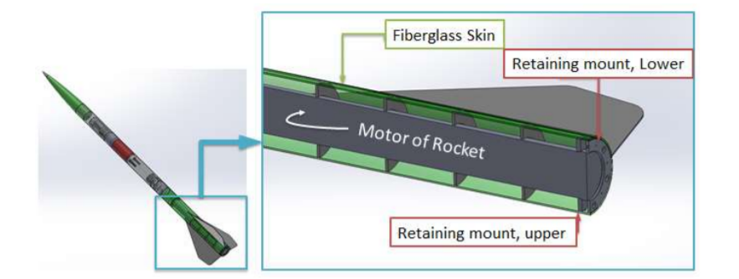

*Figure 4.2.1.2 Example of rocket with semi-monocoque structure:*

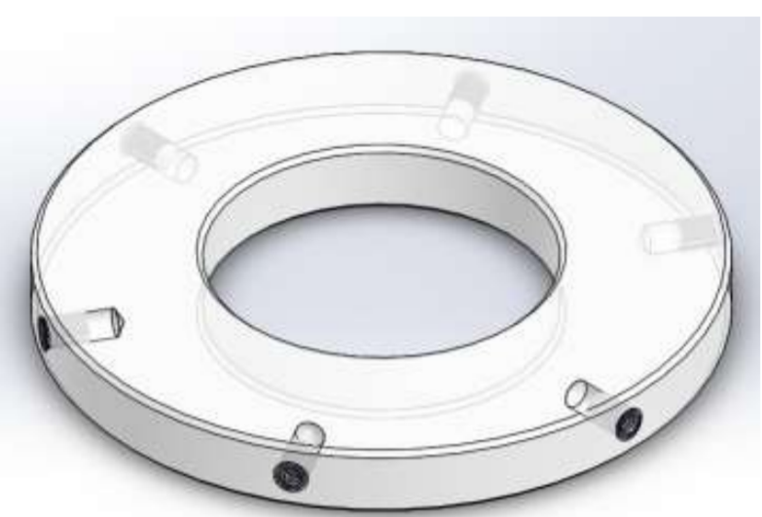

The bulkheads can be tapped through the sides in order for it to attach to the skin of the rocket. Additional holes can be machined where it is necessary for plumbing to go through the bulkhead.

The rocket skin must be able to separate into several sections in order to make access to the avionics components and plumbing simple. For this we will need a coupler. This will consist of an aluminum tube, the outside diameter of which is flush with the inside diameter of the rocket skin. The coupling tube will then be secured to each side of the rocket using hardware.

Sources:

“Carbon Fiber vs Aluminium - Comprasion.” *Dexcraft*, Http://Www.dexcraft.com/, 16 Dec. 2016, [www.dexcraft.com/articles/carbon-fiber-composites/aluminium-vs-carbon-fiber-comparison-of-materials/](http://www.dexcraft.com/articles/carbon-fiber-composites/aluminium-vs-carbon-fiber-comparison-of-materials/).

Bowman, Samuel S., et al. *Two-Stage, High-Altitude Rocket with Internal Skeleton Design Entered in Advance Category of 7th ESRA IREC*. 2012, *Two-Stage, High-Altitude Rocket with Internal Skeleton Design Entered in Advance Category of 7th ESRA IREC*.

Fortescue, Peter W. *Spacecraft Systems Engineering*. Wiley, 2011.

MEGSON, Thomas Henry Gordon. *Aircraft Structures for Engineering Students*. Elsevier Butterworth-Heinemann, 2005.

Mraz, Stephen. “Basics of Aerospace Materials: Aluminum and Composites.” *Machine Design*, 13 Mar. 2017, [www.machinedesign.com/materials/basics-aerospace-materials-aluminum-and-composites](http://www.machinedesign.com/materials/basics-aerospace-materials-aluminum-and-composites).

Soboyejo, Winston O., and T. S. Srivatsan. *Advanced Structural Materials: Properties, Design Optimization, and Applications*. CRC Press, 2007.

### 

## 4.3. Nose Cone

### 4.3.1. Aerodynamic Design

#### Types of Nose Cones

**Tangent Ogive** - The profile of this shape is formed by a segment of a [circle](https://en.wikipedia.org/wiki/Circle) such that the rocket body is [tangent](https://en.wikipedia.org/wiki/Tangent) to the curve of the nose cone at its base, and the base is on the radius of the circle. The popularity of this shape is largely due to the ease of constructing its profile, as it is simply a circular section.

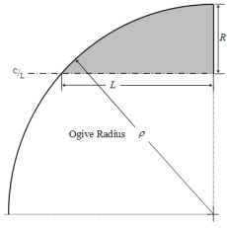

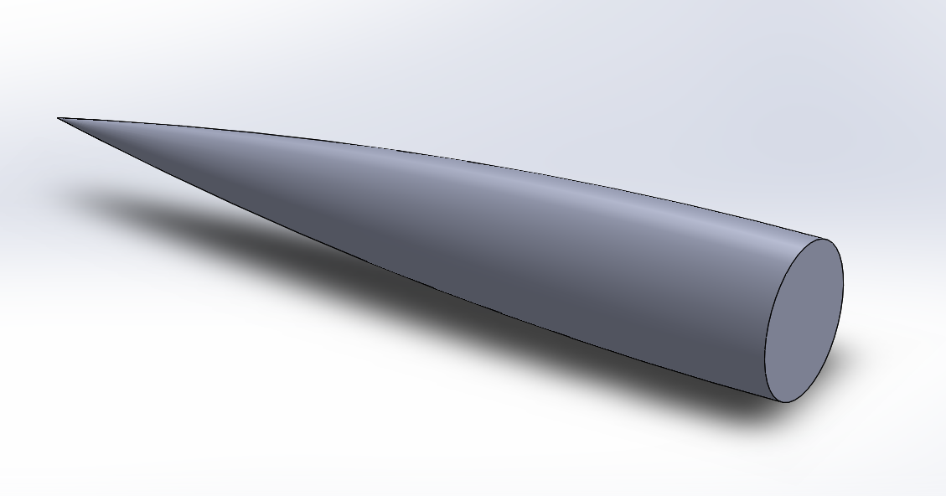

**Spherically Blunted Tangent Ogive** - A type of tangent ogive which is blunted by capping it with a segment of a [sphere](https://en.wikipedia.org/wiki/Sphere).

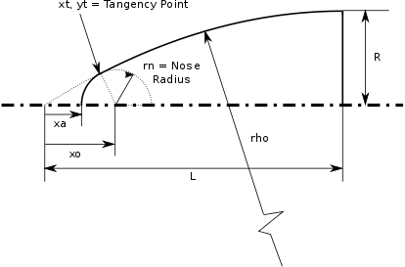

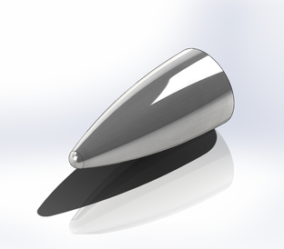

**Conic –** This nose cone shape is a simple cone. It is easy to create, but has less optimal streamlined shapes compared to other nose cones.

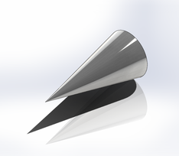

**Parabolic Series** - The parabolic series nose shape is generated by rotating a segment of a [parabola](https://en.wikipedia.org/wiki/Parabola) around a line parallel to its [latus rectum](https://en.wikipedia.org/wiki/Latus_rectum). This construction is similar to that of the tangent ogive, except that a parabola is the defining shape rather than a circle.

**Full Parabola (k = 1)**

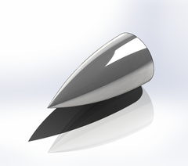

**3/4ths Parabola (k = 3/4)** – As k reduces, the nose gets thinner.

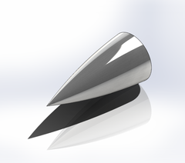

**½ Parabola (k = 1/2)**

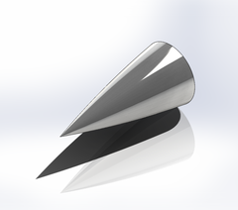

**Power Series Nose cone** - The power series shape is characterized by its (usually) blunt tip, and by the fact that its base is not tangent to the body tube. There is always a discontinuity at the joint between nose cone and body that looks distinctly non-aerodynamic. The shape can be modified at the base to smooth out this discontinuity.

**X^1/4 Power** - The power series nose shape is generated by rotating the *y* = *R*(*x*/*L*)*n* curve about the *x*-axis for values of *n* less than 1. The factor *n* controls the bluntness of the shape. For values of *n* above about 0.7, the tip is fairly sharp. As *n* decreases towards zero, the power series nose shape becomes increasingly blunt.

**X^1/2 Power**

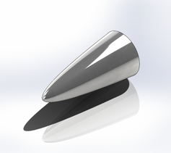

**Haack Series** - Unlike all of the nose cone shapes above, the [Haack](https://en.wikipedia.org/wiki/Wolfgang_Haack) series shapes are not constructed from geometric figures. The shapes are instead mathematically derived for the purpose of minimizing [drag](https://en.wikipedia.org/wiki/Drag_(physics)). While the series is a continuous set of shapes determined by the value of *C* in the equations below, two values of *C* have particular significance: when *C* = 0, the notation *LD* signifies minimum drag for the given length and diameter, and when *C* = 1/3, *LV* indicates minimum drag for a given length and volume. The Haack series nose cones are not perfectly tangent to the body at their base except for the case where *C* = 2/3. However, the discontinuity is usually so slight as to be imperceptible.

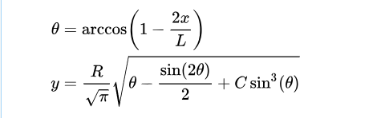

**LV-Haack (C = 1/3)**

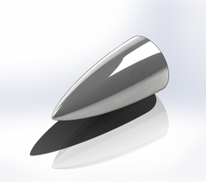

**Von Karman (LD-Haack C = 0)**

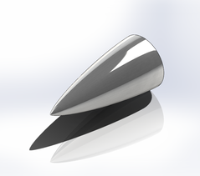

**Performance of each nose cone**

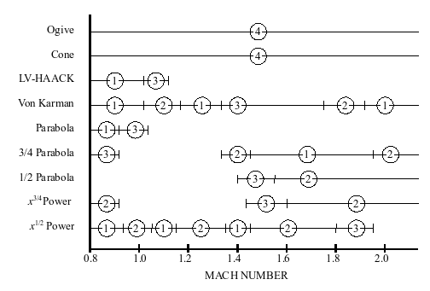

For aircraft and rockets, below [Mach](https://en.wikipedia.org/wiki/Mach_number) 0.8, the nose pressure drag is essentially zero for all shapes. Higher than this region, pressure drag increases dramatically. In this case, the shape of the nose cone becomes much more significant in order to reduce drag. The biggest factors influencing drag are the shape, its fineness ratio, and its bluffness ratio. The fineness ratio is the length of the body to its maximum width. As the fineness ratio increases, the skin friction component of drag increases. Therefore, the minimum drag fineness ratio is ultimately going to be a trade-off between the decreasing wave drag and increasing friction drag.

**Conclusion**

The data shows that the two most effective nose cones at supersonic speeds are the Von Karman, and the ½ Power nose cone. According to a NASA study, “while the x^l/2 nose apparently had a low initial drag rise, its drag continues to rise slowly over most of the Mach number range shown. This appears to be a result of its extremely blunt apex. The drag of the Von Karman nose however peaks at about M = 1.4, after which Mach number it decreases with increasing M”. Further, “The Von Karman nose has the further advantage of fairing smoothly into the body behind it which apparently is a factor in obtaining low subsonic drag and high drag-rise Mach numbers. It also seems reasonable to assume that this factor would also tend to reduce the interference drag of the nose on an afterbody in comparison with noses having finite slopes at the nose-afterbody juncture”. Therefore, the Von Karman nose cone is the most effective and is the nose cone chosen for the rocket.

### 4.3.2. Thermal Analysis

Heating for the nose cone depends on specific heat of the material used and the type of nose cone used, specifically the radius of curvature of the test body at a specific point is important

**Heating rate of a leading edge body**

Understanding the thermal load that the nose cone will undergo during flight is important to ensure that failure does not occur. Finding the temperature variation of the nose cone during flight by treating the nose cone as a leading edge body. In doing so, the heating rate of the leading edge body can be found using the following equation:

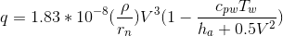

In this equation, *q* is the heating rate per unit area (W/cm2), *ρ* is the density of the fluid (kg/m3), *rn* is the radius of curvature of test body (m), *V* is the instantaneous velocity (m/s), *cpw* is the specific heat of surface material (J/kg-K), and *Tw* is the instantaneous temperature at the surface (K). The radius of curvature of the test body and the specific heat of the surface will depend on the type of nose cone that will be selected upon our research, and the density of the fluid for the rocket can be assumed to be the known density of air. The instantaneous velocity and temperature are parameters that can be calculated that will be specific to the team’s rocket.

**Velocity calculations**

To calculate the velocity that the rocket will achieve, the following equation can be used:



where 𝛥*u* is the rocket velocity, *Ueq* is the equivalent velocity, *R* is the mass ratio, *g* is the gravity constant, 𝛳 is the angle of trajectory, and tb is the burn time. Known parameters are the gravity constant, mass ratio, and burn time. The angle of trajectory is assumed to be vertical (cos(θ) = 1) and the mass ratio can be found by taking the initial mass over the burnout mass. The other parameter that must be calculated is the equivalent velocity, which can be found using the following equation:

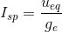

where Isp = specific impulse, Ueq is the equivalent velocity, g = Earth’s gravity constant, and Cd is the coefficient of drag. Known parameters are the specific impulse, gravity constant, and coefficient of drag, which is assumed to be approximately 0.08 for all nose cones. The combination of these two equation will result in the velocity of the rocket.

**Temperature Calculations:**

To calculate the instantaneous temperature on the surface of the nose cone during flight, the following equation can be used:

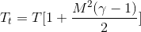

where Tt is the stagnation temperature, T is the static temperature at given altitude, M is the Mach number, and γ is the ratio of specific heat. Known parameters are the static temperature and Mach number. The ratio of specific heat is assumed to be 1.4 by treating the fluid air surrounding the nose cone as a calorically perfect gas. The static temperature at a given altitude can be found using the following plot provided by NASA:

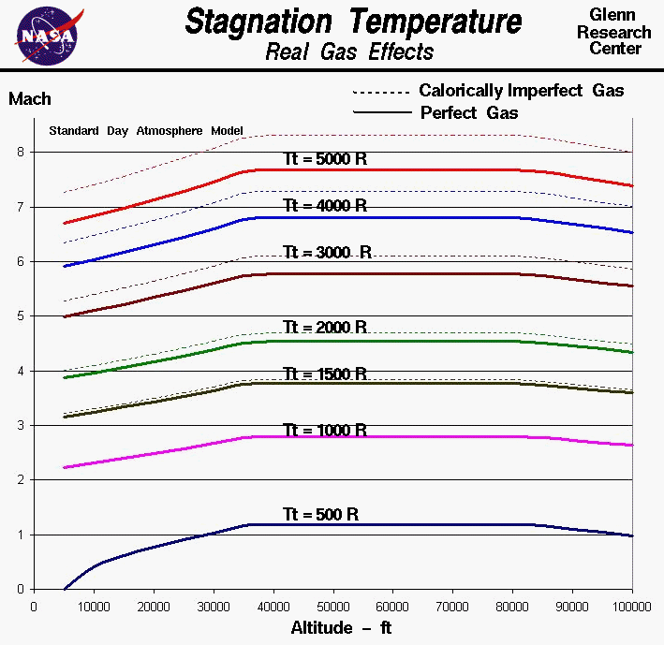

### 4.3.3. Manufacturing Processes

For manufacturing the nose cones, it heavily depends on the type of material that will be used. So far, it seems like using cloth materials like fiberglass and carbon fiber are more beneficial and time-saving than metal materials such as aluminum, since the former requires a single mold that we can use to make more nose cones as necessary in the case of breakage.

The best method for manufacturing a nose cone is to create a mold of the desired nose cone profile and lay the composite cloth materials into the mold with an epoxy resin and allowing the cone to set. The ideal type of mold would be a composite female mold, since it is important that the outer surface of the nose cone be as smooth as possible for optimal aerodynamic properties. Male mold would be quick to produce but requires additional work after the cone has been made, such as sanding down the other surface to be smooth. The female mold would require more manufacturing labor, but would produce a smooth profile on the outside of the cone if done correctly, requiring minimal finishing processes such as sanding. Furthermore, a composite mold would be easier to fabricate and maintain, bringing the cost of manufacturing low.

## 4.4 Control Surfaces

### 4.4.1. Aerodynamic Design

For the task of providing dynamic stability and aerodynamic performance, the team has decided on a design with actuated fins to provide aptitude control. The team will be doing a symmetric 4 fin configuration for the purpose of simplicity of analysis (as later explained under Flight Dynamics & Stability). The team is also leaning towards a non-canted & non-cambered fin, so there is no natural roll - all the stability will be provided by the corrective moment and damping to keep the rocket stable rather than roll / gyroscopic induced stability. Previously considered was Grid Fins, however; the hinge moment in actuating such surfaces would induce potential costs and complications.

The team will likely be manufacturing our wings out of G-10 Fibreglass for the purposes of strength and minimizing weight, but because it also has a lower cost of carbon fiber. This might cause a budget problem for the UCIRP if it must re-manufacture wings or adjust them. The fins will probably be flat and streamlined at the leading and trailing edge of the fins. The wings will be tapered and swept to reduce drag, which will slightly reduce the corrective moment, but for high performance this will the team has decided this will be a beneficial trade-off.

### 4.4.2. Assembly, Integration, and Electromechanical Design

This topic is to cover the topic of the mechanical mounting and actuating of the control surfaces. The team is choosing between between two main wing configurations as stated previously - a fixed wing and a movable wing set-up, each with 4 aligned 90 degrees from each other. For the fixed wing configuration, we are planning on manufacturing a piece fitted in the fuselage with machined out slots with bolt holes. The bolt holes will have to be tapped with precaution into the fins. It will then be bolted on securely at 4 places for each of these fins across its width. The design the team is leaning towards more is the actuated fins, where the wing will be pinned and allowed to rotate, and this pinning rod will be securely fastened structurally on the fuselage. Then, the fin will be rotated about its axial axis to induce and angle of attack, using most likely a servo motor with a set of gears. Out of space missions largely use pneumatic systems, which are mechanically very complex. This problem can mostly be avoided due to the fact the rocket’s goal isn’t reentry into the atmosphere and guidance control.

### 4.4.4. Flight Dynamics and Stability

The first main objection of the flight dynamics & stability analysis is to provide optimal dynamic qualities of the close-loop rockets. Questions of concern is the loss of stability & corrective moment of the rocket by the introduction of the angle of attack. It can be assumed the largest deviation that can concur from the desired vertical flight path angle would be at take off at the launch lugs, so we must be assured that the rocket doesn’t become unstable at this point, that is, the Center of Pressure (CP) doesn’t move forward of the CG (or preferably stays 1 calliper behind the CG). The dynamic qualities are not only determines by this corrective moment, determined by the distance of the CP behind the CG, but also a damping moment. The damping moment will arise from the effective

There will be 2 axis defined by the top of one fin to the top of the opposite fin. Rotation about this axis of the rocket will result in corrective moment and moment damping by these 2 fins only, and not the other 2 fins which define the separate axis. This means if we defined rotational DOF around one of these axis to be pitch and the other to be yaw, we can estimate 2 fins defining each respective axis to be the contribution to each moment. This means to adjust heading, a control law would be implemented to cause pitching after a certain amount of pitch deviation from the vertical has been made, and same with yaw. This is the preferred route, because there is no natural tendency for the rocket to point in any actual direction, rather - just a tendency for the rocket to keep in the direction it's heading and in the direction of a wind disturbance. We ultimately feel this would be the best for performance as well as assuring the rocket doesn’t head off too far horizontally. This actuation will induce an angle of attack to create corrective moments towards the vertical, and gyroscopic feedback control to feedback angular velocities and euler / heading angles. This control law will be further researched and developed through the testing of smaller model rockets in both UCI wind tunnels and hopefully launch sites.

The goal of the rocket is to have a static stability margin at launch of 1.5 callipers. This will determine the sizing of the fins based on information from the CG location and the aerostructures and nose-cone sizes and shapes. The UCIRP’s Propulsion team have an estimated speed of the launch lugs of 114 ft/s, with a safe lower bound of 90 ft/s. Based on information of rockets previously tested, a safe estimation of worst case stability would allow us a 13 degree angle of attack per a calliper. This would allow the rocket up to a 19.5 degree angle of attack at launching for maintained static stability, or up to a worst case scenario of allowing a crosswind 31.8ft/s. Will careful monitoring, and the rocket continually accelerating throughout the launch, this is a safe margin for rocket stability at launch. Static stability will actually decrease throughout the launch ignoring aerodynamic changes based on fuel location, supersonic speeds will move to neutral point of flow on the wing back and hence increase stability margin. Another consideration will have to be made at damping ratio. For optimal performance for the sake of structural loadings, preventing excessive weathercocking, and preventing excessive oscillations, we will want the damping ratio (to be numerically solved but later tested), in the ballpark of 0.3-0.35, a widely known recommendation for model rockets and non-guided rockets.

## 4.5. Recovery System

### 4.5.1. Recovery System Design

When researching for the design of the recovery system, we look into different positionings of the parachute. Ideally, the parachute will be deploy from the top of the rocket to avoid unnecessary movement of the rocket. Many sources suggested the usage of 2 parachutes, one drogue chute to guide the rocket after apogee and one main parachute to bring back the rocket to the ground. The usage of 2 parachutes will also decrease the distance that the rocket will travel after reaching apogee since a single parachute will make the wind carry the rocket a further distance.

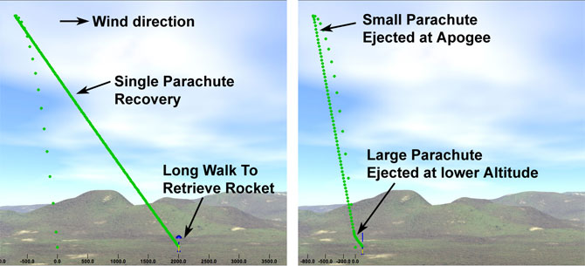

There are many ways to actuate the deployment of the parachutes. Our main obstacle is that we haven’t reach the stage in where we are building the structure of the rocket. Therefore, we don’t know the specific parameters such as the length, the diameter and the weight of the rocket. However, we did know the nature of the limiting space that we have in each section, so the priority of the design was to be as compact as we could. This meant that we discard designs that implemented complicated mechanisms.

The design we choose to develop and prototype consist of using CO2 canisters to create a pressure differential in the chamber where the parachute will be located and with that pressure force, shear the shear pins to release the parachute. The CO2 canisters would be actuated with a small amount of gunpowder. The parachute will be attach to the rest of the rocket using eye bolts.

The section where the drogue chute and the main parachute will be connected to the rest of the rocket using couplers and bulkheads, and they will be secure using shear pins. This shear pins will place in key locations so that the pressure force of the CO2 canisters will break them.

The whole design follows a similar schematic as the figure below.

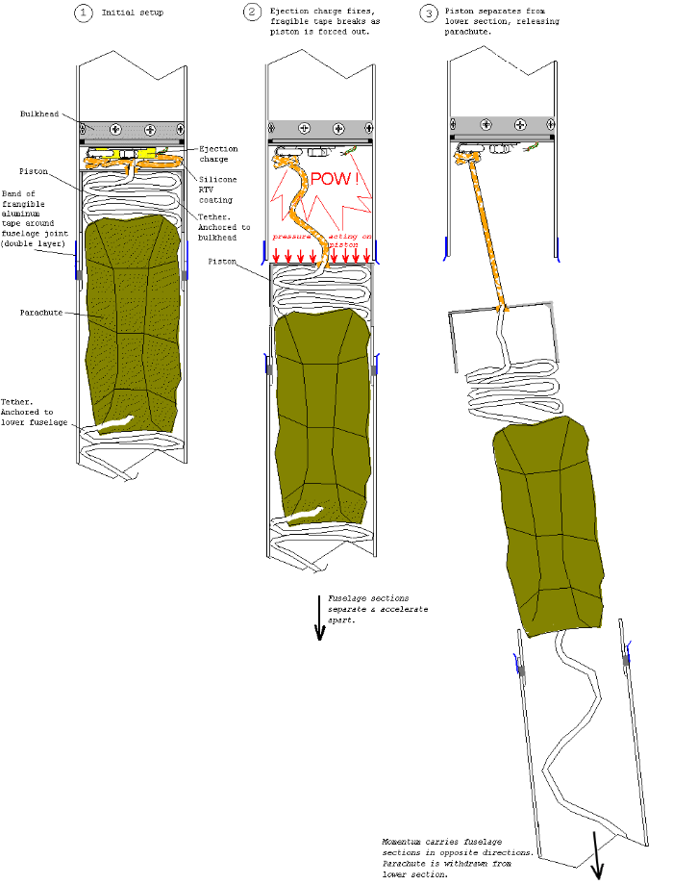

### 4.5.2. Sample Calculations

The drogue chute will be deployed at apogee: 45,000 ft

The main parachute will be deployed at 1000 ft

To calculate the area of the parachute:

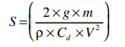

Where:

S : area of the parachute

g : acceleration due to gravity

m : mass of the rocket (with empty engine) as measured in grams

𝞺 : is the density of air (1225g/m3) at sea level

Cd: is the coefficient of drag; estimated at 0.75

V : descent velocity you choose

For the diameter of the canopy:

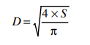

The drogue chute will be dependent of the weight of the rocket.

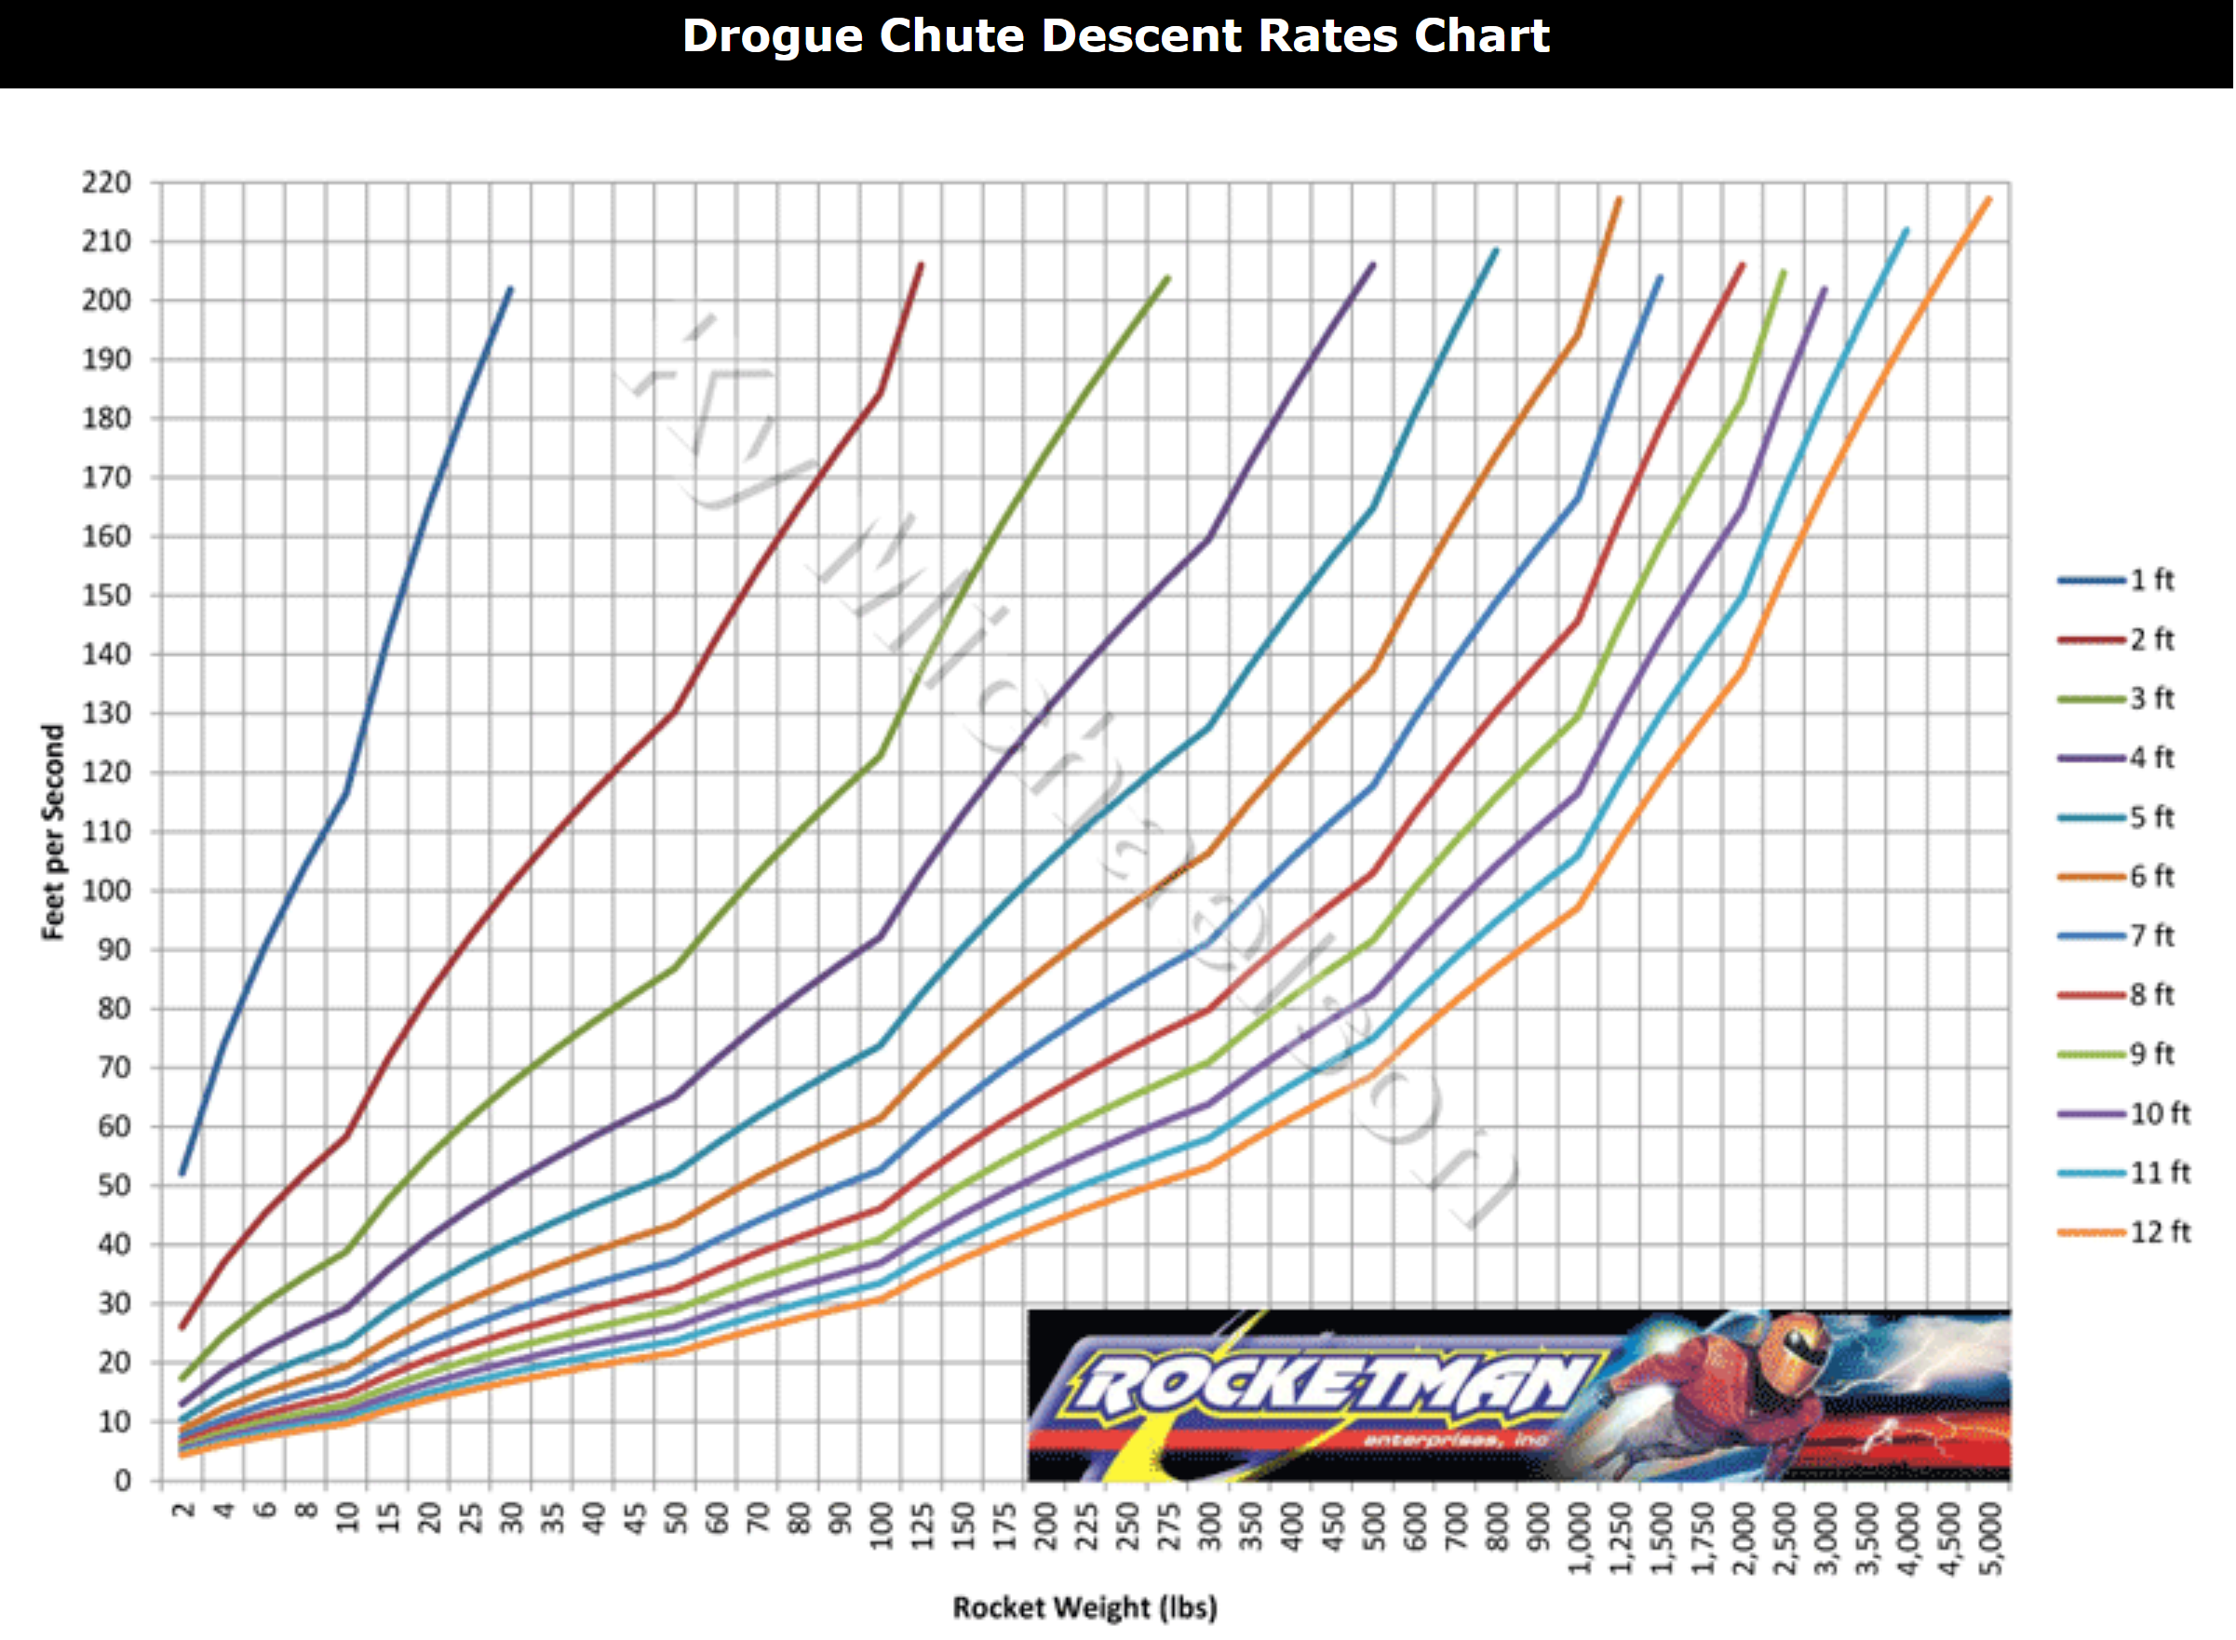

For the main parachute the following chart will be use as a guide when purchasing it from vendors.

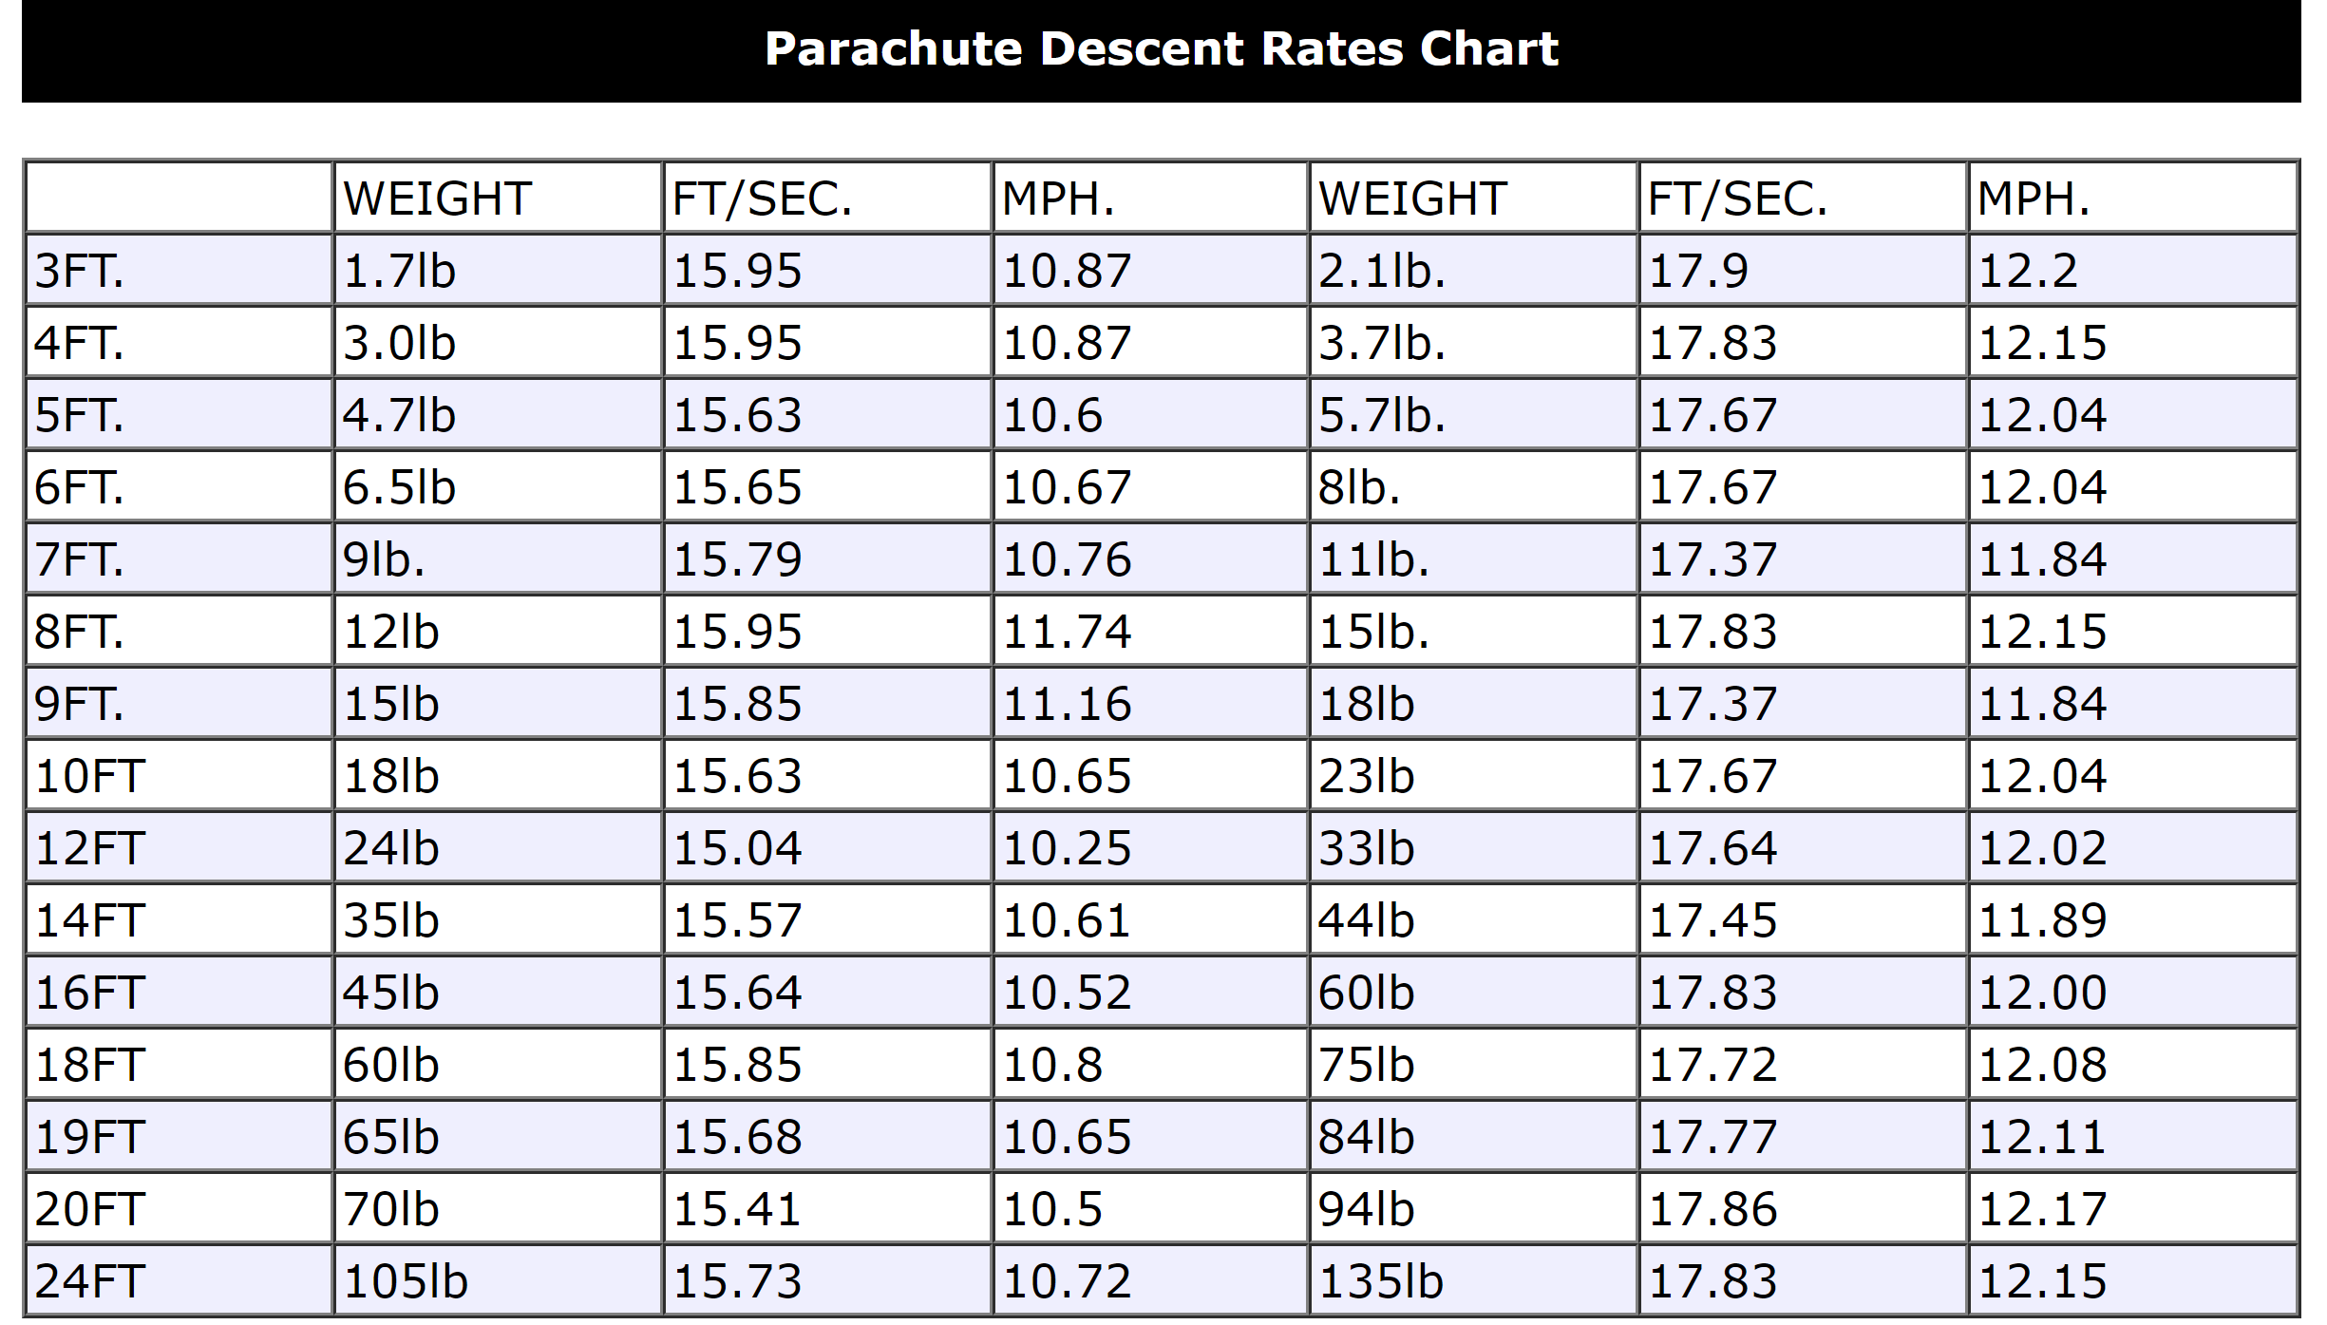

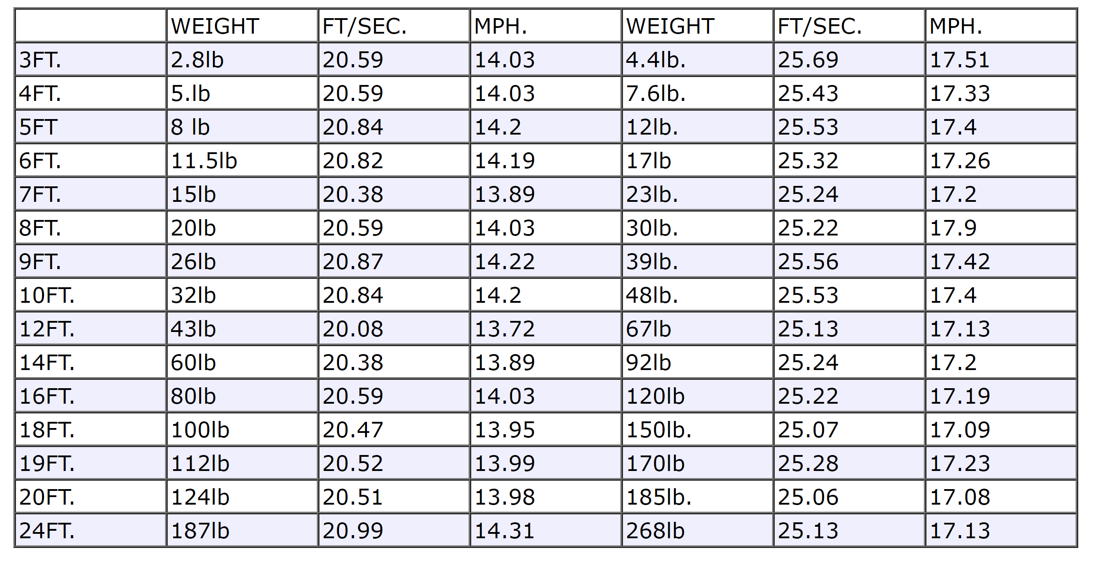

The nylon shear pins, for this specific vendor, has the approximate force that will require the shear pin to break in half. This force will be provided by the pressure force from the CO2 canisters.

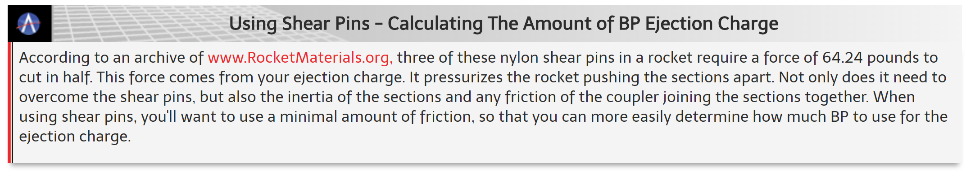

For the shock cord, we decided to use kevlar ropes for its strength. Kevlar ropes reach their maximum at 1200lb. Four ropes would be enough to safely deploy the parachutes, conserve space and support the weight of the rocket.

To determine the size and the number of CO2 canisters needed we followed the chart from the vendor that we will use to acquire the canisters.

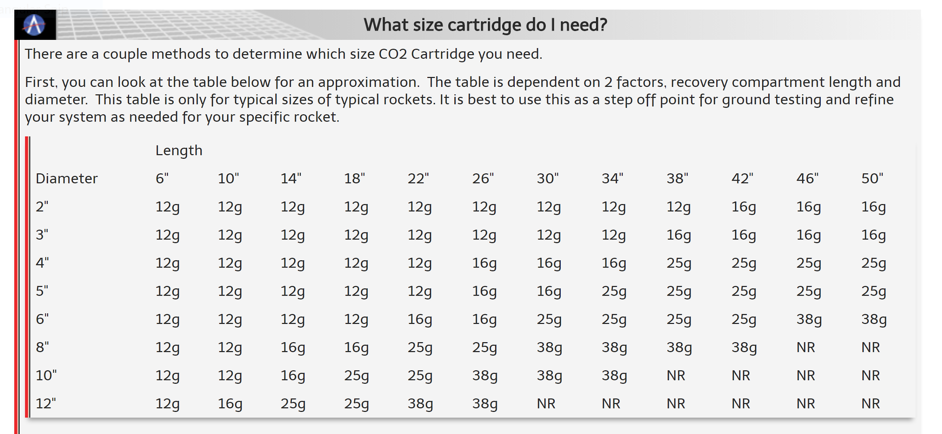

For the actuation of the CO2 canisters it will be this mechanism:

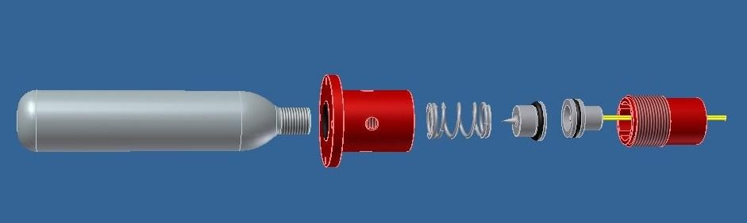

Gunpowder will be use to actuate the CO2 canister. The right amount of gunpowder will be calculated to ensure that it is optimum to break the seal of the CO2 canister and not affect the integrity of the rocket.

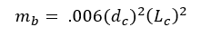

Where:

m_b : mass of gunpowder in grams

d_c : length of the inner diameter of the parachute in inches

L_c : length of the compartment in inches

As the development of the rocket continues, there will be changes in the parameters if the structure of the rocket. However, the implementation of the recovery system will not be affected. The sizing of the parachute, the number of CO2 canisters, the amount of gunpowder, the number of shear pins, and the number of shock chords will be adapted to the new parameters of the rocket.

# **5. Avionics**

## 5.1 Flight Control and Monitoring

### 5.1.1 Foreword

Flight control, sometimes called attitude control, can be defined as a way to predict and react to a vehicle's rotational movements. Two of the major types of flight control that the UCI Rocket Project (UCIRP or RP) is considering for the Base11(B11) rocket are:

* Passive Control: Control of the rocket using stationary fins
* Active Control: Control of the rocket using moveable fins

Each of these control systems has its own set of pros and cons. Considering the control requirements and functional contranstraints that B11 listed (below) the active stabilization route seems more technically intensive.

Control System Base 11 requirements:

System Monitoring and Reporting

* If an active stability control system is employed (see 3.1.16.4), critical propulsion system performance parameters shall be measured and recorded throughout launch and powered flight that pertain to flight safety conditions, system and predicted impact point.
* If stability control is not employed, onboard monitoring of propulsion and vehicle

performance parameters is optional.

Functional Constraints

* Active flight control systems that have the capability to guide the rocket or any of its components to a spatial target are prohibited.
* Active stability control systems that allow the rocket to maintain its orientation, but do not allow it to be guided to a specific location, are permitted.
* If active stability control is employed, a flight termination system must be incorporated capable of terminating engine thrust in the event of a trajectory deviation that would carry the rocket beyond the approved exclusion zone. This may be either:

a) An autonomous system, if that system is shown to have acceptable reliability as

determined by the New Mexico Spaceport Authority, or

b) A system employing ground-based radar to track the vehicle (provided through the New Mexico Spaceport Authority)

The following is just a quick mention on what is flight control and how can we control it: There are a number of type of movements that need to controlled. A rocket might translate or rotate . In rotation it might roll (on axis of symmetry), yaw (side to side), or pitch(up or down). Roll can be controlled using active fins, however yaw and pitch are more difficult to react to.

During the flight of a model rocket small gusts of wind, or thrust instabilities can cause the rocket to "wobble."

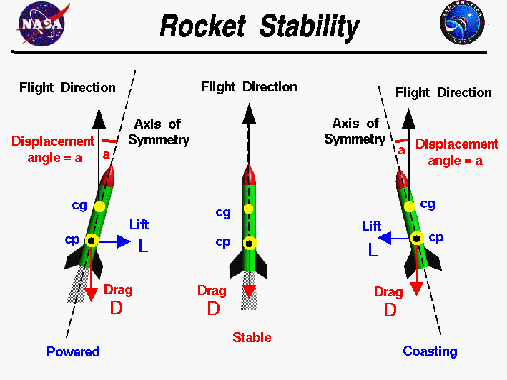

*Figure 5.1.1.1 The three states of an aerodynamically stabilized rocket.*

On this slide three cases are shown for which the flight direction is exactly vertical. In the center of the figure, the rocket is undisturbed and the axis is aligned with the flight direction. The drag of the rocket is along the axis and there is no lift generated. On the left of the figure, a powered rocket has had the nose of the rocket perturbed to the right. On the right of the figure, a coasting rocket has had the nose of the rocket perturbed to the left. The angle is denoted in both cases by the symbol *a*. Considering the powered rocket case, a lift force is generated and directed towards the right or downwind side of the rocket. On the coasting rocket case, the lift is directed towards the left, also the downwind side of the rocket. For the powered case, both the lift and the drag produce counter-clockwise torques, or twists, about the center of gravity; the tail of the rocket will swing to the right under the action of both forces and the nose will move to the left. For the coasting case, both lift and drag produce clockwise torques about the center of gravity; the tail of the rocket will swing to the left under the action of both forces and the nose will move to the right. In both cases, the lift and the drag forces move the nose back towards the flight direction. Engineers call this a restoring force because the forces "restore" the vehicle to its initial condition and the rocket is determined to be stable.

The difference in location of the center of gravity and center of pressure is crucial in making a stable rocket. In fact the center of gravity needs to be above the center of pressure for a stable rocket. The following are a few industry standard practices to control attitude mid-flight

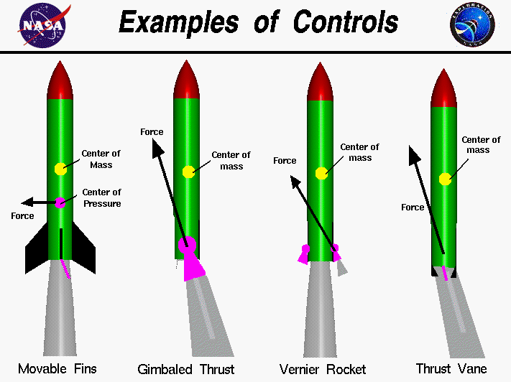

*Figure 5.1.1.2* *Options for stability control on a rocket.*

From the NASA page of Examples of Control:

*Early rockets and current air-to-air missiles typically use movable fins at the rear of the rocket. The movable fin adjusts the amount of the aerodynamic force on the rocket.*

Since the rocket can be aerodynamically stable if designed and simulated properly, the avionics team is holding off on allocating effort on the next phase, the design phase, until a confirmation is received from the structures subteam. They will be verifying our design and simulating at different conditions to check a desired output, and see if our rocket can be stable without an active fin system. A number of crucial calculations, experiments and simulations will have to be performed in the upcoming months that will be used to answer this question.

Outlined below are the hardware and software options that we are considering in case we discover that active control is truly necessary.

### 5.1.2 Hardware

In order to implement active stabilization, the basic hardware we would need is Arduinos, servo motors, and encoders. The Arduino will be used to control the actuation of the servo motors based on the state it sends to the encoder. If we do, we can look into the possible configurations of fins and program them as states in the encoder. The arduino will select what state to execute based on the feedback of the orientation gyros, and accelerometer. Below are examples of the types of products we are considering:

* Encoders: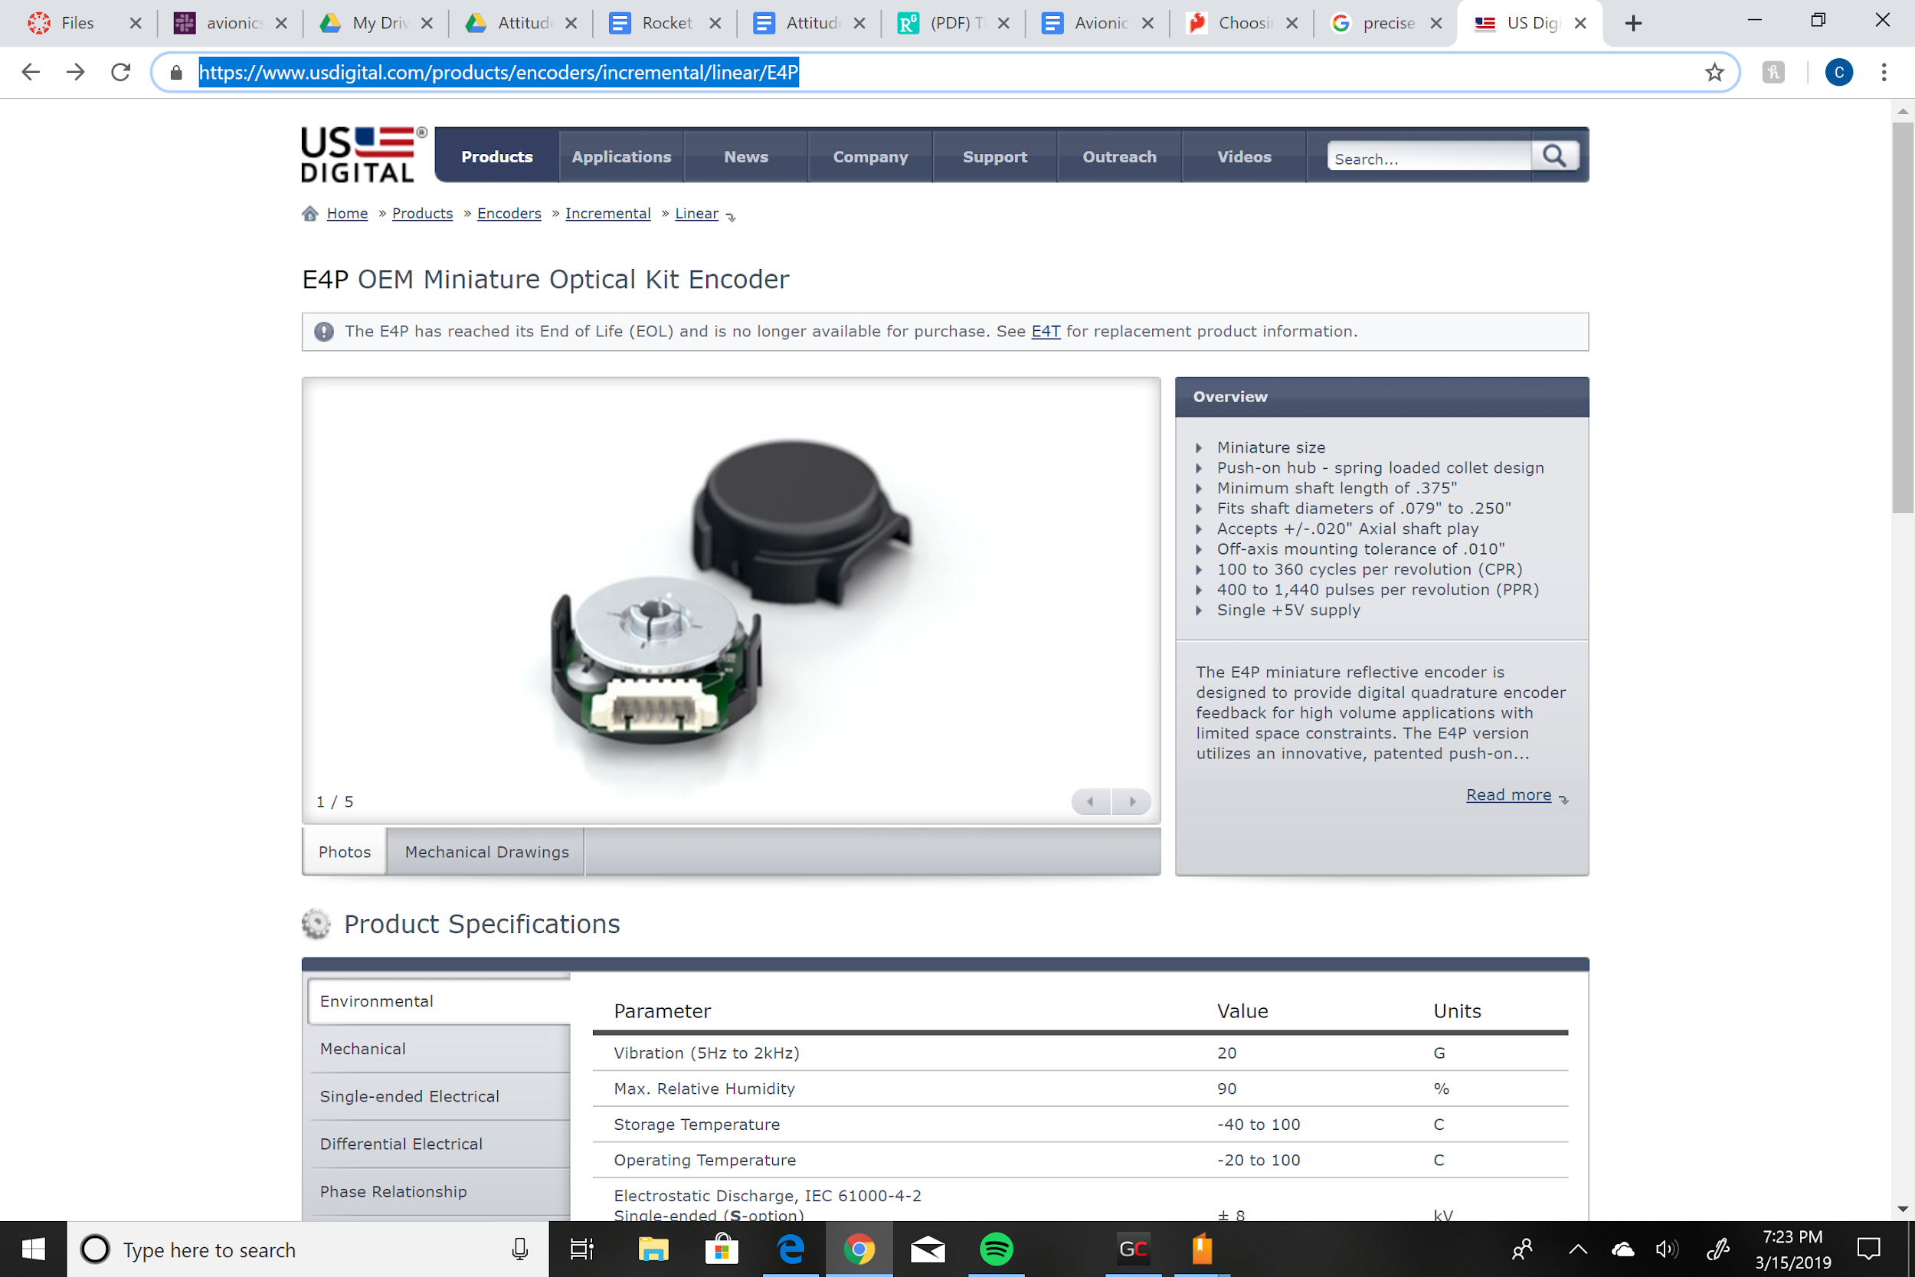

An encoder similar to the US digital’s E4P mini is being considered because of its ability to handle large volumes of data while being compact.

*Figure X : US digital encoder*

* Arduinos:

An microcontroller with power of the Arduino Mega will be necessary to handle all of the incoming information from both the flight system as well as the telemetry and propulsion systems. This Mega will likely be paired with additional arduino unos or comparable products.

*Figure X : Arduino Mega*

* Servo motors:

There are two options being considered for the servo motors. The main option is is the Micro Servo 9g which has a good speed and size for the cost. However, if in the future a faster speed becomes necessary then the Hitec Micro Heli Tail Rotor Servo is a better option. Bodine Direct also seems to have good options on heavy torque motors.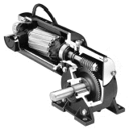

*Figure X : Micro Servo 9g*

### 5.1.3 Software

If active control is deemed necessary, the way UCIRP would approach it is as follows:

* Simulate flight using stability derivatives or a transfer function on AVL
* Implement system through arduino, sensors and control surfaces
* Test the implementation
* Debug system
* Test again
* Iterate test/debug until system is reliable

There are different flight control loops that might be used to keep the rocket pointing upwards. These are discussed later in this section. However, whatever route is chosen AVL simulations are the starting point for any of these. A system must pass the simulation stage in order for implementation to start.

A control loop is required to ensure a desired output is reached even which changing conditions. The idea is to have feedback from the output. Compare the output to the desired and measure the error. The error then determines the reaction of the system. The goal is to react such that the error consistently decreases. The possible systems for flight control are as follows:

* PD-Control

Proportional Gain multiplied by error added to differential gain multiplied by derivative of error with respect to time. This is faster and more common for rocket flight control.

* PID-Control

Proportional gain multiplied by error added to Integral gain multiplied by error integrated with respect to time then added to Derivative gain multiplied by derivative of error with respect to time. This is more relevant if our rocket is exposed to a constant wind force and overkill for flight control.

Once beyond the initial simulation stage involving AVL and assumptions, the team would focus on implementation. As mentioned earlier and Arduino would be a good vessel for this especially in early stages. Speedy implementation is encouraged due to the natural iteration in the testing process. The program would be uploaded to the arduino. Then the program is loaded. This would be most practically done on one of the team’s model rockets. Once the program is run, results are evaluated. Adjustments are made. It is then determined if the direction the system is being designed in is correct or if a rethinking is needed.

Although arduino is sufficient, it must be noted that hardware will always be faster than software. If needed the avenue of transforming the design into a circuit is the common practice among commercial enterprises. This can be accomplished through writing a hardware description using Verilog or VHDL. The avionics team is prepared for this type of work.

## 5.2 Propulsion System Control and Monitoring

### 5.2.1 Foreword

The current engine control system in development is implemented in LabVIEW. UCIRP is using the National Instruments Data Acquisition Devices (NI DAQs), the robust system simultaneously reads from multiple sensors, saves data and has manual control over all valves in the system. The next steps we are going to be taking are programming the ignition sequence, the purge sequence, emergency sequence, and critical contingency handling. Having these implemented, tested and debugged will be absolutely critical for iterating through the testing campaign planned. But for now we can proof our plumbing system at operating conditions (500 psi) by using a manual operated VI, like below.

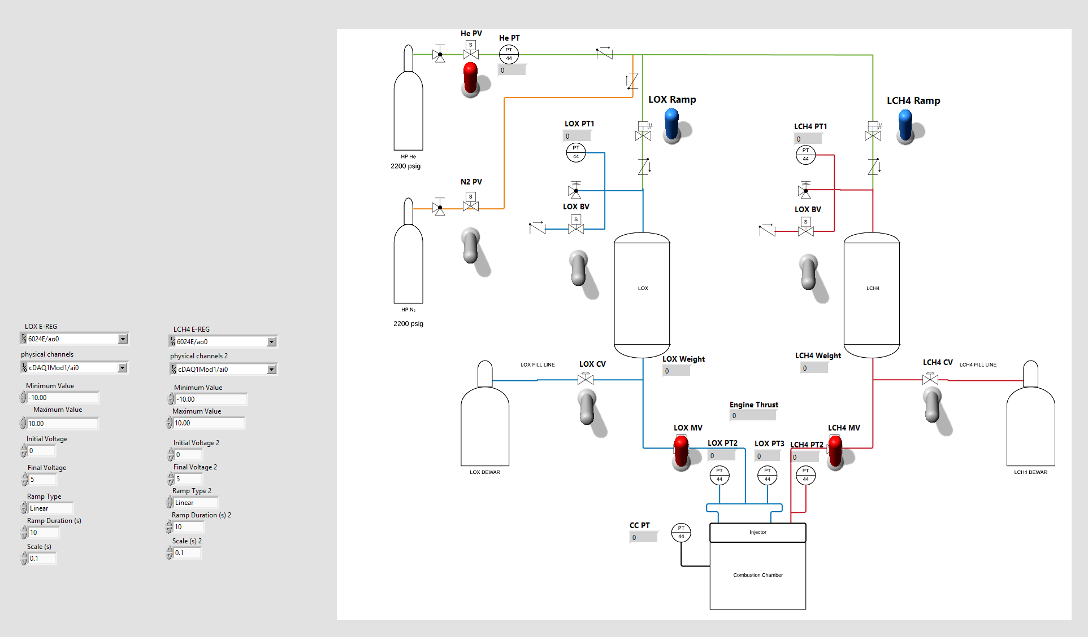

*Figure 5.1.2.1. Front control panel in LabVIEW*

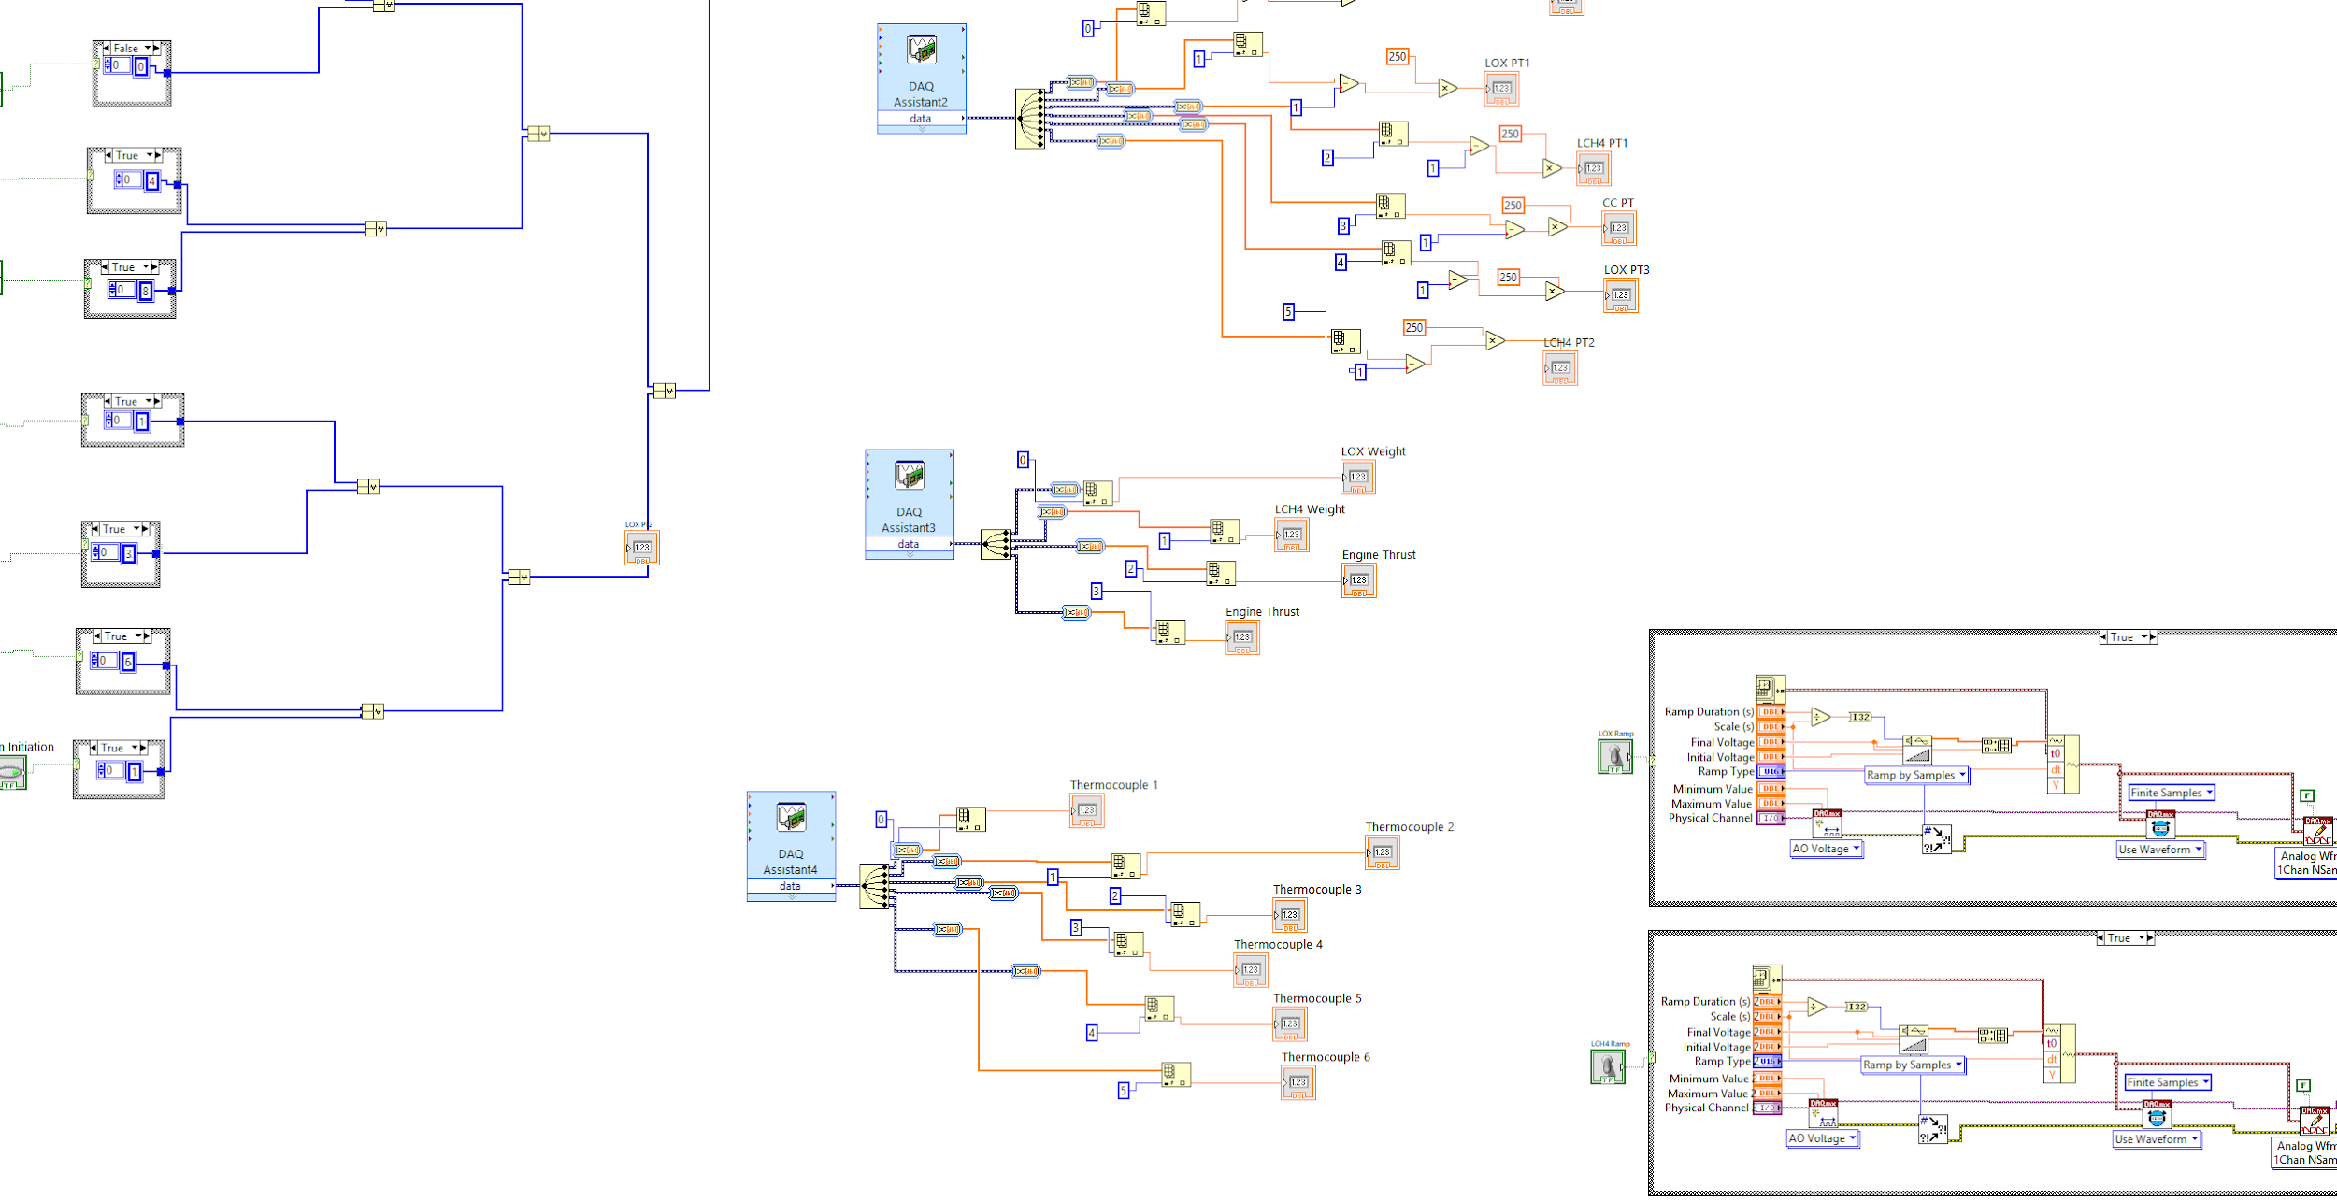

*Figure 5.2.2. Block Diagram in LabVIEW*

This VI is capable of manually operating our test stand using control switches to actuate the valves. It is also capable of displaying and recording data into an excel spreadsheet where it is then easy to graph the data. Although the NI DAQ-LabView system implements many of functions desired for engine control, the weight and immobility of the DAQ components prevent it from being used in the final system. Thus, the choice of physical components will change, but the logic currently implemented in LabVIEW will retain.

### 5.2.2 Hardware

A master-slave arduino configuration will most likely be implemented since it is open source and there is an abundance of literature on the web for these control applications. The program in itself will be an extensive control system that feeds in data and determines what to do next depending on the current state and current data readings.

### 5.2.3 Data Acquisition

Part of the signal processing relies on the analog data turning into digital data for the computer to interpret the data. That is, in mV signals. National Instruments already has integrated delta-sigma Analog to Digital Converters(ADC) to filter all sensor signals coming in to be interpreted by our computer. SMD or TH ADCs will have to be used in the rocket design. These will be bought individually, with different sampling rates and soldered onto a board. From the distinct ADCs the data will split into three different modules, the master arduino module for state processing, the telemetry module to downlink bits and pieces of data from pressure and temperature sensors, and a module where the entire flight data can be saved in an sd card or EEPROM memory. That will be most likely located in an arduino module or a PCB that we may design in the future to simplify this and our signal processing components.

## 5.3 Telemetry

### 5.3.1 Foreword

Telemetry is a form of communication where data from remote points may be sent and monitored elsewhere. Its usage can be found in healthcare and meteorology. The University of California, Irvine Rocket Project (UCIRP) hopes to make use of telemetry on its rocket. This will allow for the real-time monitoring of data crucial to optimal rocket performance.

In order to properly monitor a rocket, many types of data will need to be measured. This list includes the following:

Temperature

* Temperature is important because we want to know the internal temperature of our rocket at all times and if a certain temperature sensor gets too hot, then we want the flight and engine computer to know what to do next. This data will be collected through carefully placed k-type thermocouples at the points of interest.

Plumbing Pressure

* Plumbing Pressure is also important to monitor as it ensures that our fuel is flowing as expected. In the case that it does not, data would indicate the need for review of plumbing designs or the need for contingency plans to be executed.

Acceleration

* Acceleration will also need to be collected as it will help verify the rocket’s performance. The rocket’s ability to reach the necessary heights will need to be carefully studied.

Altitude

* An accurate altitude measurement will need to be made. This will be probably done through the use of a barometric-based altimeter.

Tri-Axis Orientation

* Orientational data will be necessary in monitoring the rocket's trajectory. Whether or not the rocket is following our predicted path is crucial data.

GPS

* The exact position of the rocket should be known at all times, but will play a crucial role in recovering the rocket are its firing.

The data collected will be in analog form, but will need to be converted to digital form for transmitting. Transmitting will then be done with through RF. Through compatible Antennae we will theoretically be able to transmit at distances of up to 100km.

As of now, UCIRP has explored many options of implementing a Telemetry system. The most promising solutions are: buying Commercial Payloads that includes telemetry features or making use of an XBee Telemetry module. Commercial Payloads would be more straightforward as all software would be included and thoroughly debugged by the manufacturer. However, XBee Modules are also very popular, should we decide to undergo a custom telemetry route.

As a way to test our research, UCIRP will be creating a small-scale telemetry system on a model rocket. This will be a way to learn and test our designs. In doing so UCIRP hopes that many design aspects of the model rocket can be scaled up and used in a much larger rocket.

### 5.3.2 Hardware

The most promising option is one called the Telemetrum, by Altus Metrum. This is a full telemetry system that would go on the rocket, which includes an RF transceiver, a GPS receiver, an altimeter, and an STM32 microcontroller. This module would be connected to the main flight controller through a serial communication line.

On the ground, the accompanying Teledongle module would be used to receive data from the RF link. With an 11-element yagi antenna, the module will be able to receive transmissions from up to 100 kilometers.

The telemetrum module also comes with two pyro channels for the desired two parachute events that can be programmable when our rocket reaches apogee and <1km from touchdown. The mechanism to deploy the chutes is not set in stone yet but the use of the pyro channels as a source will definitely be used.

### 5.3.3 Software

Data from the sensors will be sent to the main flight controller, where it will undergo some processing before being sent to the telemetry system. In particular, the flight controller will need to prioritize important data, and keep to the bandwidth limit of the hardware.

As for the Telemetrum, the firmware on the onboard microcontroller will need to be updated to transmit incoming serial data from the flight controller. Out of the box, the firmware transmits GPS and altimeter data from the built-in modules. After updating the firmware, it will be able to transmit data from all of the rocket’s sensors. The avionics team will also look into removing unneeded functionality to save bandwidth on the RF line.

On the ground, the team will most likely use the ground station interface provided by Altus Metrum. This software interfaces directly with the Teledongle module, and provides a GUI to display incoming data. But, this GUI only supports built in functionality, including GPS and altimeter readings. To display the additional data coming from the flight controller, the ground station software will need to be extended. Because the software is open source, the avionics team will be able to accomplish this.

## 5.4 Instrumentation

### 5.4.1 Selection

Ambient conditions differ from one point of the rocket to the next and these conditions determine the state of the system. Thus, sensors and components are selected with attention to operation conditions, which include - but are not limited to - temperature, pressure, and vibration.

#### 5.4.1.1 Pressure Transducers

The pressure transducers implemented in the system include the Measurement Specialites M5241-000005-500PG. The component is rated to measure 0-500 psig and withstand temperatures of -40℃-125℃ when supplied 8-30VDC. Due to their placement in the system, some pressure transducers upstream of the injector will be exposed to low temperatures. Therefore, one should take precaution to use the pressure transducers in conjunction with a 6 in. temperature stand-off.

#### 5.4.1.2 Thermocouples

The thermocouples implemented in the system are the Omega 5TC-TT-K-36-72. The 36-AWG K-type thermocouple measures a range of -328 to 2282 ℉ (-200 to 1250 ℃). In the system, the NI-9213 used in conjunction with the thermocouples contain built-in cold-junction compensation that allows accurate temperature sampling. These sensors will be used in our cryogenic proof test, ignition test, and static fire test.

#### 5.4.1.3 Load Cells

Propellant Weight Load Cells

The engine load cells, ANYLOAD 101NH (50 lbs), are connected in pairs and connected to the NI-9237. When connected in pairs and supplied 10VDC, the load cells measure up to 100 lbs, which is the approximately the weight of the LOX and LNG tanks when fueled with propellant. These load cells will also serve to calculate our mass flow rate. We can do this by subtracting two samples and dividing by the time in between them. This can continuously be done in labview and then fed back to the electric pressure regulator to correct to the desired mass flow rate.

Engine Thrust Load Cell

The engine thrust load cell measures up to 2,500 lbs of force generated by the engine. Because objects weighing near the full scale of this load cell is not readily available, a shunt resistance which simulates heavier loads is used for testing. Below are some product specifications compared to the UCIRP’s laboratory measurements.

|  |  |  |
| --- | --- | --- |
| Source | **Manufacture** | **Lab Data** |
| Zero Balance | +/- 2% | -0.1mV @14.74V |
| Safe Overload | 3750 lbs | N/A |
| Excitation | 10V - 20V | N/A |
| Full Scale Output | 3mV/V +/- 10% | 2.968 mV/V |
| Input Impedance | 385Ω +/- 30Ω | 398Ω |
| Output Impedance | 350Ω +/- 4Ω | 352Ω |
| Operating Temp | -40C to 80C | N/A |
| Temp Effect | 20 ppm/C | N/A |

*Figure 5.4.1.3. Engine thrust load cell specifications vs. lab measurements*

### 5.4.1.4 Solenoid Valves

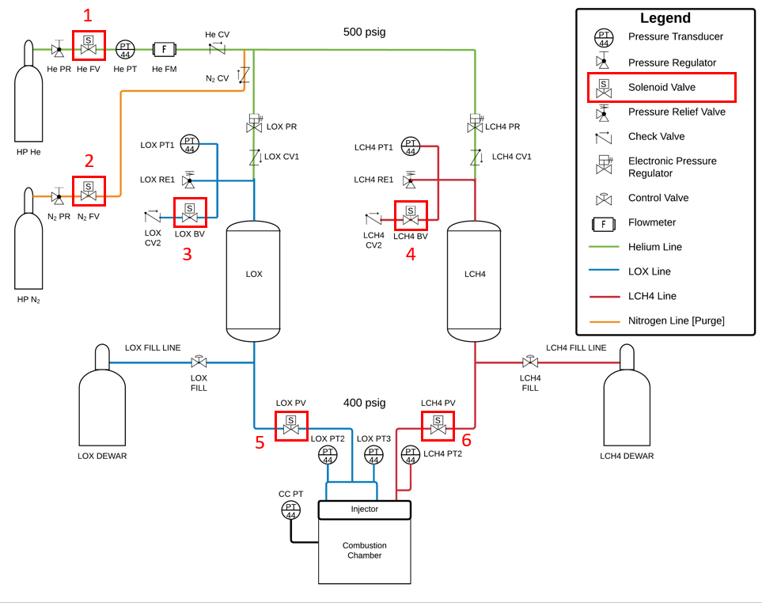

*Figure 5.4.1.4. Location of the solenoid valves*

Actuators 1,2,5, and 6 are all being operated by solenoid valves, while 3 and 4 are standalone solenoid valves that are in charge of the cryogenic boil off.

The Swagelok actuators (5 and 6) are controlled by the Ingersoll Rand Aro P251SS-012-D solenoid air control valves. The normally-closed (NC), 3-way/2-position (3/2) valves operate at 0 to 120 psi and given a 12VDC input.

The solenoid air control valves implemented with the Valworx pneumatic actuators (1 and 2) are the Valworx 529102A. Similar to the Ingersoll Rand solenoid valves, the Valworx 529102A is an NC solenoid valve. However, the Valworx 529102A has an operating range of 30 to 116 psi given a 24VDC input. In addition, it can be adapted for 5/2 or 3/2 implementation.

#### 5.4.1.5 Valves and Actuators

Swagelok

The Swagelok MS-133-SR is implemented in the system. The spring-return pneumatic actuator is currently used in conjunction with a 3-way/2-position solenoid valve. Its actuation pressure ranges from 25 to 150 psig and can operate in temperatures of 0 to 120℉. These will be placed downstream from the propellant tanks so they are cryo rated. These actuators are spring loaded so they default to a close state when in the case of loss of power.

Valworx

The Valworx valve system implements the Valworx 530150 air actuator and Valworx 522404A ball valve. Used in conjunction with a pneumatic solenoid valve, the spring-return Valworx 530150 provides up to 56 inch lbs at 80 psi, and has a maximum pilot air pressure of 120 psi. These actuators are spring loaded so they default to a close state when in the case of loss of power.

Jefferson

The Jefferson 1327BT122INAT-12VDC is implemented in the system. The direct-acting solenoid valve supports 0 to 750 psig when supplied a voltage of 12VDC and operates up to 356℉. Its placement in the system potentially expose it to cryogenic temperatures. For this reason, a cable gland is recommended to protect its conductor cable. These valves will serve as our bleed valves. Being cryogenically rated means we can use these to provide a pathway for the cryogenic boil-off when the system is in its filling procedure.

#### 5.4.1.6 Electronic Pressure Regulator

The Electronic Pressure Regulator (EPR) - which pressurizes the liquid oxygen and liquid methane tanks is the Proportion-Air QB3H. With a 15-24VDC supply voltage and a 0-5VDC input command signal, the EPR commands 0-500 psi. This EPR will have a critical role in slowly pressurizing to a desired value and maintaining that pressure output when the system is exposed to changes in flow rate.

#### 5.4.1.7 Flight Instruments

Refer to the telemetry section for possible considerations for flight instruments.

### 5.4.2 Verification

#### 5.4.2.1 Verification of Pressure Transducers

The pressure transducers that Avionics has chosen have 3 wire output. There is a red wire for input voltage, a black wire for ground, and a white wire for the output voltage. The input voltage that the transducer can accept ranges from 8-30 volts. The output voltage ranges from 1-5 volts. Below is the circuit for wiring a pressure transducer to the daq.

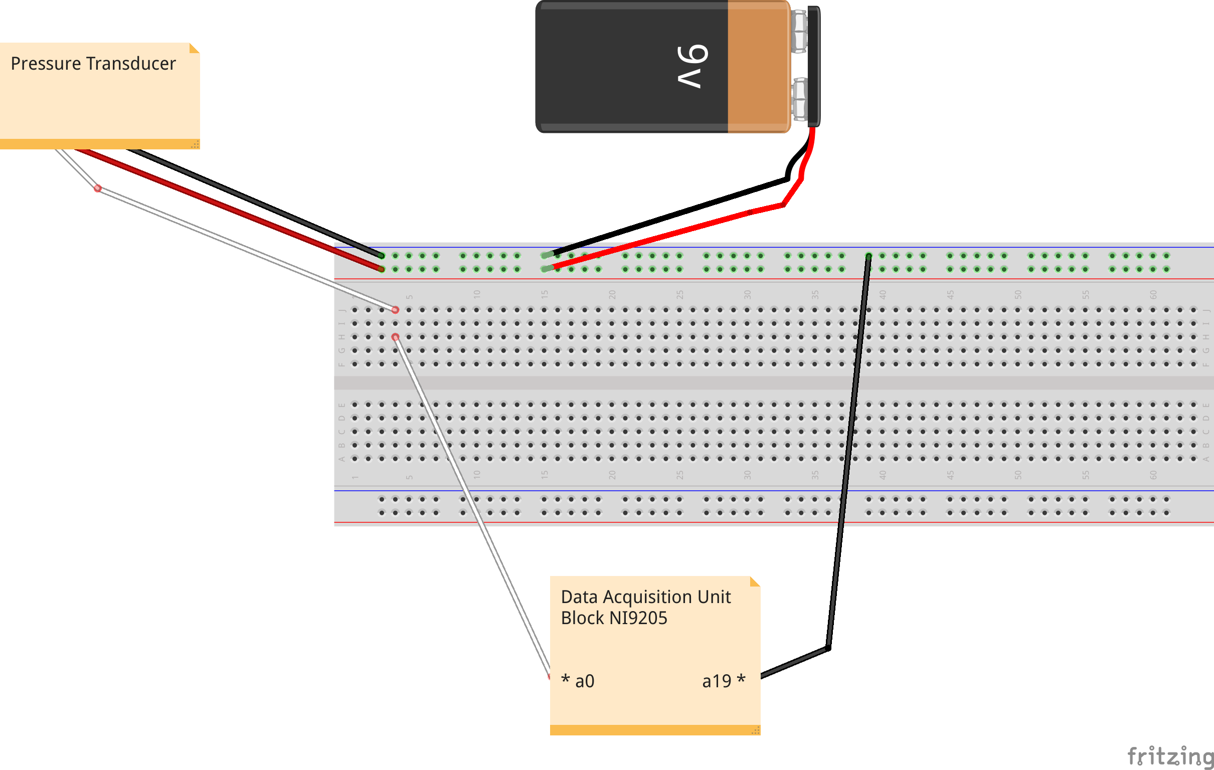

In the diagram, the 9 volt battery is meant to depict the existence of an external power source in this circuit. In an actual circuit, an external power source ranging from 8-30 volts would be needed. The a0 and a19 channels on the daq represent physical ports for connecting a voltage output signal.

The conversion from the voltage reading to psi, where the voltage is v, is (v - 1) * 250.

#### 5.4.2.2 Verification of Thermocouples

Thermocouples are polarized transducers that measure temperature. Verify the polarity and connect it to the NI-9213 by depressing the orange button then inserting the thermocouple in appropriate slot. Run NI-MAX and read the analog Temperature input from the slot.

To verify the thermocouples without use of a data acquisition device, acquire an ice bath and a voltmeter. Insert the non-frayed end of the thermocouple into the ice bath (as a cold junction). Then measure the voltage difference between the two frayed wires. Compare the results to a known voltage-to-temperature table for thermocouples.

#### 5.4.2.3 Verification of Load Cells

Propellant Weight Load Cells

For a simple load cell connection, connect an RJ-50 cable to the NI-9237. Connect the RJ-50 to a 10-conductor terminal breakout board. Match the load cell wires to the appropriate NI-9237 module by connecting it to the breakout board.

For a paired load cell connection, connect the corresponding wires of the load cells in parallel and to the RJ-50 cable. Connect the RJ-50 cable to the NI-9237.

Open NI-MAX and read the analog input by creating a Force (Bridge) task.

Engine Thrust Load Cell

The following is the step-by-step procedure for the three general tests that were performed at the lab:

1. Resistance Verification - A study of the resistances at the arms of the bridge. The purpose was to take advantage of the wheatstone bridge and note how much the resistance changed as weight was put on the load cell.
   * 1. Measure the resistances at each arm and at the input and output terminals.
     2. Apply 80 lbs of weight to the load cell and measure the resistances again to see if the deformation caused by the weight is great enough to detect.
2. Shunt Resistance Measurement - A further look into how the shunt resistor would affect each arm of the bridge by only shunting two terminals together at a time.
   * 1. First acquire two different valued resistors that will be used individually for shunting. In this case, a 100Ω and a 200Ω resistor.
     2. There will be three conditions under which shunting will be measured: no shunt, 100Ω, and 200Ω.
     3. Each terminal will eventually be shunted to see how the system is affected. This means that there are four configurations that will be looked at.
     4. Shunt R1 (Red-Green)
     5. Shunt R2 (Green-Black)
     6. Shunt R3 (Black-White)
     7. Shunt R4 (White-Red)
     8. Finally, measure and record the resistance with a multimeter at the four arms and at the input and output terminals.
3. Load vs Output Test - The most comprehensive as it took the active readings from the sensor as weight was continued to be placed on top, validating assumptions and deriving conversion formulas.
   * 1. For the entire procedure, R2 (Green-Black) will be shunted.
     2. The outputs at five types of shunt simulations will be measured
        1. No shunt
        2. 25% Full Scale = 116.1 kΩ (Represents 625 lbs)
        3. 50% Full Scale = 57.98 kΩ (Represents 1250 lbs)
        4. 75% Full Scale = 38.6 kΩ (Represents 1875 lbs)
        5. 100% Full Scale = 28.99 kΩ (Represents 2500 lbs)
     3. After attaching the shunt for each condition, apply a 14.74 V power supply from one battery pack.
     4. Measure the signal that is produced with a multimeter increasing from 0 lbs of extra load to 80 lbs of extra load by placing weighted plates on top.

#### 5.4.2.4 Verification of Solenoid Valves

NC solenoid valves open with a voltage input. To verify their operation, determine the minimum operating voltage of the solenoid valve. Connect the valve to an appropriate power source.

#### 5.4.2.5 Verification of Valves and Actuators

Swagelok

Connect an NC pneumatic solenoid valve to the Swagelok actuator/valve system using ⅛” tubing. Apply 25-150 psig to the solenoid valve. (De)energize the solenoid valve to (close) open the Swagelok ball valve.

Valworx

Apply up to 120 psi to the Valworx pneumatic solenoid valve that is attached to the Valworx actuator. (De)energize the solenoid valve to (close) open the Valworx ball valve.

Jefferson

Connect the Jefferson valve to a power source using the appropriate cable. Energize the valve with an input of 12VDC. Avoid impurities from entering the valve by securing the included air caps until the valve is integrated in the system.

#### 5.4.2.6 Verification of Electronic Pressure Regulator

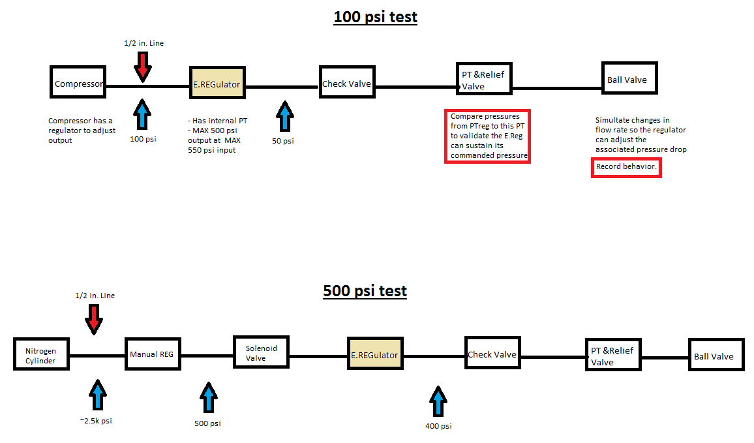

100 psi test:

1. Turn on compressor until capacity, and set regulator to 0 psi output
2. Set E.REG to 0 psi output
3. Regulate up the compressor to 100 psi
4. Set E.REG to 25 psi output
5. Verify PTreg and PTdownstream read the same value for 2 minutes
6. Increment 25 psi and repeat step 5, until 100 psi limit is reached
7. Once at 100 psi, open ball valve half way to induce flow rate change which creates a pressure drop
8. Observe the downstream pressure transducer as the E.REG corrects pressure drop back to 100 psi
9. To purge, close pressure source and let system vent

500 psi test:

1. Close **all** regulators, set them to 0 psi output
2. Open nitrogen cylinder **slowly** until fully open
3. Use manual regulator to output a 500 psi downstream pressure
4. Actuate solenoid valve, and set E.REG to 100 psi output
5. Verify PTreg and PTdownstream read the same value for 2 minutes
6. Increment 100 psi and repeat step 5, until 400 psi limit is reached
7. Once at 400 psi, open ball valve half way to induce flow rate change which creates a pressure drop
8. Observe the downstream pressure transducer as the E.REG corrects pressure drop back to 400 psi
9. To purge, close pressure source and let system vent

## 5.5 Overall System Interface

### 5.5.1 Software

The whole system will be interfacing through the master slave configuration of arduinos and specifically communicating using I2C. Besides the arduino array, a telemetry module mentioned in above will also be interfacing with everything else using its UART line connection. This poses no problem since we are only going to be sending bits and pieces from our pressure and temperature sensors to transmit down to the ground station. The data/operation flow is described like this: Sensors from the telemetry module and the propulsion system get processed through ADCs and get interpreted by the the M/S arduino. We send bits of pressure data and temperature data to the telemetry module to also transmit this data back down along with the essential telemetry data. The data from the propulsion system constantly gets processed by the main control computer to determine the state of the system. These states will be programmed and are just combinations of valves opened and closed in a certain manner at a certain time. E.g. If we are pumping propellants and no sensors raise any red flags, then we are ok to move to the next state which is pressurization.

There is a level of complexity to these integrated systems but if we approach the testing phase a step at a time then it is definitely doable given the launch window.

## 5.6 Summary

The avionics team right now is dividing effort and working on a small scale telemetry system, engine control research and testing campaign preparedness. Since the team budget for a 100km rocket is too expensive for the team right now, the focus is in proofing the current system so investors can be introduced into the question. Avionics’ effort is being focused on developing a reliable Data Acquisition and Control system for the first engine iteration. After this the team will begin to focus on downsizing the DAQC system proofed during the testing campaign. Run through another testing campaign using the other choice of hardware and then integrate it to a prototype rocket. Those are the biggest upcoming milestones.

# 6. Engine Test

## 6.1 Engine Test Stand Design

The team has also designed a test stand for our preliminary test engine. The design shown below has been fully manufactured in preparation of our static test fire, and contains cryogenically rated tanks and piping, and has been designed to measure the mass of the tanks and the thrust of the engine during fire. A similar piping system will be developed for the full scale design, although the structures will be designed for a larger thrust and designed to hold larger tanks to test the engine for the full firing time.

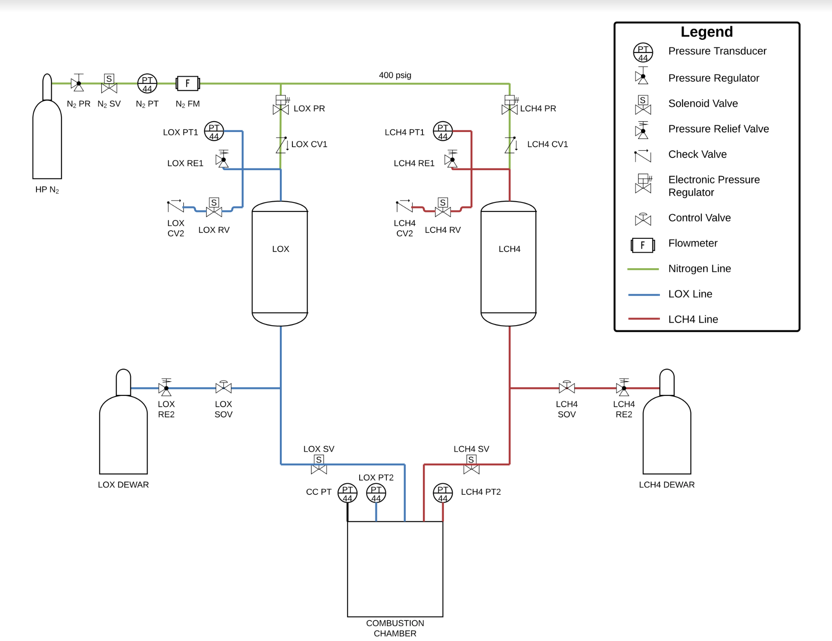

*Figure 2.1.1 Full System Piping Diagram*

### 6.1.1 Full Test Stand Assembly Drawing and BOM¶

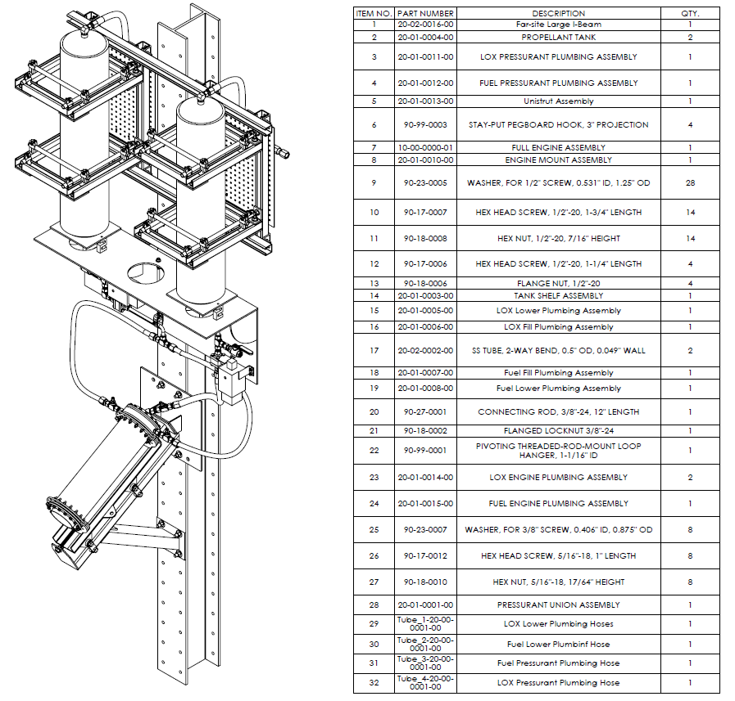❡

*Figure 2.1.2 Full Test Stand Assembly Drawing and BOM¶*

# 7. Safety

## 7.1 Hazard Analysis

### 7.1.1 High Pressure Systems

The UCI Rocket Project requires all team members who are directly involved with designing or testing of any system that poses hazardous materials to take safety trainings. For setups that include high pressure systems, explosion due to a sudden release of high pressurized gas is a major safety hazard. BLEVE, or boiling liquid expanding vapor explosion, occurs when the relief devices do not operate properly in case of trapped superheated liquid inside a tank. Explosion and BLEVE accidents result in high injuries, however, such incidents can be prevented by proof testing the valves and pressure regulators beforehand. Propellants are an example of a high pressure system that may also result in explosions if they are handled carelessly. Compressed gas cylinders are stored in compatible areas and chained in position to prevent falling over and created any damages to the cylinders. When transporting the cylinders, a cylinder dolly will be used to ensure they are handled safely and strapped in place. Leak tests will be performed to identify any leak paths from valves or regulators as well as systems.

### 7.1.2 Cryogenics

The UCI Rocket Project team will be using LOX (liquid oxygen) and LNG (liquid methane) as the propellants. LOX is a strong oxidizer that can result fires due to the enriched oxygen environments. Although oxygen fire hazards are subtle and hard to predict, all team members must be aware of all possible contingencies that might occur in a setting where LOX is present. In case of fire, the team must be familiarized with appropriate emergency protocols to mitigate the hazard. We have created detailed emergency procedures in the event fires do occur in our lab. Another safety issue with using LOX and LNG is the extreme cold of the liquid that can result in cryogenic burns when in contact with the skin. Whenever a cryogenic liquid comes into contact with room temperature substances, a large amount of boiling occurs, which may result in splashing. Therefore, personnel will be wearing proper lab attire when handling LOX, LNG, or any cryogenics to mitigate any unwanted accidents. Personnel is advised to use goggles, cryogenic leather gloves, longs pants and high topped shoes.

### 7.1.3 Ignition System

An External Solid Propellant ignition system will be incorporated in UCI Rocket Project’s liquid bipropellant engine within the combustion chamber. Inside the combustion chamber, a solid rocket motor is placed through the nozzle on a stake and the motor ignites and fires into the combustion chamber heating it to autoignition temperature and igniting the propellant/oxidizer mixture. Because the team is using a pyrotechnic ignition system, there are several contingency situations that must be considered. To minimize possible injuries from safety hazards associated with the ignition system, all personnel are required to leave the immediate vicinity of engine and igniter assembly. The most important safety precaution the team must consider with the use of pyrotechnic devices is fire safety. In a case when the igniter circuit catches on fire, the relevant safety personnel will immediately assess the situation and, if possible, will attempt to put out the fire with a fire extinguisher or other flame retardant. Further instructions will then be provided by the safety personnel to the team to vacate the premises.

## 7.2 Risk Assessment

### 7.2.1 Fueling

Prior to loading the fuel into the propellant tanks, the rocket must be upright and attached to the launch rail. In addition, a valve functional test and a leak test will performed beforehand. Incorrect fittings and prior significant damages on the supply cylinders may pose a risk of high-pressure explosion and the leakage of liquid propellants may lead to cryogenic burns and create oxygen-enriched environment vulnerable to fire hazards. Therefore, proper fittings for the loading and unloading process of supply tanks will be checked by both the safety officer and personnel responsible for the transferring process. A leak test will also be conducted to identify any leak paths with valves and regulators. To minimize any damages on the cylinder, a cylinder dolly will be used when transporting with a protective cap placed prior to moving. Cylinder that show any signs of dents or corrosion shall not be used.

### 7.2.2 Launch

The following failure modes associated with the launch of a liquid-fueled rocket will adhere to the procedural approaches: rocket motor ignition failure and improper installation of rocket on launch rail. The primarily causes of motor ignition failure are improper installation of igniter, slow burn, and electrical delay. If either of these cases occur in the ignition system, the rocket will fail to launch and possibly cause injury to nearby personnel if the motor ignites after a delay. Per the NAR High Power Rocket Safety Code, the safety personnel will turn off the igniter circuit and wait 60 seconds after a motor misfire before approaching the rocket. Then they will remove the igniter assembly from the engine and inspect the igniter assembly and igniter circuit for any faults and rectify as necessary. For an improper installation of the rocket on the launch rail, due to its negative effects on the flight path of the rocket, the safety officer will visually inspect the launch rail and rocket rail buttons and verify that there are no burrs, bumps, and bends beforehand.

### 7.2.3 Flight

The stability of the rocket is crucial and appropriate preparation and design must be outlined in

order to provide safe control during its flight. A key factor in the design for a rocket with static stability is the correct thrust to weight ratio. When the ratio does not meet the minimum requirements to stabilize against wind speed. Failure to take accountable for the weight of the rocket and other environmental factors that interfere with the trajectory of the flight. Therefore, a series of tests will be performed to determine the conditions the rocket might be exposed to during flight to ensure stability and sufficient amount of thrust capable of delivering a rocket to an altitude of 328,000 ft within the safety margin. Another failure mode consideration regarding the flight is the weakening of the body frames for the rocket. Severe impact or other external forces may cause instability during the flight, thus structural analysis on the materials for the frames will be performed to ensure that structural integrity is no severely affected during the flight..

# 8. Team Development

## 8.1 Succession Planning

Succession for an undergraduate project is a key factor in ensuring success for a team. The UCI Rocket Project has developed a number of internal tools and programs to ensure role succession and comprehensive training for students. Our approach focuses on recruitment, new member development, and leadership training.

### 8.1.1 Recruitment

Starting in Fall 2018, our team developed comprehensive recruitment packets and interview guidelines. We provide students in the Henry Samueli School of Engineering and the Donald Bren School of Information and Computer Science with detailed packets containing textbook and information resources. These materials provide guidelines to learn more about what our team does as well as resources to supplement technical knowledge. In addition to external recruitment materials, our project has created a list of standard interview topics to guide future project managers and leads, ensuring they get all the information needed to gauge candidates appropriately. Interviews are generally conducted during the first week of every quarter, and decisions are made as fast as possible to minimize downtime during that week.

### 8.1.2 New Member Development

When new members join the project, they are assigned to a specific sub-team. Quite often it is the case that they don’t have all the technical background needed to be successful on that team. Unfortunately, that is a consequence of the nature of the project. Designing a liquid rocket takes knowledge and experiences that are not taught in a typical undergraduate engineering program. In addition to that, we would like to recruit members who will be on the team for more than a year to address issues in continuity. However, sophomores and juniors don’t always have the classes necessary to understand the system, such as fluid mechanics and thermodynamics. Our project decided to handle these problems by creating sub-team packets that contain resources like textbooks, video lectures, and research documents containing relevant information the project has deemed necessary for all members to know. New members are thus required to “complete” these packets by studying the topics that they have not had any classroom or technical experience with. They are required to complete the packet over the course of the quarter. Students can not be reasonably expected to read an entire textbook in a quarter, so the project has chosen the most relevant chapters out of those textbooks or lectures. These members are expected to be able to keep up with tasks alongside their study.

### 8.1.3 Leadership Development

After a member has been on the team for a quarter, they have the opportunity to apply for a lead position if they are interested. At the end of every quarter, all sub-team members must fill out a returning member application, in which the project lists out lead positions that are open. If a member is interested, they must write a short message, explaining why they believe they are qualified for the position, and submit the application. The Project Manager and Chief Engineer then work together to decide who is most qualified to become a lead. Once those decisions are made, the leads are chosen, and they enter our leadership development program. The development program consists of a quarter of being a “lead in training”. The purpose of the training quarter is to slowly increase the responsibility of the new lead. By the end of the quarter, leads in training will have demonstrated their capability of doing everything a regular lead must do. These include, but are not limited to, attending weekly leads meetings, creating and assigning well thought out, organized, and descriptive tasks, acquiring regular updates from sub-team members on those tasks, providing technical help as needed, and updating management and other sub-team leads on their overall progress, obstacles, and outlook.

## 8.2 Knowledge Retention

There are a variety of important pieces of information that are necessary for the team as a whole remember. Being an undergraduate team, the difficulty of this is that members are on the team at most for three years. On average, team members aren’t even on the team for two years. It is critical for the future success of the project that current members have the training, knowledge, and resources that prior teams have had, so they may build on the project. This type of knowledge comes in many forms and it is difficult for an early team to know everything that they should document. A good plan for longevity is to have a good foundation to build off of as the team sees necessary. The UCI rocket project has attempted to build that base by creating a strong training program (see section 9.1.2), implementing documentation standards, and creating an organized team drive online to store all of our information appropriately.

### 8.2.1 Documentation

The UCI Rocket Project has created documentation standards in an effort to alleviate certain knowledge retention issues. The first standard, is that everyone on the team must use the same documentation template. The template is the same one that is used in this report. One of the advantages of using this template is ease of use. The documents need to be readable, but they also need to be navigable. Our document templates make this possible and easy to use by integrating with Google Docs, and using some of their built in tools. We make use of the automatically updated table of contents and the “outline” view of a webpage, making document editing and searching a streamlined process for our members. The template also includes a revision number table, allowing us to track down what edits were made and by whom. In addition to this, a clean title page, header, and footer, coupled with smart organization allows for a pleasurable reading experience.

The second, more general standard, is that everything must be documented. This rule is going to be more specific as the team gains experience. Right now, it is intended to be a catch-all rule so if anyone on the team questions whether or not they should be documenting something, their immediate answer will lean towards “yes”. All research, analysis, conclusions, trade studies, test procedures, and test results are required to be documented. This is an incomplete list, and there are other resources that management plans on creating for future members. For example, the amount of information that a project manager needs to know is immense. Project managers need to understand the functionality and back-end excel code for our purchase sheet, catalogue, recruitment forms, and roster, in addition to knowing the full role and scope of every member on the project, and how to direct the team’s focus in a way that optimizes progress and survivability of the team. To sharpen the learning curve, the project plans on putting together training documentation specifically for project managers. As the team gains experience and insight, more information and resources will be added to our drive, making it easier for future teams to succeed.

### 8.2.2 Drive Organization

Another important, sometimes overlooked, aspect of knowledge retention is the organization of the resources the team has access to. The Rocket Project uses a google drive that everyone on the team has access to. The drive is separated into 5 main folders: Administration, Propulsion, Avionics, Structures, and Operations. The sub-team folder organization is handled by those team leads. Anything that is related to the entire team is in the Administration folder, which is outlined in the figure below:

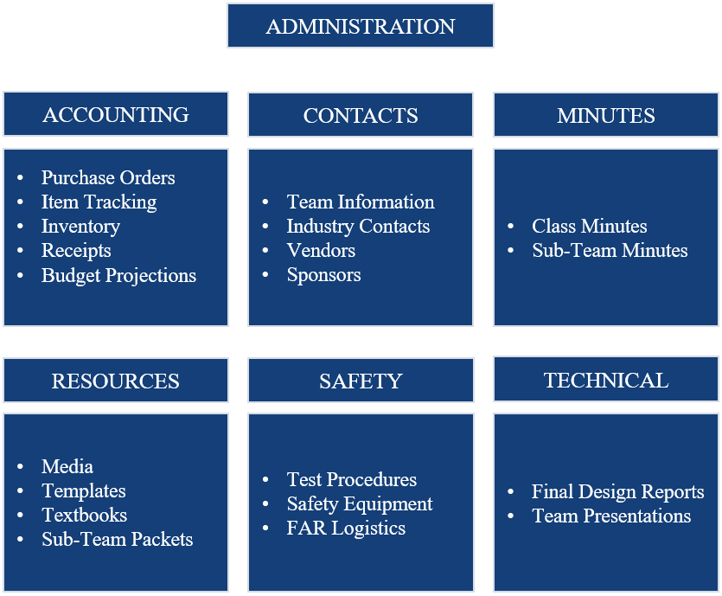

*Figure 8.2.2.1: Administration Folder Organization*

### 8.2.3 GrabCad

The google drive did not solve all of the problems that the project had coming into this academic year. The team still had to solve issues that come with multiple team members all revising the same Solidworks assemblies. There were problems with knowing which drawings were actually updated, who made the last changes to a drawing, and what changes were made to previous iterations of the assemblies. These problems are common in multiple industries, with software development being the most prominent. Version Control Software (VCS) has been an important tool in software development used to attack these issues and make collaboration more efficient. While there is no widely used equivalent that the team was able to find, the UCI Rocket Project has attempted to use guiding principles from VCS protocols like Git to allow the team to keep track of the large amount of updates and changes that are made to the assemblies on a regular basis.

The UCI Rocket Project currently uses GrabCAD to host our drawings. To avoid the issues outlined previously, the team has created strict standards for who is allowed to make updates, procedures for updating files, naming conventions, file organization, assigning part numbers, etc. The GrabCad is tightly bound into our catalogue and part naming convention as well. Our catalogue was created to ensure the team has a

### 8.2.4 Summary

Creating a well organized information storage system has enabled the rocket project to make progress in the last quarter faster than any of the previous years’ teams. Before this school year (2018-2019), the project’s drive and CAD management was in disarray. The messy information made it difficult for members to complete tasks that required finding any information on previous systems, if there was any. It took the leadership the entirety of the fall quarter and a majority of the winter quarter to do a ground-up redesign of our drive, catalogue, and grabcad sites. Organization and planning for the future is an important and integral part of management and systems engineering. While time must be spent creating these procedures and capabilities for the team, engineering and design must go on at the same time. UCI Rocket Project’s challenge over the first half of this school year has been attempting to progress our designs while at the same time trying to make sure future members have the resources and knowledge to progress those designs further, fix mistakes, and launch rockets without having to waste time trying to understand why the current team made the decisions it made.

## 8.3 Outreach

The students involved on the team have been handed an opportunity that not many people get. Even at the undergraduate stage, a significant amount of applicants get turned down for lack of appreciable hands-on project experience. At the professional level, it is extremely difficult to find well qualified engineers who have more than just good grades in their classes. This is why it is so important for teams like the UCI Rocket Project to not only welcome, but seek out young students and show them that they don’t have to wait to be engineers. Engineering is a mindset more than it is a title, and being an engineer by name does not make one good at the engineering process. Showing students that they can start engineering long before they start taking engineering classes is important, and is the best way to ensure that the next generation of graduates is even better than the last. The UCI Rocket project does this by collaborating with local high schools and community colleges, providing lab tours, and opportunities for collaboration.

### 8.3.1 Lab Tours

The team has been given a generous donation that has allowed the development of a modern, capable lab space with access to multiple computer stations with design and analysis software, whiteboards, tools, workbenches, and anything else a design team might need. The UCI Rocket Project provides lab tours to local high schools, community colleges, or even visiting international students, as a way to give back to the community, and foster growth in the industry. It is an important and small contribution to the engineering community, and UCIRP is happy to provide the tours. During the tours, the team discusses current goals, prior work, design principles, and challenges that the team has faced and overcome. Here are a few highlights from these tours:

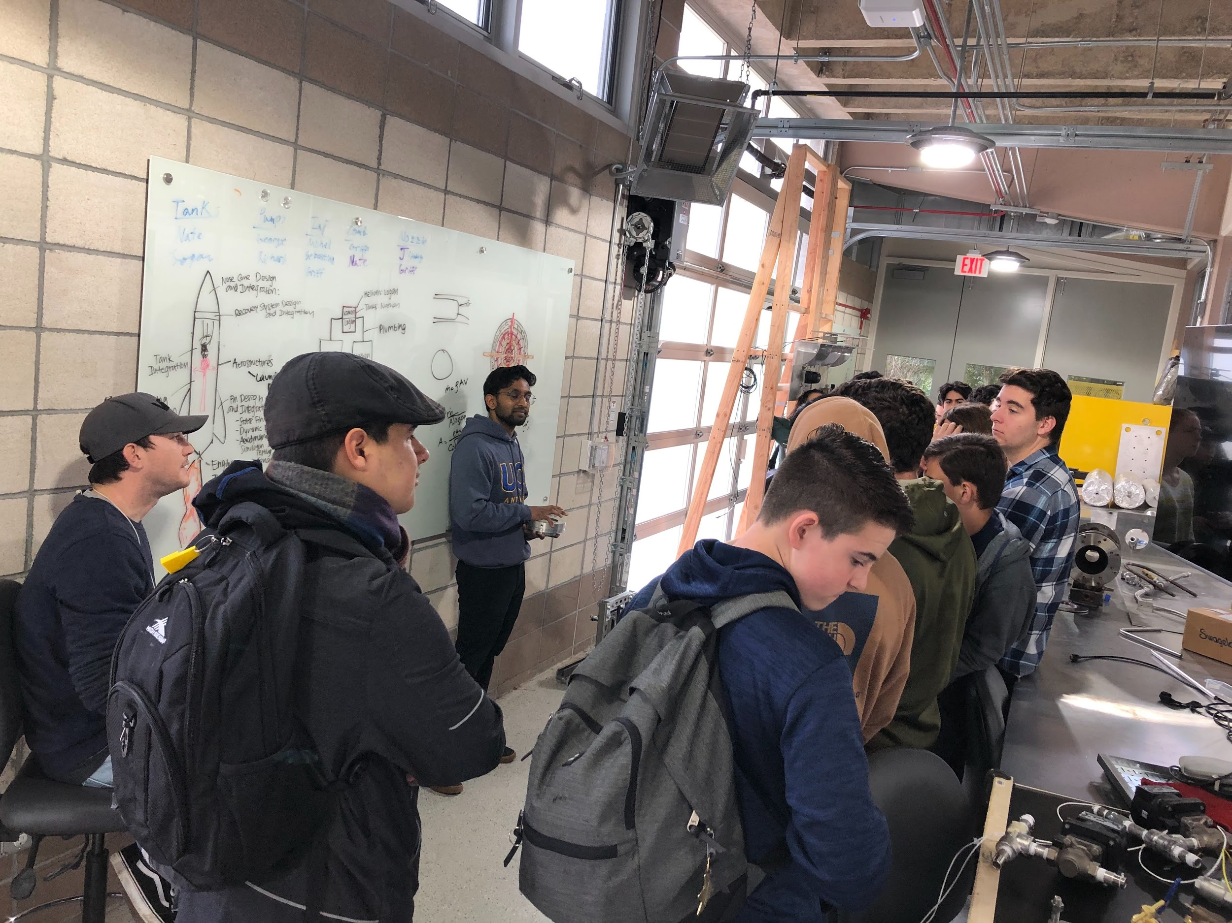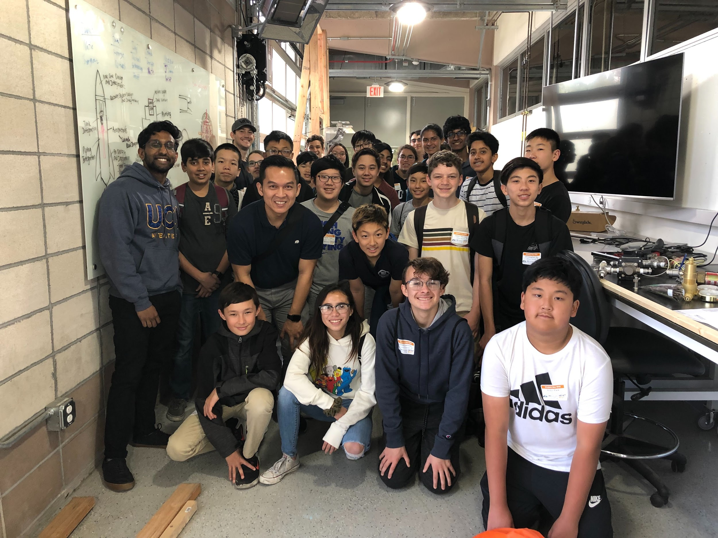

### 

*Figure X: UCI Rocket Project Lab Tours*

### 8.3.2 Community College Collaboration

A large percentage of the team is made up of community college (CC) transfer students. There are some common traits among transfer students that tend to make good choices for engineering teams. For example, a lot of CC students had to pay for school themselves. This tends to give them a stronger drive in making their time at school worth the money, thus they put more effort into extracurriculars like the UCI Rocket Project. Another common transfer trait is that they are older, returning students. Older students who have already worked for a living, maybe have families that they have to provide for, tend to also be more motivated. These are not hard rules, but they are correlations that management on the team has noticed. In an attempt to encourage CC students prior to attending UCI, the team has started a collaboration program with Orange Coast Community College (OCC).

During the fall quarter, UCI Rocket Project had two students on the team from OCC. They were introduced to our system and worked with us once a week in the lab. There were some slight difficulties from a logistical point of view, because UCI has strict regulations on who is actually allowed in the lab and who is allowed to contribute to the project. This involved getting access to various lab trainings required by the school and a lot of meetings between faculty at OCC and UCI. This proved quite difficult, so the relationship has evolved into something a little different. Currently, UCI is working with OCC machining instructors to develop a pipeline for machining students to come to UCI and join our project. In addition, the project would like to machine most of the parts for the rocket at OCC. These parts would be machined by students under the supervision of the shop instructors, due to the small tolerances allowed on the parts. The team will continue to foster relationships with local community colleges and high schools. These relationships are important to ensuring the project continues to survive and thrive in the future.

## 8.4 Business and Marketing

### 8.4.1 Overall Budget

As mentioned before, the UCI Rocket Project was given a donation from Base11 for which the team is very grateful for. A significant portion of the donation (more than $800,000.00) was put into the construction and furnishment of the UCI Rocketry Lab. Between the construction costs and the expenses that the 2017-2018 UCIRP spent, the current budget sits at around $40,000.00. This is clearly not going to be enough to fund the development of a rocket capable of reaching the Karman line. Rough estimates put the required cost to be more than $200,000.00. The $40,000.00 we have left will be used to continue the development of our Preliminary Test Rocket (PTR). This is broken up into verification testing of our engine and plumbing system, static test fire, and our aerostructure manufacturing and flight computer development costs. Due to the sizeable difference in cost of developing a space-capable rocket and the remaining funds available to the project, a marketing strategy must be implemented.

### 8.4.2 Marketing Strategy

There are three main ways UCIRP gets financial assistance for the project. The first, most reliable way, is through MAE189 class fees. The rocket project is an actual design course on campus that comes with $170 in lab fees per student per quarter. The project only sees about $100 of this money after the school takes it’s cut. The project currently has around 25 members enrolled in MAE189, and a few more enrolled in other design courses with fees that are less sizeable (around $50). In total, the project has gotten around $2500 per quarter from lab fees. The goal is to grow the team to a size where it can expect around $10,000 per year from student fees.

The next most common way that the project has been supported has been discounts on manufacturing. Many companies out there are willing to provide sizeable discounts on services in exchange for the benefits of supporting a university design team. Xometry, the company who manufactured UCIRP’s injector, has provided us with an appreciable discount on our next service. Another carbon fiber company in Orange County has agreed to manufacture a carbon fiber nosecone for our preliminary test rocket. A lot of effort goes into contacting, networking, making brochures, and reaching out to companies like these in an attempt to save money. The individual discounts or donations might not be a lot compared to the amount of money the project needs, but every little bit helps.

The only way the team is going to be able to successfully manufacture the space capable rocket, however, is by receiving a monetary donation. This was a large part of the decision to push the development of the preliminary test rocket. If the team scrapped that design, and moved on to the design and manufacturing of a larger rocket, donations would have to come in before the project had anything to show. UCIRP desperately needs something tangible to show companies who might be interested in supporting the project financially. As of now, there is not very much, aside from detailed testing procedures, drawings, analysis, etc. Anyone can put designs on paper, but making the leap to successfully building, testing, and launching, is rare. The idea is that once UCIRP successfully fires and launches PTR, outside investments will be much more reasonable.